

KGrowth 30-60-90 Day Evaluation Series

This product is designed to support the successful onboarding and long-term performance of new hires. Through evaluations completed by both the employee and their manager at each milestone, the series delivers a clear, data-driven picture of early performance and integration.
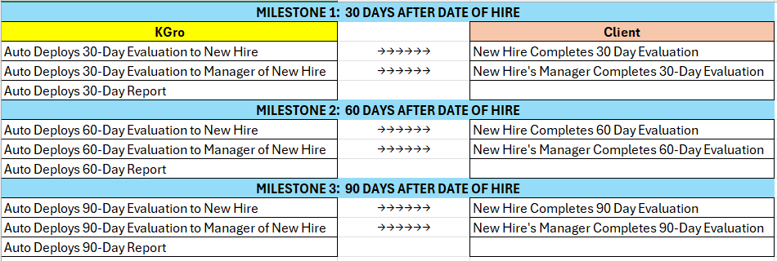
How it works:

Auto Deployment: KGro will automatically email evaluations to the employee and their manager at each checkpoint.

Reports at Each Stage: KGro will develop reports after each stage based on feedback received from the employee and his/her manager that will highlight:

- Overall performance trajectory
- Key strengths
- Primary areas of concern or development
- General alignment or discrepancies between the employee and his/her manager

COST = $225/employee
Includes all set up, deployment & reporting for each new hire

If you are ready to upgrade your onboarding process with very little effort or time taken from your already busy staff, contact KGro today to discuss how we can help.

Katie@KGroHR.com or Sam@KGroHR.com
717-554-6290 717-414-0433

www.KGroHR.com

