Blend and Grind- TDFO Hospitality Company

Products
Coffee bean sourcing, acquisition, roasting, grinding, blending, sale/delivery
Tea sourcing, acquisition, roasting, grinding, blending, sale/delivery
Applicable/Associated Merchandise and Accoutrements

Initial market penetration for both B2C and B2B offering Blend and Grind custom blends of both Coffees and Teas.

B2C- Amazon style sale/distribution via guest and members
Members initial fee $129 annual and $99 a year thereafter with benefits such as 1st year gift of a French Press Travel Mug (customized/logo/name/brand), monthly samples.

Future market penetrations Brick and Mortar locations
Standalone locations, high traffic capability 1200-1700 sqft owned and operated (indoor/outdoor seating elevated outside cigar friendly atmosphere, partnered and licensed, and licensed non ownership locations.

Website

For an artisan coffee blending service with a luxury aesthetic (black + bronze, premium branding), WordPress theme that emphasizes:
- E-commerce capability (WooCommerce integration for online sales)
- Product customization options (for blend mixing and roast selection)
- Visual storytelling (high-quality imagery, elegant typography)
- Wholesale functionality (B2B pricing, bulk order forms)
- Mobile optimization (Instagram-style visuals for social synergy

1. Astra + Elementor
- Why it works:
  - Extremely lightweight and customizable
  - Works perfectly with Elementor for drag-and-drop design
  - WooCommerce-ready for online coffee sales

  - Can easily integrate product configurators for custom blends
- Style: Minimalist, luxury-friendly with full control over fonts/colors (bronze accents on black background).

2. Divi
- Why it works:
  - Elegant design system with built-in visual builder
  - Great for creating premium brand aesthetics
  - WooCommerce integration for retail + wholesale
  - Advanced customization for blend selection forms
- Style: Perfect for storytelling and luxury branding.

3. OceanWP
- Why it works:
  - Highly flexible for e-commerce
  - Supports custom product pages for artisan coffee blends
  - Fast loading and SEO-friendly
- Style: Clean, modern, adaptable to black-and-bronze theme.

4. Shopkeeper
- Why it works:
  - Designed for premium online stores
  - Gorgeous product grids and typography
  - WooCommerce-ready with wholesale extensions
- Style: High-end retail look, perfect for coffee packaging visuals.

5. Neve
- Why it works:
  - Lightweight, fast, and mobile-first
  - Works with Elementor or Gutenberg for easy customization
  - Great for subscription models (coffee club)
- Style: Sleek and modern, adaptable to luxury branding.

✅ Recommended Add-ons
- WooCommerce Product Add-Ons → For custom blend options (origins, roast level).
- Wholesale Suite → For B2B pricing and bulk orders.
- Elementor Pro → For luxury design flexibility.
- WPML → If you plan to sell internationally.

Interactive Maps for choosing and/or purchasing coffee and teas to prep and blend with info and infographics of the regions, types, accompanying notes, strength, altitude ranges, processing methods and icons.

Customizing the name/recipe (limited options for consumers and more customized for members).

Information on steeping techniques, water temperatures all types of coffees and teas.

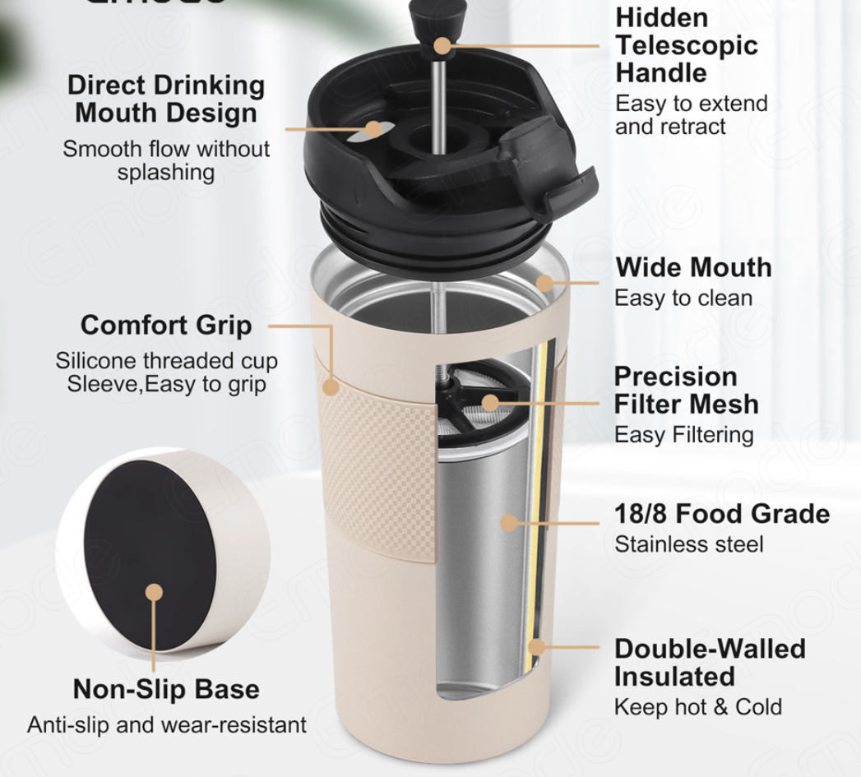

Coffee
Green coffee beans can last quite a long time before roasting if stored properly. Here’s a breakdown:

🟤 Shelf Life of Green Coffee Beans
- Typical Shelf Life: 12 to 24 months
- Optimal Quality Window: Best used within 6 to 12 months for peak flavor.
- Extended Storage: Up to 3 years is possible under ideal conditions, though flavor may degrade over time

✅ Storage Tips for Longevity
To maximize shelf life and preserve quality:
- Cool, Dry Environment: Store at temperatures between 60–70°F (15–21°C).
- Low Humidity: Keep humidity below 60% to prevent mold.
- Airtight Containers: Use sealed containers to protect from oxygen and moisture.
- Avoid Light: Store in opaque containers or dark areas.
- No Freezing: Freezing can damage the beans due to moisture condensation.

Summary Table (Region → Bean Type & Flavors → Procurement Source)
Region | Bean Type & Flavors | Source(s)
Minas Gerais, Brazil | Arabica, smooth, nutty, chocolatey | Genuine Origin
Vietnam (Central) | Robusta, bold, earthy, bitter | Vietnam Coffee Direct
Colombia (Triangle) | Arabica, balanced, fruity, floral | Colombian Direct Coffee
Indonesia (Sumatra, Java, Sulawesi) | Arabica/Robusta, earthy/spicy, multi-faceted | Specialty Indonesian exporters
Ethiopia | Arabica, fruity/floral, tea-like acidity, blueberry/mocha | Yebetbuna, Muda Coffee
Honduras | Arabica, fruity-chocolatey, bright | TraceX-listed exporters
Peru | Arabica, fruity/floral, nutty; organic/specialty | PERUNOR, Cafetos Andinos
India | Arabica/Robusta, spicy, full-bodied | Indian specialty exporters
Guatemala | Arabica, complex, cocoa, spice, floral | La Coop Coffee, TYPICA
Costa Rica | Arabica, bright, creamy, chocolate, citrus; varied process styles | Genuine Origin, Colipse, Stone Street Coffee
Kenya (Africa) | Arabica (SL28, SL34, Peaberry), bright acidity, berry/citrus, floral | Dormans Coffee, KCCE, Connect Coffee, Eagle Crown, Rockbern Coffee
Rwanda (Africa) | Arabica (Bourbon, Caturra, Jackson), bright acidity, floral, citrus/red berry, medium body | RWACOF, Unguka Muhinzi, Land of a Thousand Hills, Bourbon Coffee, Cooperative exporters [rdb.rw], [en.wikipedia.org]
Burundi (Africa) | Arabica (Bourbon, Jackson, French Mission), bright citrus/red berry, silky body | Long Miles Coffee Project, Burman Coffee, JNP Coffee, Onyx Coffee Lab, Café Imports [jnpcoffee.com], [cafeimports.com], [coffeereviewhq.com]

Tea
Here’s a comprehensive guide for Blend & Grind’s tea program, modeled after the coffee sourcing and processing workflow you mentioned:

✅ Tea Types & Freshness Strategy
Tea is categorized by oxidation and processing level. Here are the major types and how to source the freshest:

1. Green Tea
- Freshness: Highest when sourced as First Flush (Spring Harvest).
- Regions: Japan (Sencha, Gyokuro), China (Longjing, Mao Feng).
- Storage: Vacuum-sealed or nitrogen-flushed packs; store in airtight, opaque containers at cool temperatures.
- Shelf Life: 6–12 months if sealed properly.

2. White Tea
- Freshness: Young buds, minimal processing.
- Regions: Fujian (China), Darjeeling (India).
- Storage: Same as green tea; extremely delicate.
- Shelf Life: 6–8 months.

3. Oolong Tea
- Freshness: Semi-oxidized; complexity increases with age but initial aroma fades.
- Regions: Taiwan, Fujian.
- Storage: Airtight tins; some premium oolongs can age like wine.
- Shelf Life: 12–18 months.

4. Black Tea
- Freshness: Fully oxidized; retains flavor longer than green.
- Regions: Assam, Darjeeling, Sri Lanka (Ceylon), Kenya.
- Storage: Airtight tins; cool, dry environment.
- Shelf Life: 18–24 months.

5. Pu-erh (Fermented Tea)
- Freshness: Improves with age; store like wine.
- Regions: Yunnan (China).
- Storage: Breathable wrapping in low-humidity environment.
- Shelf Life: Indefinite (aged teas are prized).

6. Herbal & Botanical Teas
- Freshness: Best when dried immediately after harvest.
- Examples: Chamomile, hibiscus, mint, lemongrass.
- Storage: Airtight jars; avoid light and moisture.
- Shelf Life: 6–12 months.

✅ Blend & Grind Tea Workflow (Coffee Model Adaptation)

1. Sourcing
- Partner with direct-trade farms for seasonal harvests.
- Focus on first flush green teas and premium varietals.
- Acquire whole-leaf teas for maximum freshness.

2. Acquisition
- Ship in vacuum-sealed or nitrogen-flushed packaging.
- Maintain cold chain logistics for delicate teas (green, white).

3. Processing
- Roasting equivalent for tea: Light pan-firing or steaming (done at origin).
- Grinding equivalent: For matcha or powdered blends, use ceramic burr mills to avoid heat damage.

4. Blending
- Combine base teas (green, black, oolong) with botanicals, spices, or dried fruits.
- Use controlled humidity blending rooms to prevent moisture absorption.

5. Packaging
- Use airtight tins or foil-lined bags with one-way valves (similar to coffee).
- Include nitrogen flush for premium blends.

6. Sale & Delivery
- Offer loose-leaf tins, single-serve sachets, and matcha jars.
- Subscription model: Seasonal tea boxes (similar to coffee bean subscriptions).

✅ Keeping Tea Fresh the Longest
- Avoid oxygen, light, heat, and moisture.
- Store in airtight, opaque containers.
- Use desiccant packs for humidity control.
- For retail: Emphasize “Fresh Harvest Date” and “Best Before” on packaging

Logo Concept Ideas and Branding Materials

🔥 Logo Concept Ideas
Here are a few directions we could explore:

1. Heritage & Craft
- Visuals: Vintage coffee grinder, barrel silhouette, elegant serif typography.
- Colors: Deep espresso brown, aged gold, charcoal black.
- Style: Classic, timeless, upscale.

2. Modern Luxe
- Visuals: Minimalist coffee bean + barrel fusion icon, clean lines.
- Colors: Matte black, copper, ivory.
- Style: Sleek, premium, modern.

3. Rustic Industrial
- Visuals: Stamped logo style, distressed textures, coffee sack elements.
- Colors: Earth tones, muted greens, warm browns.
- Style: Artisan, grounded, authentic.

🧾 Branding Materials
Here’s what we can develop for your brand package:

Logo Assets
- Primary logo
- Secondary logo (simplified icon)
- Monochrome and inverted versions
- Favicon and social media icons

Typography
- Headline font (luxury serif or bold sans-serif)
- Body font (clean, readable)

Color Palette
- Primary: Rich coffee brown, matte black
- Accent: Copper, cream, deep burgundy

Packaging Concepts
- Coffee bag designs (matte finish, foil-stamped logo)
- Barrel-inspired tins or boxes
- LuxePurveyors co-branding tag

Digital & Print Collateral
- Business cards
- Social media templates

Step 1: Instagram Story Templates
- Format: Portrait (1080×1920)
- Theme: Black & bronze (matte black background, bronze gradient accents)
- Logo: Included at bottom center
- Templates:
  - Promo (space for product image + headline)
  - Announcement (headline + subtext area)
  - Lifestyle (image-focused with subtle branding)

- Website header and footer graphics
- Email signature
- Product sell sheets
For Facebook, you’ll want to use tags and categories that maximize discoverability for both retail and wholesale coffee buyers. Here are some strong options:

✅ Primary Categories
- Coffee Shop
- Food & Beverage
- Retail Company
- Wholesale & Supply Store
- Specialty Coffee Roaster

✅ Tag Words / Keywords
- Coffee Roasting
- Coffee Blending
- Specialty Coffee
- Gourmet Coffee
- Artisan Coffee
- Coffee Beans
- Fresh Roasted Coffee
- Coffee Merch
- Coffee Accessories
- Coffee Gear
- Coffee Lovers
- Coffee Subscription
- Wholesale Coffee
- Coffee Distributor
- Coffee Supplier
- Coffee for Cafes
- Coffee for Restaurants
- Coffee for Offices
- Coffee Gifts
- Luxe Coffee
- Premium Coffee Brand

✅ Additional Lifestyle Tags
- Morning Coffee
- Coffee Culture
- Coffee Time
- Coffee Break
- Coffee Art
- Coffee Experience

✅ Hashtag Strategy for Facebook & Instagram
Use a mix of broad hashtags and niche hashtags:
- #BlendAndGrind
- #LuxeCoffee
- #CoffeeRoasters
- #SpecialtyCoffee
- #GourmetCoffee
- #CoffeeCulture
- #CoffeeGear
- #CoffeeSubscription
- #WholesaleCoffee
- #CoffeeSupplier
- #CoffeeMerch
- #CoffeeAddict
- #MorningCoffee

✅ How to Use These Hashtags
- Include 3–5 core hashtags in every post (#BlendAndGrind, #LuxeCoffee, #SpecialtyCoffee).
- Rotate the others to avoid repetition and reach different audiences.
- Combine broad hashtags (#CoffeeAddict, #MorningCoffee) with niche ones (#WholesaleCoffee, #CoffeeSupplier) for both retail and wholesale engagement.

✅ Suggested Post Structure
Caption Example:
Elevate your coffee experience with Blend and Grind. From artisan roasting to premium blends, we deliver luxury in every cup.
☕ Available for coffee lovers and wholesale partners.
#BlendAndGrind #LuxeCoffee #SpecialtyCoffee #CoffeeRoasters #CoffeeCulture #WholesaleCoffee

✅ Facebook Bio
Blend and Grind is your ultimate online destination for premium coffee. We source the finest beans from renowned origins worldwide and roast them to perfection—light, medium, or dark—just the way you love. Create your own signature blend by mixing our curated offerings and experience coffee like never before. From single-origin purity to artisan blends, we deliver luxury in every cup.
Shop online today and craft your perfect brew. Wholesale options available.

✅ Tagline
“Blend. Roast. Customize. Your Coffee, Your Way.”
or
“Luxury Coffee, Crafted by You.”

✅ 4. Three Sample Posts

Post 1 – Retail Consumer
Caption:
Your perfect cup starts here. Choose from premium origins, select your roast—light, medium, or dark—and craft your own blend. Because coffee should be as unique as you are.
☕ Shop now → [website link]
#BlendAndGrind #LuxeCoffee #SpecialtyCoffee #CoffeeAddict #MorningCoffee

Image Idea:
Close-up of shiny bronze logo on black packaging with steaming cup and beans scattered.

Post 2 – Wholesale Buyers
Caption:
Looking for premium coffee for your café, restaurant, or office? Blend and Grind offers wholesale options with customizable blends and roasting profiles. Elevate your coffee program today.
📦 Contact us for wholesale pricing → [website link]
#WholesaleCoffee #CoffeeSupplier #BlendAndGrind #CoffeeRoasters
Image Idea:
Bulk coffee bags with logo, elegant packaging, and tagline overlay.

Post 3 – Lifestyle / Coffee Culture
Caption:
Coffee isn’t just a drink—it’s an experience. At Blend and Grind, we bring luxury to your mornings with artisan blends crafted from the world’s finest beans.
✨ Start your journey → [website link]
#CoffeeCulture #BlendAndGrind #LuxeCoffee #CoffeeGear
Image Idea:
Flat lay of coffee accessories (grinder, cup, beans) with bronze accents and logo.

✅ Next Step
- Post themes (education, lifestyle, product highlights, wholesale promos)
- Captions
- Hashtags
- Image ideas

✅ Instagram Bio
Blend and Grind
Luxury coffee, crafted by you.
☕ Customize blends | Premium origins | Online only
📦 Wholesale available
✨ Shop now → [website link]

✅ Highlight Covers (Visual Concept)
Minimalist, elegant covers with your black-and-bronze theme and clean icons. Suggested highlights:
- Shop – Shopping bag icon in bronze
- Origins – Globe or map pin icon
- Roasts – Coffee bean icon
- Blends – Mixing icon (two beans overlapping)
- Wholesale – Box or bulk bag icon
- Merch – Mug or accessory icon
- FAQ – Question mark icon
- Contact – Envelope icon

