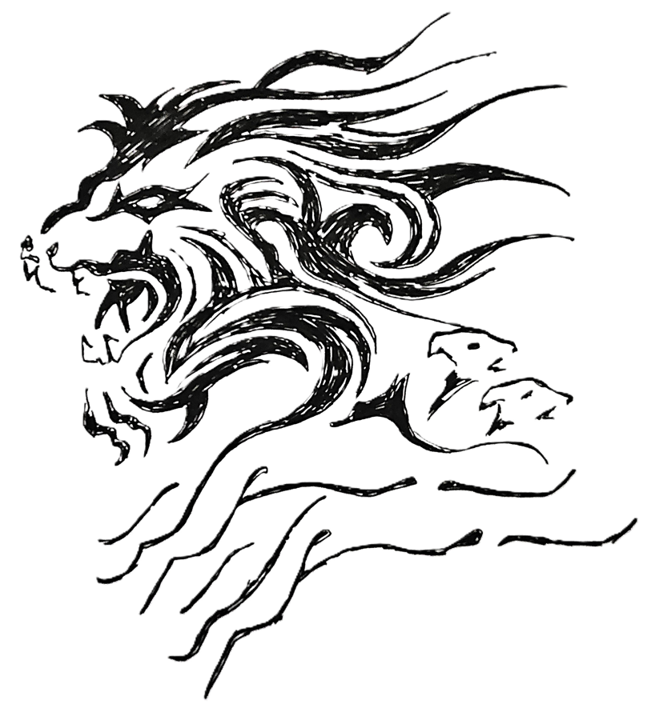
Design need formalising ie hard shading etc
GROUNDIT
UNLEASHED

Gray Nicolls Fusion 1500
Size -SM
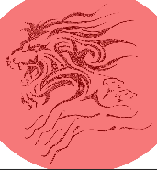
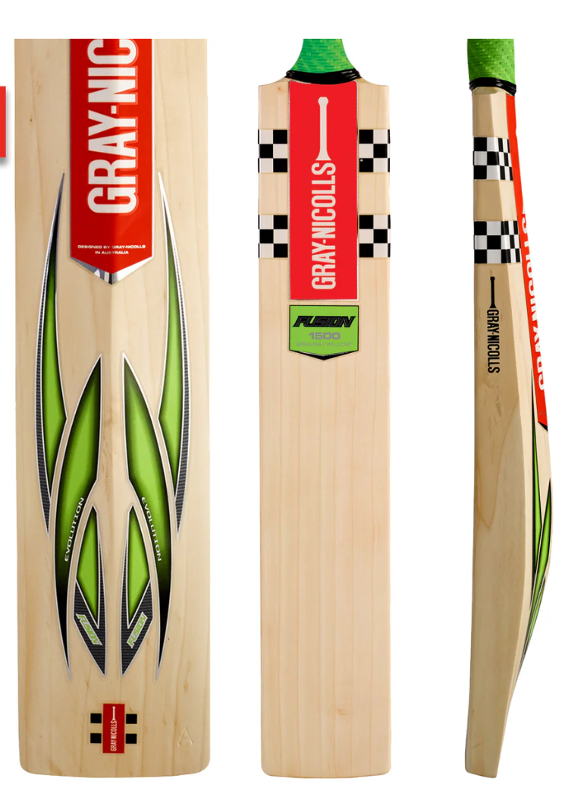
GROUNDIT
UNLEASHED
- White lettering on red back ground
- Lion / dog to be in white on red background
- KJB to in RED / Black
- Change checker colours
- Open to ideas
KJB
