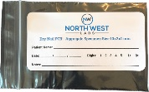
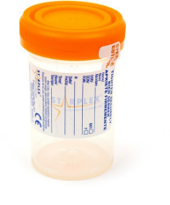
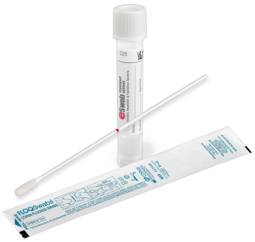
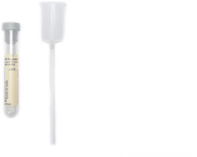
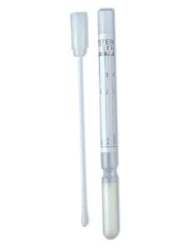
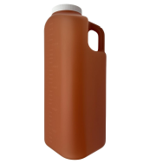
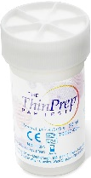
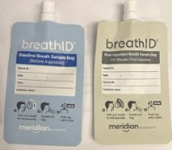
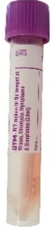
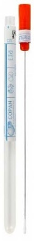
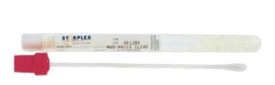
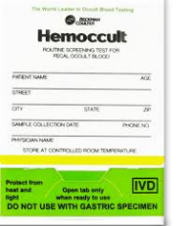
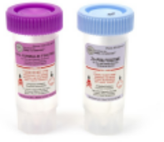
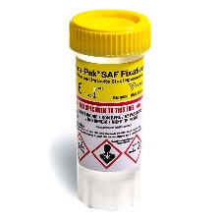
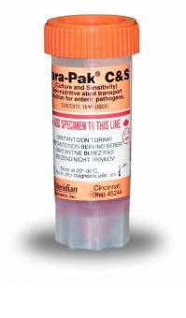
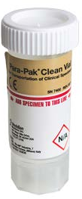
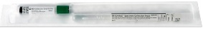
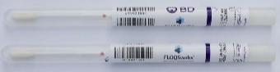
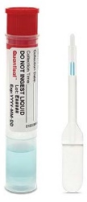
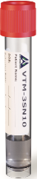
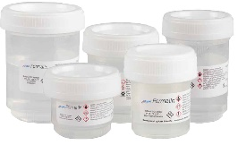

Specimen Collection Reference Guide
Questions? Call 248 301 6917
Plastic Envelope
(nail bag)
Nail Fungal PCR
Wound PCR
Additional PCR tests
All Urine Drug screen and confirmation testing
Sterile Collection Container
Other
- Synovial Fluid
- Sputum Culture
- Kidney Stone (4788L)
Urine
- Urinalysis
- Chlam/GC Urine
- Mycoplasma Genitalium
- Trichomonas

Nasopharyngeal Swab

Bordetella/ Pertussis

Stool Culture Vial

Stool Culture

Clean Stool Vial

C-Diff
Fecal Fat
H.Pylori Stool
Lactoferrin, Stool

BD Surepath Swab

Self- Swab HPV
Fecal Occult Blood Test Kit

Fecal Occult Blood Test
Viral Transport Media

Herpes Culture
Viral Culture
Varicella Zoaster PCR

Breath ID Kit

H. Pylori Breath Test
(Blue & Grey bags only)
O & P Stool Containers

Ova and Parasites
Thin Prep

24 Hour Urine Jug

E Swab

- Protein
- Total 24 hour Urine
- Catecholamines
- 24 hour
- Protein Elect & IFE, 24 Hour
Stuart Media Swab

MRSA NAA

Epredia Biopsy Container

All Sources – Formalin Container
- Chlam/GC
- Trichomonas
- Pap Smear
- HPV
Ear, Eye, Nasal, Vaginal, Rectal, Skin, Throat, Tongue, Wound, MRSA Culture,
and Other Anaerobic Culture
GC Screen
Gram Stain
Rapid Strep A (Throat)
Strep Group B Screen (VAG) (41)
ARX Viral Transport Media

COVID-19 PC
Respiratory Profile PCR
Influenza A & B
RSV
Starswabs II CTS

Urine Culture Collection Kit
Urine Culture & Sensitivity
UTI PCR & UR Culture PCR

Vaginitis Panel NAA
- BV
- Trich
- Candida sp
- Candida Glabrata
STI Panel
- Chlam/GC
- Trich
Chlam/GC Swab
Trichomonas

BD Molecular Swab
Oral Toxicology Swab

Any Confirmation Testing

