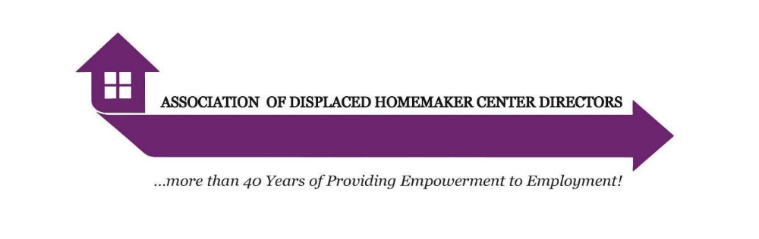
Subject: Urgent: Restore Funding for Displaced Homemaker Programs in the 2026-2027 NYS Budget

Dear [Senator/Assembly Member],

Julia, a single mother of two, came to one of our Displaced Homemaker Program (DHP) Centers feeling hopeless after years of relying on public assistance. She dreamed of providing stability for her children but didn’t know where to start. Through weeks of personalized training and unwavering support, Julia gained the skills and confidence to secure a lucrative job at an insurance company. Today, she is thriving - supporting her family and living independently. Stories like Julia’s are the heart of what DHP does every day across New York State

For 48 years, the Displaced Homemaker Program has helped women facing divorce, widowhood, domestic violence, single parenthood, or the loss of Temporary Assistance for Needy Families. We empower them to achieve financial independence through employment counseling, intensive workforce training, computer instruction, and job placement services.

- Since 1978, we have helped over one million women rebuild their lives.
- In the past decade alone, our 12 Centers guided more than 12,000 women toward sustainable careers.
- We remain the only statewide program dedicated to helping those who have lost family support find employment instead of turning to public assistance.
- The Executive Budget traditionally excludes funding for DHP Centers, restoring our allocation depends entirely on action from the Assembly and Senate.
- Without action from the Senate and Assembly, our programs may not be funded, leaving thousands of women and families at risk of falling deeper into poverty.

For more than 12 years, statewide funding for DHP remained stagnant at $1.6 million - far below what is needed to operate our centers. Last year, that amount was cut to $1.2 million, reducing allocations per center from $135,000 to just $101,250. This drastic cut has had a critical impact on our ability to respond to the increasing needs of the women we serve.

We are requesting $1.92 million in the 2026–2027 NYS Budget, restoring funding and increasing allocations to $160,000 per center. These dollars are essential for staffing, rent, transportation, training materials, and emergency client support. They will also allow us to meet emerging workforce needs, including training job seekers in AI and other technologies to match employer demands.

Every dollar invested in DHP saves New York State $14 by reducing reliance on public assistance, Medicaid, and unemployment benefits. This is not just a moral imperative - it’s a smart economic investment. Your leadership can ensure that this proven program continues to break the cycle of generational poverty, support families, and change lives across New York State.

Thank you for standing strong with our DHP Centers and the women we serve.
Sincerely,
Elizabeth Miller Jan Bridgeford Smith Karizma Wadsworth Lisa Berman
Executive Director Executive Director WERC Director Project Director
Albany/Troy Ithaca/Syracuse Utica/Rome/Herkimer Brooklyn

