Indigo’s Connected Career Spiral Model
The Indigo Connected Career Spiral illustrates the evolving relationship between your authentic self, lived experiences, and your impact in the world. Rooted in the belief that careers and learning are lifelong journeys, the spiral invites you to grow through self-awareness, meaningful relationships, and intentional decision-making. As it expands outward, it continually returns to your inner core—reminding you that true alignment begins with knowing who you are.
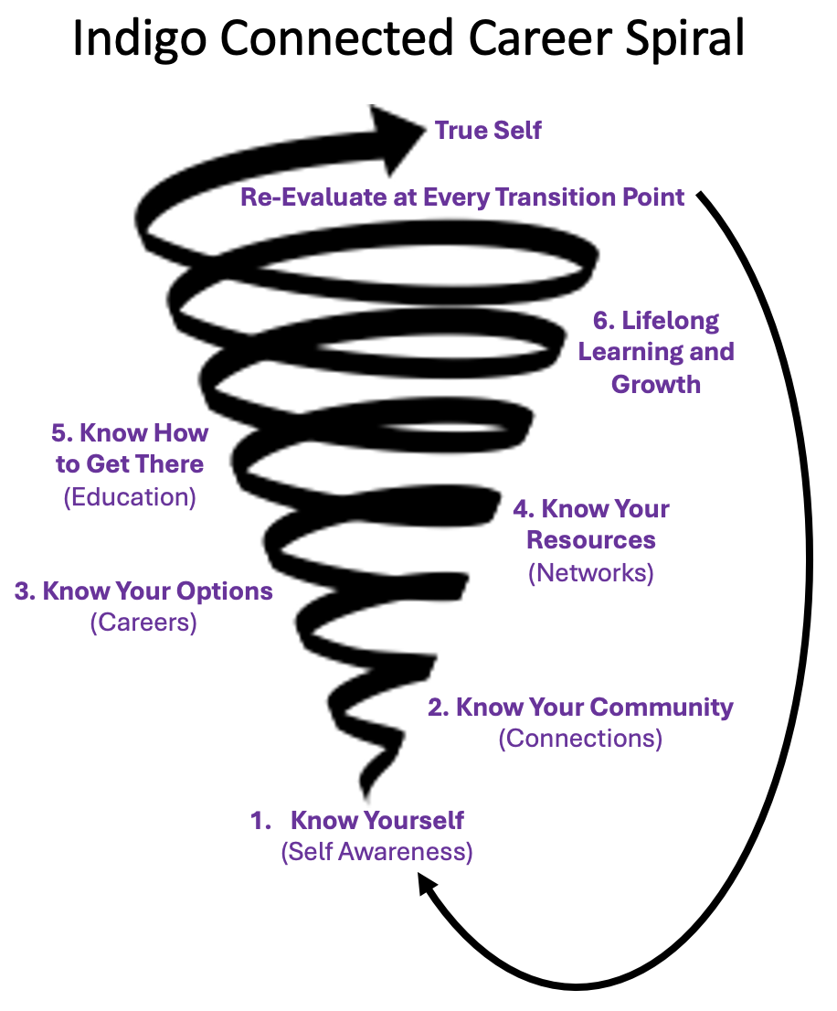
As your career journey unfolds, each transition brings an opportunity for deeper self-awareness, broader perspective, and greater impact. With every step forward, you gain more clarity, more choice, and a stronger sense of meaning in both life and work.
Indigo fosters self-awareness-based learning — empowering people to recognize their intrinsic value, interconnectedness, and unique purpose.

