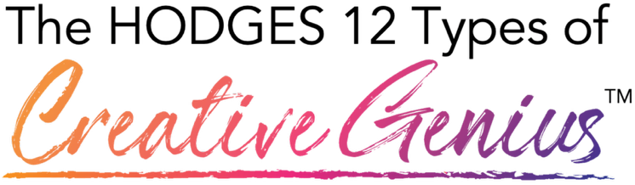

Link to assessment: https://form.typeform.com/to/AU78LTb4

The Hodges 12 Framework and the 3 Domains
A Framework for Understanding Creative Problem-Solving Creativity is not just artistic talent, it's the production of novel and useful ideas, strategies, products, and processes that solve problems.

RELATIONAL GENIUS - How you work with people

THE CONNECTOR
The Connector solves problems by bringing the right people together at the right time. You intuitively see potential matches between people, opportunities, and resources that others miss. Your creative genius is building strategic relationships and creating exponential value by connecting dots that seem unrelated to everyone else.

THE CULTIVATOR
The Cultivator solves problems by creating environments where people can thrive. You build cultures, systems, and conditions that help others discover their potential and flourish. Your creative genius is nurturing growth while also establishing the boundaries and protections that enable safety and success for individuals and communities.

THE HEALER
The Healer solves problems by helping people restore their wellbeing when they're struggling. You address the root causes of pain and suffering, not just the symptoms and guide others to access their own capacity for recovery and growth. Your creative genius is finding compassionate, effective ways to alleviate pain and help people become whole again.

THE TEACHER
The Teacher solves problems by creating learning experiences that transform what people know and can do. You find innovative ways to help others develop new skills and understanding by adjusting your approach until concepts truly click. Your creative genius is designing educational experiences that build capability and confidence, and empowering people to grow in ways they didn't think possible.

ANALYTICAL GENIUS - How you think about problems

THE COMMUNICATOR
The Communicator solves problems by making complex ideas clear and compelling. You find fresh ways to explain difficult concepts, so people truly understand and take action. Your creative genius is crafting messages that resonate with different audiences, whether you're informing, persuading, or inspiring.

THE SCIENTIST
The Scientist solves problems by pursuing truth through systematic investigation. You generate new knowledge and understanding by asking questions, gathering data, and testing what's true. Your creative genius is using rigorous research methods to discover fresh insights and expand what humanity knows about how the world works.

THE STRATEGIST
The Strategist solves problems by envisioning future possibilities and charting clear paths to reach them. You think several steps ahead, navigate uncertainty, and make complex decisions about where to go and how to get there. Your creative genius is seeing opportunities others miss and designing strategies that position people and organizations for success.

THE SYNTHESIZER
The Synthesizer solves problems by connecting ideas from different fields to create new insights. You integrate diverse information into coherent frameworks and see patterns that tie everything together. Your creative genius is finding the principles and connections across seemingly unrelated domains, then combining them into fresh perspectives that reveal what others couldn't see.

FUNCTIONAL GENIUS - How you build solutions

THE ARTIST
The Artist solves problems by creating work that helps people see, feel, or understand things in new ways. Through visual art, music, writing, or performance, you translate ideas and emotions into forms that resonate deeply with others. Your creative genius lies in making the invisible visible and the intangible tangible through aesthetic expression.

THE BUILDER
The Builder solves problems by creating things that actually work in the real world. You turn ideas into functional products, systems, and organizations that people can use. Your creative genius is taking concepts and making them real through hands-on building, testing, and iterating until you've created something valuable and practical.

THE DESIGNER
The Designer solves problems by creating experiences that are both beautiful and easy to use. You design products, spaces, and interfaces that prioritize what people actually need while making them delightful to interact with. Your creative genius is balancing aesthetics with functionality to create solutions that just work elegantly and intuitively.

THE ORGANIZER
The Organizer solves problems by bringing order to chaos. You create systems, processes, and structures that help people and resources work together smoothly and efficiently. Your creative genius is seeing patterns others miss and designing workflows that eliminate bottlenecks, reduce waste, and make complex operations run seamlessly.
DESIGN PROJECT
DESIGN ELEMENT 1: The Wheel/Circle
A circular diagram showing all 12 types organized by their three domains.
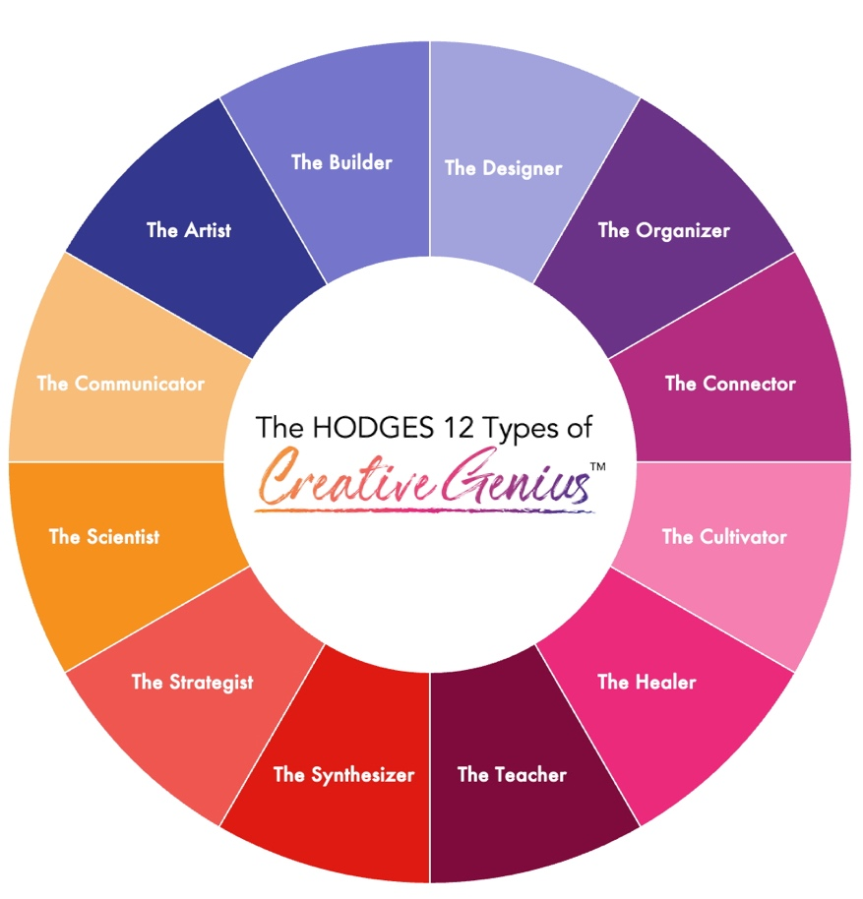
Here’s what I have so far, I created this in PPT. It uses some of the elements you have already created for me like the colors and fonts.

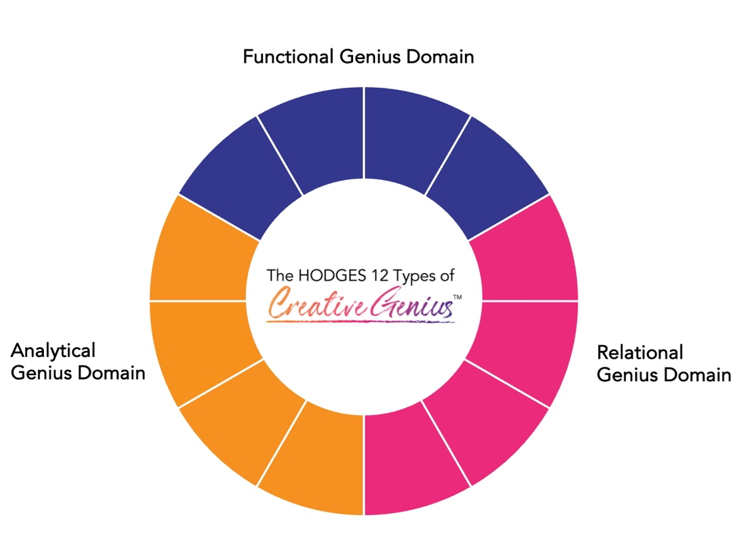
Here is a representation of the 3 Domains (Relational, Analytical and Functional)

DESIGN ELEMENT 2: The 12 Archetypes of Creative Genius (Human Representations)
Each of the 12 types represented as a human figure.
Style options to consider:
- Silhouettes — Clean, simple, universal (gender-neutral, racially ambiguous). Each silhouette could hold or interact with a symbol of their type.
- Or Illustrated figures — More personality, could show action/posture that reflects the type (e.g., Connector introducing people reaching out hands, Builder holding tools, Artist painting, Strategist looking toward horizon)
- Abstract/geometric figures — Modern, stylized human forms with symbolic elements
Key considerations:
- Diversity & inclusivity — If using detailed illustrations, represent diverse ages, genders, races, body types. If using silhouettes, keep them universal.
- Action/posture — Each figure should be doing something that reflects their type (connecting, building, healing, teaching, etc.)
- Consistency — All 12 should feel like they belong to the same visual family while being distinct from each other.
An idea: Silhouettes might be strongest—they're inclusive, timeless, and let the reader project themselves into the type. Each silhouette could be shown with one signature object or in one signature pose. But I’m open to other ideas.
TONE & FEEL
- Empowering — "You ARE creative"
- Inclusive — For corporations, classrooms, faith congregations, clinics, communities
- Warm but credible — Grounded in psychology research, but accessible and human
- Revolutionary — "The Creative Genius Revolution"
The design should feel:
- Modern but not cold
- Professional but not too corporate
- Hopeful, energizing, inviting
- Sophisticated enough for business readers, warm enough for everyone else

