Creative Brief: Yogurt Spout Pouches
We are launching a new yogurt brand and seeking a talented designer to create packaging materials that are modern, eye-catching, and appealing to families and health-conscious consumers. The designs should convey freshness, fun, and premium quality.
Scope of Work:
- Yogurt Pouch Design: Primary packaging design for yogurt pouches (multiple flavors i.e Stawberry, Mango, Blueberry, Vanilla & Natural).Pouch size 10*15cm+6cm (Spout size 8.6mm)
- Box Packaging Design: Secondary packaging design for multipack boxes (to hold multiple pouches).
- Create a cohesive visual identity across all materials.
- Include space for nutritional facts, barcode, regulatory details, and flavor differentiation.
- Ensure designs align with FMCG retail standards and stand out on supermarket shelves.
Style & Inspiration:
- Fresh, natural, and playful with clean, modern typography.
- Bright and colorful palettes adaptable by flavor (e.g., strawberry, Mango, blueberry, vanilla, Natural).
- Approachable, family-friendly style inspired by Stonyfield, GoGo Squeez Yogurtz, and Farmers Union pouch yogurt.
Deliverables:
- Print-ready packaging designs for pouches and boxes.
- Editable source files for future updates.
- 3D mockups to visualize the designs on real packaging.
Target Audience:
- Families with children.
- Young, health-conscious consumers seeking nutritious and tasty snacks.
Brand Keywords:
Fresh • Natural • Healthy • Fun • Premium
Objective
Develop a visually engaging and functional ready-for-print packaging design (pouches and boxes) for our yogurt spout pouch line (strawberry, vanilla, Mango, Blueberry and natural) that captures the attention of health-conscious consumers and promotes our brand's values of freshness, natural ingredients, and gut health. The design should appeal to both kids and adults, making it an easy grab-and-go option for all ages.
Target Audience
- Primary: Kids ages 2–15, who enjoy tasty, fun snack options, especially those that are easy to hold and consume independently.
- Secondary: Young adults and parents, ages 25–45, who seek nutritious, convenient, and eco-friendly food options for themselves and their families.
Product Positioning:
- Quality & Freshness: Emphasize the use of locally sourced, high-quality ingredients with no artificial additives. “Single origin milk”
- Health-Oriented: Highlight probiotics and the benefits of yogurt for gut health.
- Convenience: Show that the spout pouch is designed for on-the-go lifestyles, perfect for busy mornings, lunches, and travel.
- Eco-Conscious: Incorporate sustainable materials and/or eco-friendly messaging to appeal to environmentally aware consumers.
Tone & Style:
- Playful yet Sophisticated: Bright, inviting colors and a clean design that maintains a fun, youthful appeal while ensuring it remains credible for adults.
- Natural and Fresh: Use earthy tones or nature-inspired visuals to evoke freshness, purity, and healthiness.
- Simple & Clear: Avoid clutter; focus on clear messaging about flavor, health benefits, and ease of use.
Key Visual Elements:
- Logo Placement: Ensure the brand name is prominent and instantly recognizable, with the logo ideally placed near the top for visibility.
- Flavor Indicators: Use colors or small icons that signify different flavors (i.e., strawberries, vanilla, Mango, blueberry & nature-plain) to allow quick recognition for consumers.
- Illustrations & Graphics: Incorporate friendly, minimalistic fruit or probiotic graphics that represent the yogurt’s natural ingredients and health benefits.
- Spout Usability Highlight: Illustrate the ease of the spout for consuming on the go, with clear usage cues to attract attention from busy parents and commuters. The spout pouch caps for this yogurt packaging are designed with safety in mind, specifically to be baby-friendly and choke-proof.
Packaging Requirements:
- Format: Spout pouch, aluminium foil lined.
- Size: Each pouch should hold a single serving (150ml) of yogurt.
- Confirm colours used...
Deliverables:
- Finalized design mockups (front and back) for the yogurt spout pouch packaging.
- Color scheme and flavor differentiation concepts.
- Eco-friendly packaging suggestions or icons to reinforce the brand’s sustainability commitment.

Inspirational designs from other companies.
- Spout Pouches
Looking for vibrant colourways just like the one for ‘Once Upon a Farm’ below
Flavours: –
- Strawberry,
- Vanilla,
- Natural
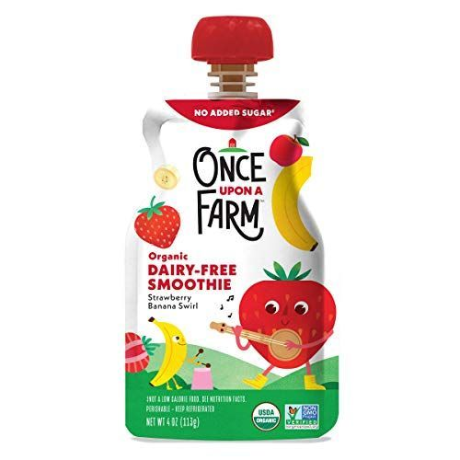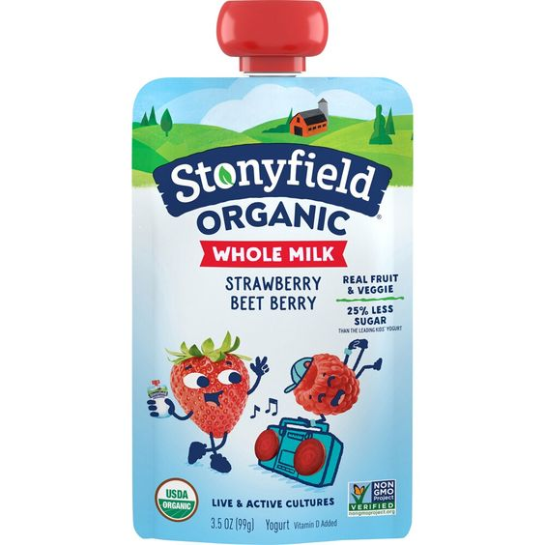
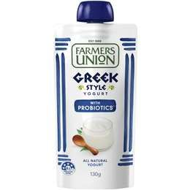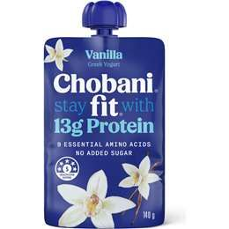

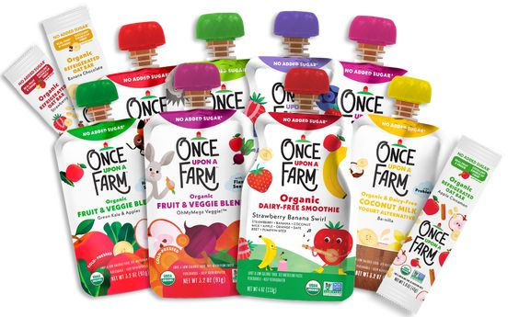

- Yogurt 6 and 12 and 24 boxes packs

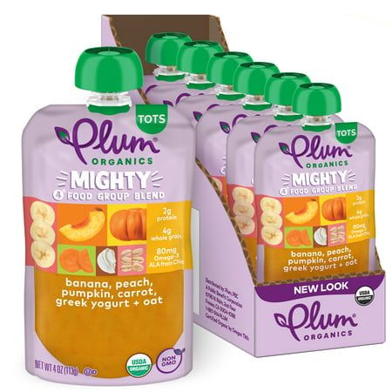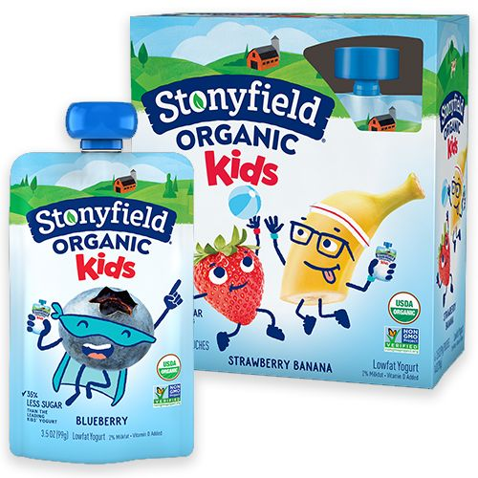

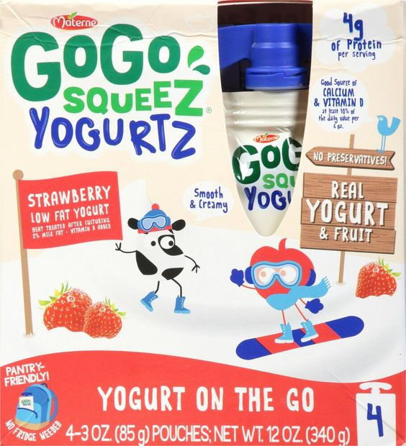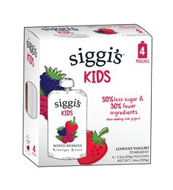

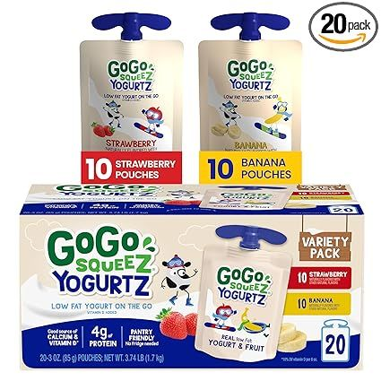

Additional details on both pouches and box bundle:

Front
- Brand Name: Gogurt
I’m Real Yogurt on the go
with probiotic
- Capacity: 150 ML
Back
- Capacity: 150 ML
- INGREDIENTS:
100% Whole Cow Milk, Probiotic Cultures, Flavour, Sugar
- PRODUCT OF KENYA
- Nutrition

Nutrition Facts
1 serving per container

Serving Size 1 pouch (150ml)
ENERGY/NUTRITION | AMOUNT
Energy | 95kJ
Butter | 3.4%
Protein | 3.4g
Carbohydrates | 11.5g
Vitamin A | 125iu
Vitamin B2 | 0.17MG
^Probiotics< | 1 billion+

- Shake well before use. Once Opened, Keep refrigerated and consume within 3 days. Best served chilled.
- Symbols for : Recycle, Reusable, BPA-Free, Non-GMO, 100% Natural
- Kenya Bureau of Standards: 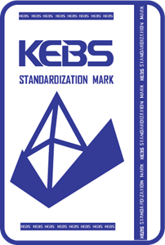
- Barcode
- Section to print:
MFG:
EXP:
BATCH:
- A product of:
Sunburst Mornings Co. Ltd
P.O. Box 18970, GPO 00100, Nairobi, Kenya.
Tel: 0780473800
Email: info@sunburstmornings.com

