1. Project Overview
GripLog is a high-precision performance-tracking app built for track-day drivers who want to optimize tire performance, improve lap times, and extend tire life. The product is used by passionate driving enthusiasts—primarily men ages 30–60 with higher disposable income and a strong interest in automotive performance.
We are creating a refreshed, professional, and future-ready brand identity that signals precision, speed, and control. This includes a new primary brand icon, wordmark, and accompanying lockups—while remaining emotionally aligned with the sample logo provided.

2. Brand Personality
GripLog’s identity should convey:
- Precision – data-driven, exact, trustworthy
- Performance – motorsport-inspired, energetic
- Mastery – competence, expertise, optimization
- Masculine sophistication – sleek, premium, minimal
- Modern tech – clean, forward-leaning, app-friendly
Tone should be serious and technical, avoiding anything cartoonish or “arcade-like.”

3. Target Audience
- Age: 30–60
- Average age: 51
- Gender: 80%+ male
- Income: High; sports-car owners
- Education: 96% college educated
- Mindset: Data-oriented, performance-focused, enthusiast-level drivers
- Devices: iPhone primary (iOS-focused design language matters)
The look should appeal to mature, detail-obsessed drivers who value engineering, not gimmicks.

4. Visual Direction & Inspiration

Primary Inspiration
The reference image provided (tachometer-style icon with a red needle) should heavily inspire the final direction—but elevated to meet 2025 design trends.

Key Visual Cues
- Tachometer / gauge forms
- Tire-inspired outer ring (car tire not motorcycle tire)
- Clean, sharp dial markers
- Red performance needle
- Minimalist shading (avoid over-glossy 2010s style)
- Subtle metallic or motorsport textures (tasteful, not cheesy)

2025 Design Trends to Align With
- High-contrast, minimal UI-friendly icons
- Soft 3D (neumorphism-light) or refined flat+depth hybrids
- Bold, geometric sans-serif typography
- Focus on adaptability across light/dark modes
- Scalable vector simplicity for small-size clarity

5. Color Direction
Target palette:
- Primary: Deep black / graphite / charcoal
- Accent: Red (performance needle)
- Secondary: Silver / steel grey (motorsport tech aesthetic)
Preferences:
- Avoid overly bright color palettes
- Avoid gradients unless subtle and refined
- No neon, unless used very tastefully

6. Notes on Style
Important:
- Avoid cartoonish tachometers
- Avoid heavy chrome or shiny metal effects
- Avoid drop-shadow-heavy or beveled looks
- Keep the mark modern, sharp, and balanced
- Consider how the identity appears on car dashboards, helmets, stickers, and merchandise

10. Success Criteria
The final design should:
- Instantly communicate performance + precision
- Be flexible across app, web, print, and merchandise
- Look premium and trustworthy to a seasoned automotive audience
- Be memorable and clearly associated with motorsport
- Scale beautifully from a tiny iOS icon to large signage

Below are 5 mockups I have used AI to generate that are in the area that I like the most. I am open to other creative ideas as long as they meet the ideology of the goals.

- The brand name is “GripLog”. The font does not have to be all caps or proper case. If proper case is used the “G” and “L” must be capitalized.
- The logo will be used in situations of black background, white background, and sometimes a colored background in rare situations.

- This is the closest, thus far, that I like. What I like is you can see there is a tire, the tire tread indicates tires are critical to the app. I like that there is a gauge that indicates analytics are important. What is missing from this is motion or speed somehow. I am open to other elements that could evoke emotion for the viewer of the logo. Once I separate the app name from this as a standalone logo I feel it will be missing some character and gravitas.

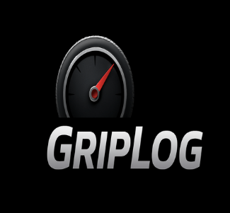

- I don’t feel this logo has much character, I share this to call out that the tire tread in combination with the lighting effects makes this look more like a motorcycle tire than a car tire, which is not good for the logo. The gauge needle does not look incorporated into the uniformity of the rest of the logo. I don’t want to restrict the design to within the confines of the wheel but in this one it does not add to the character of the logo in my opinion.
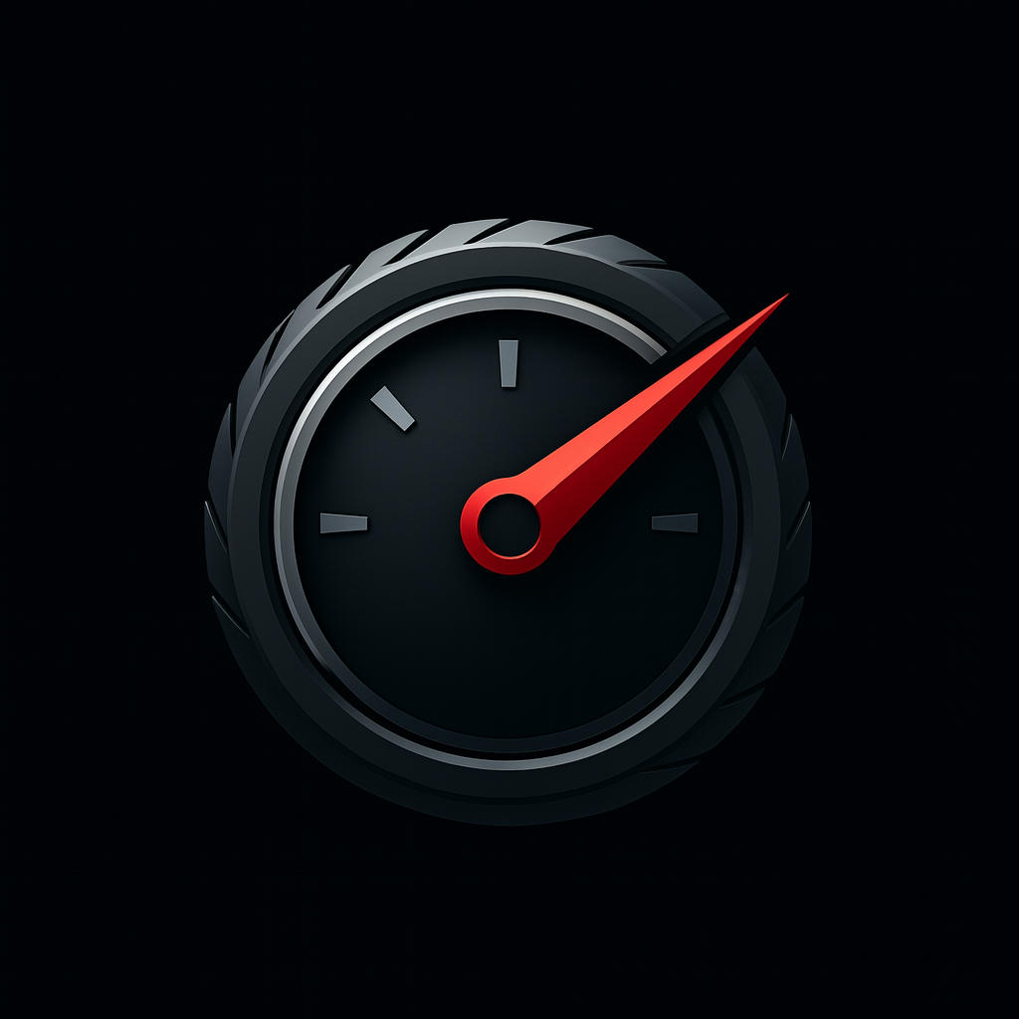

- This potential logo looks like a random gauge, it does not evoke any emotion from the viewer.
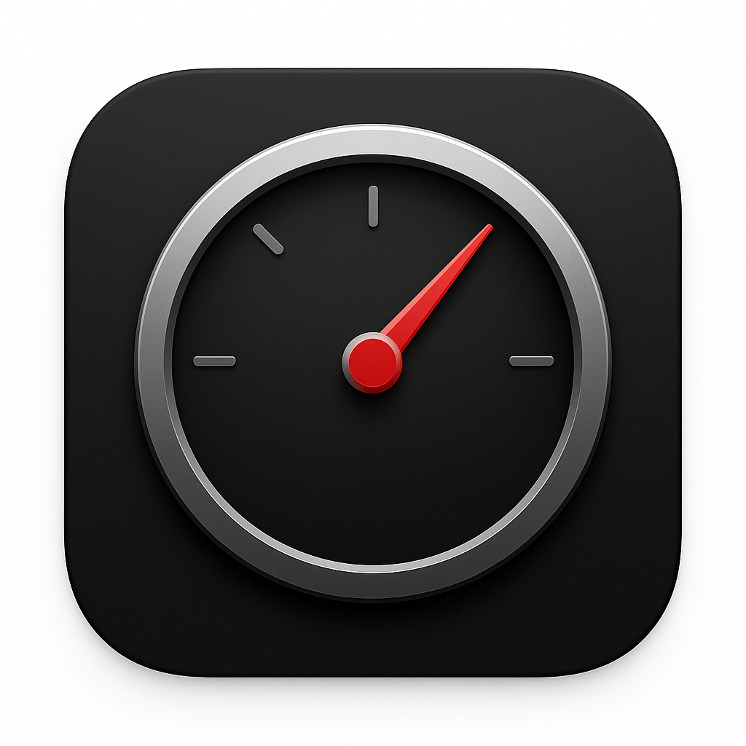

- This is also missing clarity that there is a wheel, there is no emotional part to grab attention to the viewer.


- This file is a transparent background. I don’t have any additional detail to provide past the comments on the above samples. This is still missing the emotion part, motion, and clarity that tires are key to the app.


