Creative Brief: Williams AV 50th Anniversary Logo
November 25, 2025
- Project Overview
Williams AV will celebrate its 50th anniversary in 2026—marking five decades of innovation in assistive communication technologies, professional audio, and inclusive listening solutions. To commemorate this milestone, we are creating a special 50th Anniversary logo that reflects the company’s heritage, celebrates its evolution, and highlights its continued commitment to innovation. This logo will serve as a visual mark used throughout the anniversary year across multiple marketing and communications touchpoints.
- Project Goals
- Celebrate 50 years of innovation, excellence, and leadership in professional and assistive audio technology.
- Honor the company’s history while presenting a modern, forward-looking visual identity that reflects where Williams AV is headed.
- Build excitement among customers, partners, employees, and the broader AV community.
- Enhance brand visibility by tying anniversary messaging into product launches, events, campaigns, and global marketing throughout 2026.
- Target Audience.
The 50th anniversary logo should resonate with:
- Long-time customers and channel partners who appreciate Williams AV’s legacy in assistive listening and audio communication.
- Current and prospective clients across key verticals including education, houses of worship, corporate, government, and entertainment.
- Employees and internal teams who represent the brand and will proudly use the anniversary logo in daily communication.
- Industry partners including integrators, designers, distributors, and technology allies.
The visual tone should balance heritage + innovation, appealing to a broad professional audience.

- Intended Use & Application. The anniversary logo will appear throughout 2026 across a wide range of digital and print assets, including:
Digital
- Williams AV website & TeachLogic website (secondary use)
- Social media platforms
- Email signature lines
- Webinars and digital event materials
- Digital ads and partner portals
Print
- Lapel Pins. We want to create an enamel label pin for employees
- Event Graphics. Trade show graphics and booth signage
- Literature. Product literature, brochures, and sell sheets
- Packaging. Packaging or promotional inserts (where applicable)
- Design Considerations
- The company was founded in 1976. We would like the design to provide a nod to the past (perhaps with a 1970s style font), but with a look towards the future. (perhaps a design element that suggests motion, or the future of the company)
  - NOTE: The company’s logo colors were originally blue and white in 1976 and changed to red and black in 2018.
- Would like to incorporate “50 years of innovation” into the design
- Would like to incorporate the Williams AV logo into the design. The design can use just the “W” artwork or the full Williams AV logo.

- Would like a design with option to be produced in a single color and multicolor
- Should scale effectively from small applications (email signatures, social icons, lapel pin) to large-format signage (trade show booth).
- Should integrate seamlessly with the existing Williams AV brand mark when paired.

- Deliverables
Designer to provide the anniversary logo in the following formats:
- Primary vector file (AI, EPS, and SVG)
- High-resolution PNG (transparent background)
- High-resolution JPG
- Black, white, and Multi-color versions
- Spacing/usage guidance (optional but appreciated)
- Design Mood Board. Following are anniversary logo designs that we find interesting.

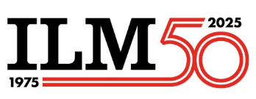 | - The retro, double line font for the number 50  - Company name integrated into the design  - Incorporation of the years  - Sense of motion in the logo  - Logo uses both the red and black of our current logo design.
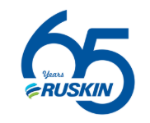 | - The logo font feels both retro and contemporary  - Company name integrated into the design  - Easy to read number
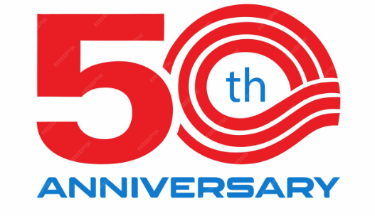 | - The retro, double line font for the number 50  - The motion of the lines in the 0 feels like the logo has a forward motion.  - Room under the number to incorporate “years of innovation”
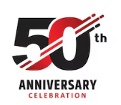 | - The use of red and black in the design  - The diagonal lines (that represent computer wires) provide motion in the logo.  - Room under the number to incorporate logo and “years of innovation”
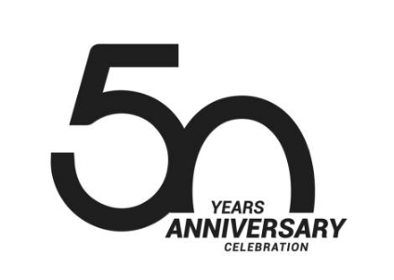 | - The retro front presentation  - Space for the Williams AV logo where the word “Anniversary” is positioned  - Simple presentation
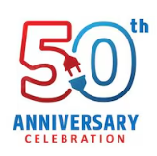 | - Incorporates a design element (the plug) into the logo. As a company that provides audio products, we frequently use an audio / sound waves in our designs  - Sense of motion in this design  - Space for the company logo or tag line. (50 years of innovation)
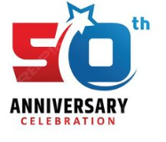 | - We don’t like the “50” font, but do like how the star was incorporated into the design.  - Logo has motion – and start may suggest innovation.
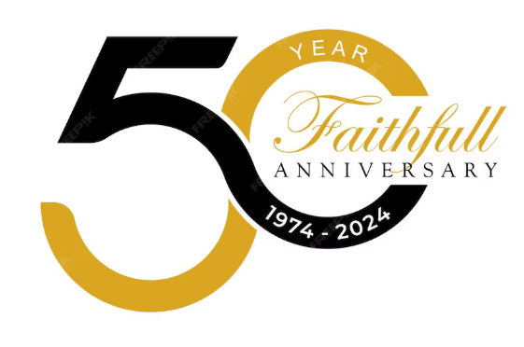 | - Room for company logo  - Strong sense of motion  - Opportunity to add “years of innovation” or anniversary dates (1976 – 2026)

