Homepage

Site Map on the top of the page with the logo in the middle

Home
Advisory Services
About Us
Logo in the middle
Blog
Contact Us
(no search button)

Have an image in the background that speaks to the aerospace and defense community similar to the https://palaerospace.com/ website but not the exact same image.

Add Header/Tagline below: In all caps -Accelerate Your Mission.
Distinctive Edge Partners exists for one reason to help connect the federal ecosystem with the technologies that matter most to America and her allies. We help build the communications, government affairs and marketing strategies and systems your organization needs to grow and protect market share –helping our clients meet their mission objectives.
Our team of award-winning communications strategists bring deep experience across government, defense, and technology. We build systems, teams, and campaigns that drive outcomes for federal contractors and innovators supporting national security, space, and industrial growth.
Our team has served in the military, supported the DoD and federal leaders, and led communications, marketing, and government affairs for major government, tech and investment organizations. We understand the missions that matter — and we help our clients achieve them through precision communications, policy engagement, and strategic connection-building.
We are committed to strengthening the defense industrial base and enabling our clients to thrive through growth and transition to achieve mission success.
Proven Results That Drive Real Growth

We’ve helped brands strengthen their digital presence, expand their network, and accelerate opportunities across the defense, space, and government sectors. In just one year, our clients have achieved:
- Business Growth & Network Expansion
  - +72% increase in database contacts through CRM implementation and targeted marketing campaigns
  - 100+ introductions to tech-scouting contracts across the DoD and the aerospace & defense ecosystem
  - Positioned a client for transformative growth, fueling a 570% increase in stock price and attracting $50M AUD in new investment

(slider with rotating client quotes from case studies + numbers
- “Partnering with Distinctive Edge Partners accelerated the growth of our company. Their strategic insight, deep federal expertise, and hands-on support transformed our U.S. expansion. In less than six months, they built our presence in the United States from the ground up, helping us secure contracts, advocates, and visibility at the highest levels. Working with Distinctive Edge Partners has been a true game-changer for our company.” - Steve Ragiel, President and Managing Director, Flash Metals USA
- General Rainey quote
- “Collaborating with Distinctive Edge Partners was a game-changer; their innovative approach and strategic insight propelled our work to new heights. Their unwavering commitment to not just meeting, but exceeding expectations, has been a cornerstone of our success.” -Toffler Associates Account Lead
- "Partnering with Distinctive Edge for our speaker acquisition and management helped to make Fed Supernova 2023 a major success for Capital Factory. We sold out three weeks before our event, secured speakers who had never worked within our organization, and significantly expanded our network. Distinctive Edge’s expertise in strategic speaker acquisition was evident throughout the entire process; they were able to identify over 300 top-tier industry experts that aligned with our event’s diverse tracks and panels. The team was easy to work with, well-organized, and highly connected within the aerospace and defense ecosystem. All of this and more produced massive impact and value for our event." - Mary Gwinn, Vice President of Customer Success, Capital Factory
Our Services
- Add some sort of visual/icons for this section
  - Corporate Communications
  - Public Relations
  - Government Affairs (New/Add)
  - Crisis Communications (New/Add)
  - Digital Marketing
  - Strategic Connections (New/Add)
  - Investor Relations
  - Event Management
- Button: Learn More (send to Services page)

Our Edge
We combine deep federal sector insight, technical understanding, and a powerful network across government, industry, investors, and media. Our proven approach drives results — from major contract wins and successful M&A to increased valuation, strategic investment, and political support.
Our strategies begin with your mission and business goals, ensuring every message, relationship, and action advances growth and impact.

What to Expect When Partnering with Us
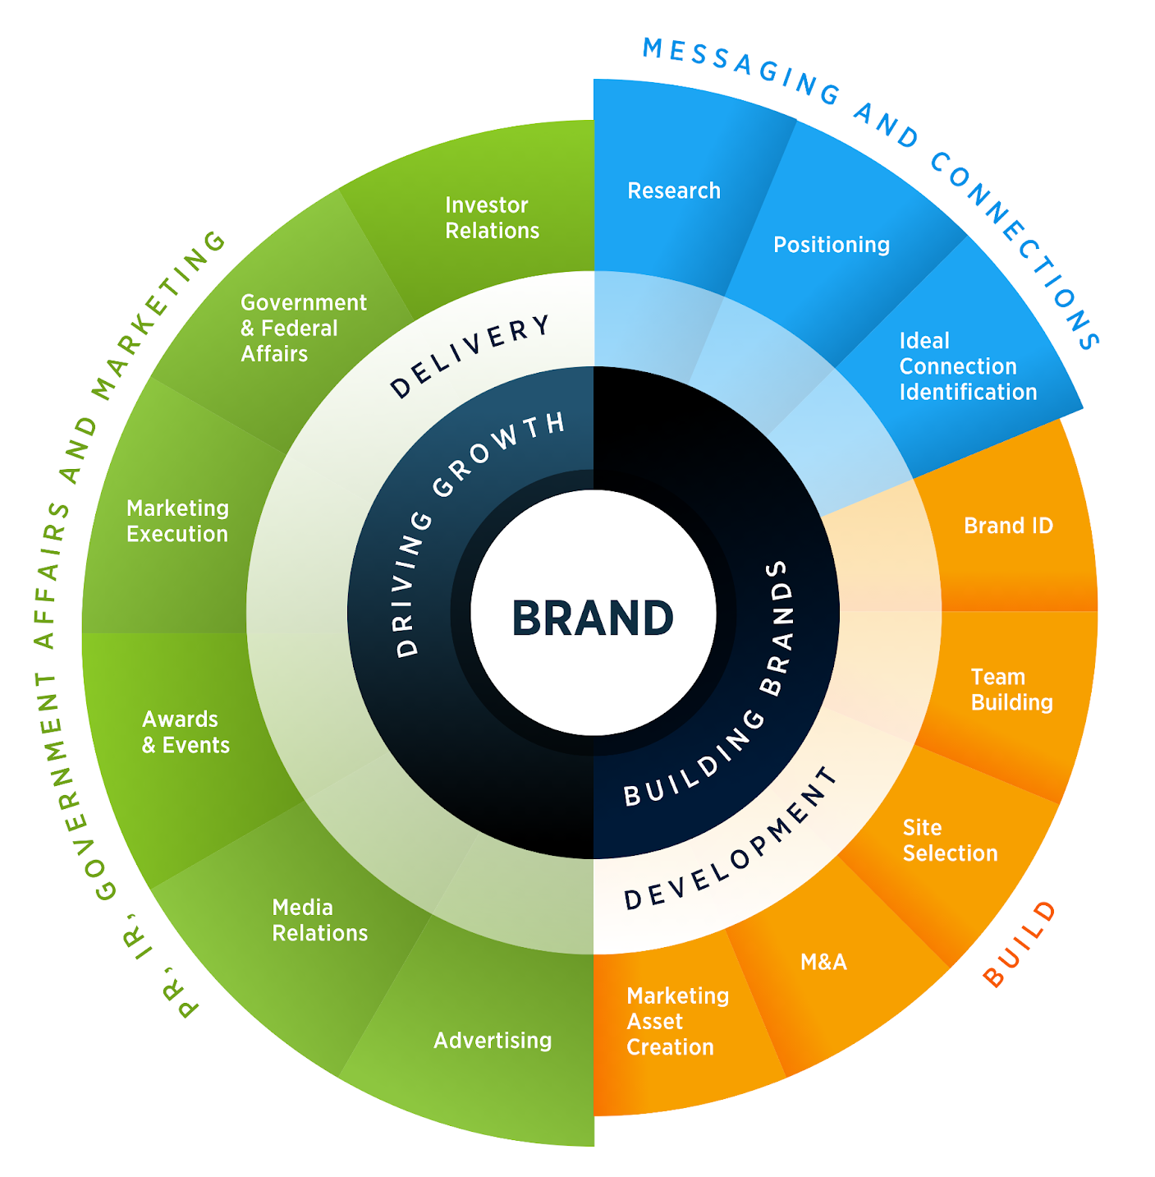
With decades of experience, a results-focused methodology, and cutting-edge marketing and communications tools and technologies, we begin every engagement with a discovery and planning process to ensure we are building a strategy that cuts through the noise to achieve our measurable results. As specialists in government crisis communications, we additionally examine our client’s current strategy for risks ensuring we are building on a stable foundation.

By truly understanding our client’s goals, key milestones, potential areas of risk, ideal customer and investor targets, partner profiles, and other key drivers, we create messaging and strategy that goes beyond traditional brand awareness to meet mission objectives. As a full service firm, we work across all the areas in the graphic.

Our time-tested methodology is based on building and executing a strategy aligned with client mission objectives. With the strategy in place, we execute tactics with precision, efficiency, and the highest quality of customer service.

Button: Get in Touch (links to contact form) –this will be HubSpot code.
