SHINGLE DR.

Shingle Dr. is a roof-rejuvenation brand that treats aging asphalt shingle roofs using science-based, restorative applications. Instead of replacing the entire roof, Shingle Dr. restores shingles’ flexibility, durability, and lifespan helping homeowners protect their investment at a fraction of the cost of replacement.

1. Character & Suspenders Details
- Character must wear suspenders clearly and prominently.
- Add a medical cross symbol centered on the suspenders’ bib (this replaces the symbol that was previously on the hat).
- Remove the medical symbol from the hat.
- Maintain the cartoon-mascot, bold, friendly style.
- Character must wear a stethoscope around the neck, and the stethoscope must be shown listening to the heart inside the house icon used in the logo.
- Character remains separate from the primary logo layout, same structure as our preferred version.

2. Medical + Brand Symbol Requirements
- Replace previous house icon with a house containing a centered heart.
- Ensure the stethoscope visually connects to or “listens” to the heart inside the house.
- Keep the roofline + heartbeat motif consistent with earlier versions.

3. Primary Colors
- Teal / Aqua Blue — Dominates the top half of the van.
- Burnt Orange — Used heavily in the background behind the illustrated character.
- Dark Brown — Covers the lower half of the van body.
- Cream / Light Beige — Used for highlight areas and background elements of the logo.

Accent Colors
- White — For small text and highlights.
- Black — Outlining, shadows, and small details.
- Skin tones — For the illustrated handyman character.
- Red (Muted) — In the shirt of the illustrated character and some decorative elements.

Logo Colors
- Dark Brown / Black — For the “GOODY” text outline.
- White — Inside the “GOODY” letters.
- Orange / Burnt Orange

4. Outline & Effects
Apply a clean, thin white sticker-style outline around:
- The character
- All typography
- The words “SHINGLE DR.”
Outline must be high-contrast and consistent across all variations.

5. Typography
- Use a bold, rounded sans-serif style consistent with earlier mockups.
- Apply the white outline to all text.
- Approved taglines:
  - Inspect, Restore, Revive
  - Saving Your Roof’s Life
  - Roof Rejuvenators

6. KickCharge-Style Layout Requirement
Follow the KickCharge Creative-style layout structure:
- “Shingle Doctor” positioned at the top, bold and prominent.
- “Roof Rejuvenators” placed inside the banner/ribbon beneath the main title.
- Keep the character art separate from the main badge/logo shape, just like KickCharge’s signature approach.
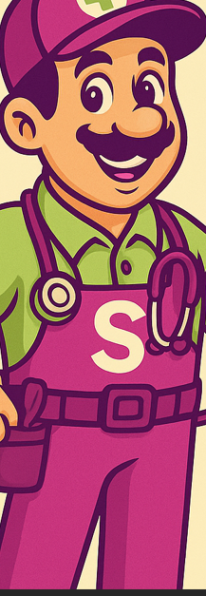- Character with suspenders reference
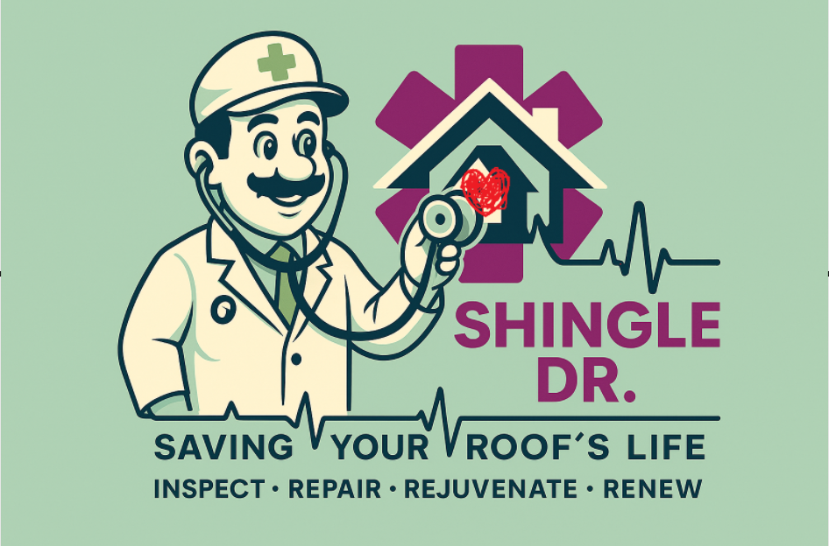
Make heart inside the house
- Retain stethoscope listening to heart of house
SAME COLOR AND LAY OUT FROM THE PICTURE BELOW

