Questions To Ask Your Doctor About Memory Loss

In our communities, memory and wisdom are sacred. When our Elders begin to experience changes in how they remember, think, or act, it’s important to understand what’s happening–so we can care for them with knowledge, love, and respect.

Memory loss can progress to dementia. Dementia is a group of conditions that affect memory, thinking, and the ability to carry out everyday tasks. Alzheimer’s disease is the most common type of dementia, but there are other types, too.

If you are concerned about or experiencing memory loss, it’s important to talk to your doctor. The following pages can help you start the conversation.

Questions to Ask Your Doctor:
- When should I be concerned?

- What kind of testing can be done for memory loss?

- What other things could be causing memory loss?
- Anxiety or depression
- Sleep disorders
- Thyroid problems
- Vitamin deficiencies
- Head injuries
- Dehydration
- Infections (Urinary tract, Respiratory, etc.)
- Medications

What happens after diagnosis?
- Are there lifestyle changes that could help?
- What safety measures should be taken? What are the signs of certain activities becoming unsafe?
- What community resources are available?
- How can we prepare for progression?

Questions Your Doctor May Ask You:
- When did your symptoms of forgetfulness begin?
- What tasks do you find difficult?
- What specific behaviors related to memory loss are concerning you?
- Have you recently been sick?
- Have you recently been in an accident?
- Have you recently fallen or hit your head?
- Have you recently had a loss of someone who is close to you?
- Have there been any recent major changes in your life?
- Have you been dealing with a stressful event in your life?

Symptom Tracking: By tracking symptoms like forgetfulness, confusion, or difficulty with everyday tasks, individuals and their caregivers can provide accurate information to healthcare providers, leading to better planning and support.
A symptom tracker template and examples can be found at ______.

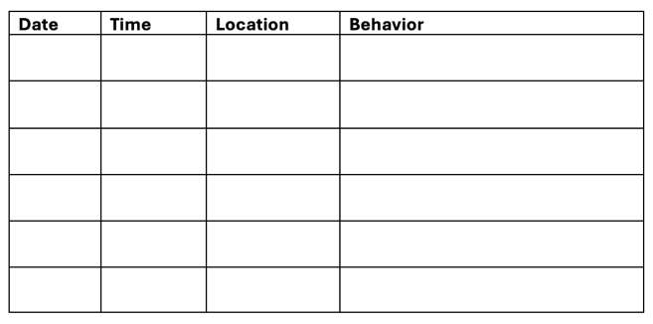
Note: change last column to “Symptoms and Behavior”
For More Information
About Memory Loss

10 Signs of Thinking or Memory Changes that Might be Dementia:
https://bit.ly/10SignsIA2
Dementia Friends Room:
Iasquared.org/dementia-friends/rooms
UW Living with Memory Loss:
https://bit.ly/UWMemoryLoss
AARP Questions to Ask:
https://bit.ly/AARPQA
Pathways to Well-Being with Dementia:
https://bit.ly/DementiaPathways

(Funding Statement)

