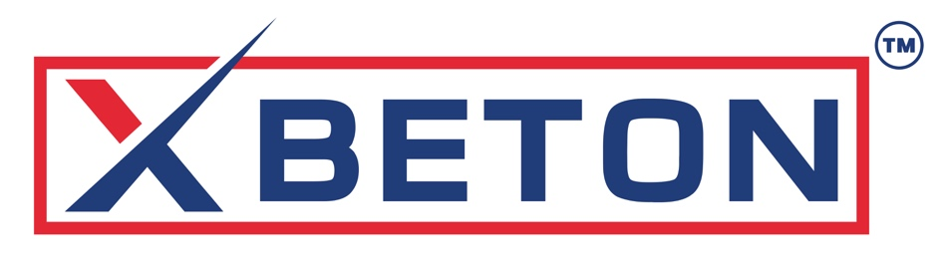

BETON HOLDINGS LLC DBA XBETON
a South Dakota limited liability company

Revolutionizing North American Construction
with NANO Graphene & Autoclaved Aerated Concrete

Product Portfolio
We offer a product line that encompasses most all materials needed to construct residential and light commercial buildings, including the following:

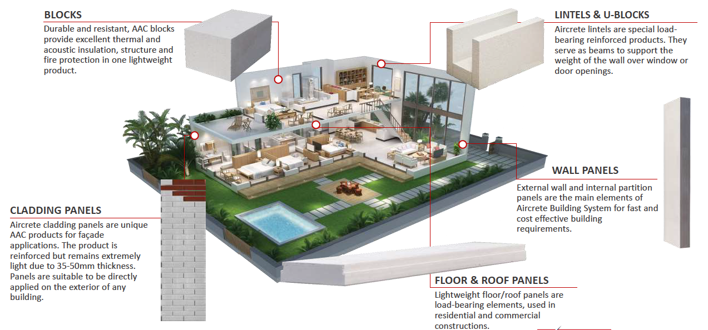

The XBeton™ Dose Pack formulations:

- XBOND™ – AAC Thin-Set & Panel Adhesive. The thin set formulation improves half-life and extends application time while enhancing leveling and bonding performance for block assembly. Fast, clean assembly, high early bond, fiber/graphene reinforced options.
- XBASE™ – Leveling & Structural Repair. The repair formulation enables rapid cavity repairs for electrical, plumbing, and raceway installations. Basecoat, patching, load-transfer repairs, and nail plates that match AAC modulus and boost flexural performance.
- XRENDER™ – Graphene-Reinforced Stucco/Render. The stucco formulation converts economy type N-Mortar to premium fiber and graphene-reinforced stucco specifically enhanced for AAC compatibility. Crack-resistant, lightweight, highly workable render optimized for AAC porosity and breathability.
- XFINISH™ – Exterior & Interior Finish Coats. The exterior finish coat provides unique thermal deflection properties and customizable finishes, while the interior finish coat, the only non-graphene formula in the catalog, accelerates interior finishing processes. Color/textures, low permeability with tuned vapor-open profiles; UV and stain resistance.
- XSEAL™ – Joints, Flashings & WRB/Vapor Control. The primer and sealant formulation optimizes impermeability. Joint compounds, sealants, primers/WRB that lock out bulk water while maintaining AAC drying.

- MARKET OPPORTUNITY

Industry Dynamics
The global AAC market reached $12.8 billion in 2025 with projected growth to $23.5 billion by 2035, representing a 6.3% compound annual growth rate. Despite AAC's century-long history and widespread adoption across 90 countries through 600 manufacturing facilities, North American penetration remains remarkably low at under 1% compared to 40% in Europe and 60% in Germany.
The North American construction market exceeds $1.27 trillion annually: commercial construction represents $380 billion growing at 9% annually, residential construction accounts for $340 billion growing at 7% annually, infrastructure projects total $220 billion growing at 11% annually, and industrial construction comprises $120 billion growing at 6% annually.

Supply-Demand Imbalance
North American production capacity currently totals approximately 800,000 cubic meters annually across only three facilities located in Mexico, Florida and Georgia. Estimated demand based on comparable European penetration rates suggests potential consumption of 2.5 million cubic meters annually, indicating current supply meets only 32% of potential demand. Transportation costs averaging $75-$125 per cubic meter for long-distance shipping create natural protection for locally positioned producers.

Key Market Drivers
- Regulatory Evolution: Stricter energy codes (California Title 24, IECC 2021) and fire ratings favor AAC's superior performance characteristics
- Climate Resilience: AAC's resistance to fire, hurricanes, earthquakes, and floods positions it as material of choice for resilient construction with insurance premium reductions
- Labor Shortages: 430,000 unfilled construction positions as of 2025; AAC requires 50% less labor than traditional masonry, reducing project timelines 30-40%
- Sustainability Requirements: Lower embodied energy, reduced transportation emissions, and superior thermal performance supporting net-zero buildings

Competitive Landscape
Limited North American competition creates favorable entry conditions. Aercon’s Florida plant focuses primarily on Southeast markets and its newly acquired plant in Monterrey Mexico serves some U.S. Imports remain sporadic with extended lead times, high logistics costs and quality concerns.
Traditional building materials face increasing challenges: wood frame construction confronts rising lumber costs, fire risks, and durability concerns; concrete masonry units require additional insulation with longer installation times; steel frame construction involves complex coordination and thermal bridging issues.

TECHNOLOGY & OPERATIONS

Core AAC Technology
Autoclaved aerated concrete represents proven technology with over 100 years of global application. The manufacturing process combines sand, cement, lime, water, and aluminum powder to create lightweight cellular structure with exceptional properties. Steam curing under pressure in autoclaves creates tobermorite crystals providing strength and stability.
Our Manufacturing facilities will employ state-of-the-art European equipment from established suppliers including Wehrhahn, Masa, and Hess AAC Systems, enabling production flexibility while maintaining consistent quality standards.

Proprietary XBeton™ Technology
The partnership holds exclusive Worldwide distribution rights to XBeton™ Dose Pack, a revolutionary nano-graphene admixture technology substantially enhancing AAC performance. Independent testing validates impressive performance improvements:

Performance Metric | Improvement
Compressive Strength (ASTM C39) | 200% increase
Permeability Reduction (ASTM C1202) | 400% reduction
Flexural Strength (ASTM C78) | 100% increase
Fire Resistance | 4 hours to 12 hours (up to 6,500°F)

Manufacturing Strategy
The Company will execute phased facility development to minimize execution risk while maximizing market capture. The initial plant will be strategically positioned to serve West Coast markets currently dependent on limited production facilities. Each facility will produce 100,000 cubic meters annual capacity utilizing automated production lines with Industry 4.0 capabilities, rail siding for efficient raw material delivery, and quality control laboratories for product certification.

Supply Chain & Quality Control
Securing reliable raw material supplies at competitive costs remains critical to operational success. Multiple sources for key inputs ensure continuity: regional quarries provide sand with long-term supply agreements, major producers supply cement with volume pricing commitments, established suppliers deliver lime with quality guarantees, and global leaders provide aluminum powder with technical support.
Comprehensive quality management encompasses raw material testing and qualification, in-process monitoring and control, finished product testing to ASTM standards, and third-party certification for building code compliance. Target certifications include ICC Evaluation Reports, UL listings for fire ratings, ASTM compliance verification, and environmental product declarations

Beton Holdings LLC, dba Xbeton
South Dakota limited liability company
Shah Aryana
shah@Xbeton.us
Call/Text: 727-641-2822

