DesignCrowd Project Brief

Design Type
Logo + Label Design (Men’s Grooming Brand & Product Packaging)

Business Description
Guy is a new, modern men’s grooming brand built around clean, everyday performance and high-quality natural ingredients. Our first product is a 2 oz men’s hair pomade with a Fresh & Clean scent. The design should establish a strong, masculine identity that can extend later to shaving gel, body wash, and skincare products.

Project Objectives
- Create a primary logo for the brand “Guy.”
- Develop a core packaging label for the 2 oz pomade jar.
- Establish a consistent color and typography system that can apply to future products.
The design should be simple, bold, and masculine — conveying authenticity and modern style without feeling flashy or overdesigned.

Target Market
Men aged 18–50 who value clean, modern, everyday grooming—premium but not showy. They care about quality and natural ingredients but prefer a minimalist aesthetic.
Comparable brands include:
- Harry’s
- Cremo
- American Crew
- Blind Barber

Design Style & Direction
Tone: Masculine, minimal, confident, approachable
Keywords: Clean, bold, authentic, modern masculine
Style Preferences:
- Bold, legible typography (modern serif or geometric sans-serif)
- One or two ink colors screen-printed over a solid base color (white, black, or navy)
- Flat, matte finish (no gradients or foil)
- Must look excellent in black & white
- Scalable across product categories

Printing Considerations
We plan to use screen printing (1–2 colors) on an opaque base jar with a flat screw top lid to keep manufacturing costs down.
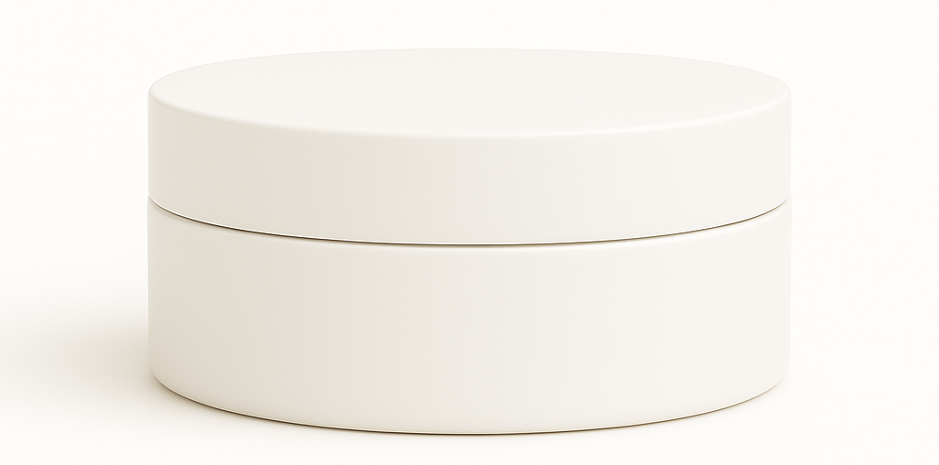

Deliverables
- Vector logo (AI, EPS)
- High-resolution JPG and PNG versions
- Color palette (CMYK, RGB, HEX)
- Font specifications
- One mockup of the 2 oz round pomade jar (screw-top)
- Optional: one small preview of logo applied to another product (tube or bottle)
*We’re seeking a clean, professional, and extensible design system—not a complete packaging suite at this time.

Additional Requirements
- All fonts must be commercially licensable.
- Full copyright transfer upon final payment.
- Design must remain legible and visually balanced when printed on small 2 oz jars.

Label Copy / Text Content
Content for Lid of Packaging:
Guy
Hair Pomade
Fresh & Clean
Medium Hold – Matte Finish
NET WT 2 oz (57 g)

Optional text for either lid or side
• Naturally derived plant & bee-based ingredients
• Alcohol Free, Non-Irritating
• Formulated to minimize scalp irritation
Content for Base of Packaging/Jar:
DIRECTIONS:
Melt small amount of pomade between hands before massaging into damp hair (for sleeker look) or dry hair (for more texture). Style as desired. For external use only. Avoid contact with eyes. If irritation occurs, discontinue use.
INGREDIENTS:
Butyrospermum Parkii (Shea Butter), Cera Alba (Beeswax), Polyglycerol-3 Beeswax (Cera Bellina), Caprylic/Capric Triglyceride (Fractionated Coconut Oil), Tocopherol (Vitamin E), Fragrance (Parfum)
MANUFACTURED BY:
Guy Health Products, Concord, NC 28203
Visit us at guyhealthproducts.com
Our Brand Identity:
Essence: Simple. Natural. Excellent.
Brand Statement:
Guy Health Products crafts high-quality health and grooming essentials made with simple, natural ingredients that promote health and confidence. We believe great products shouldn’t be complicated—they should just work. Our brand stands for dependable quality, clean formulations, and straightforward service backed by a full satisfaction guarantee. We deliver premium performance without flash or pretense—just honest, consistent products that keep you feeling fresh, confident, and ready for whatever comes next.
Supporting Examples
These mockups give an idea of the kind of simple, minimalist design we’ve been imagining, but we are open to ideas. The goal is a timeless design system that can flex across other men’s products.
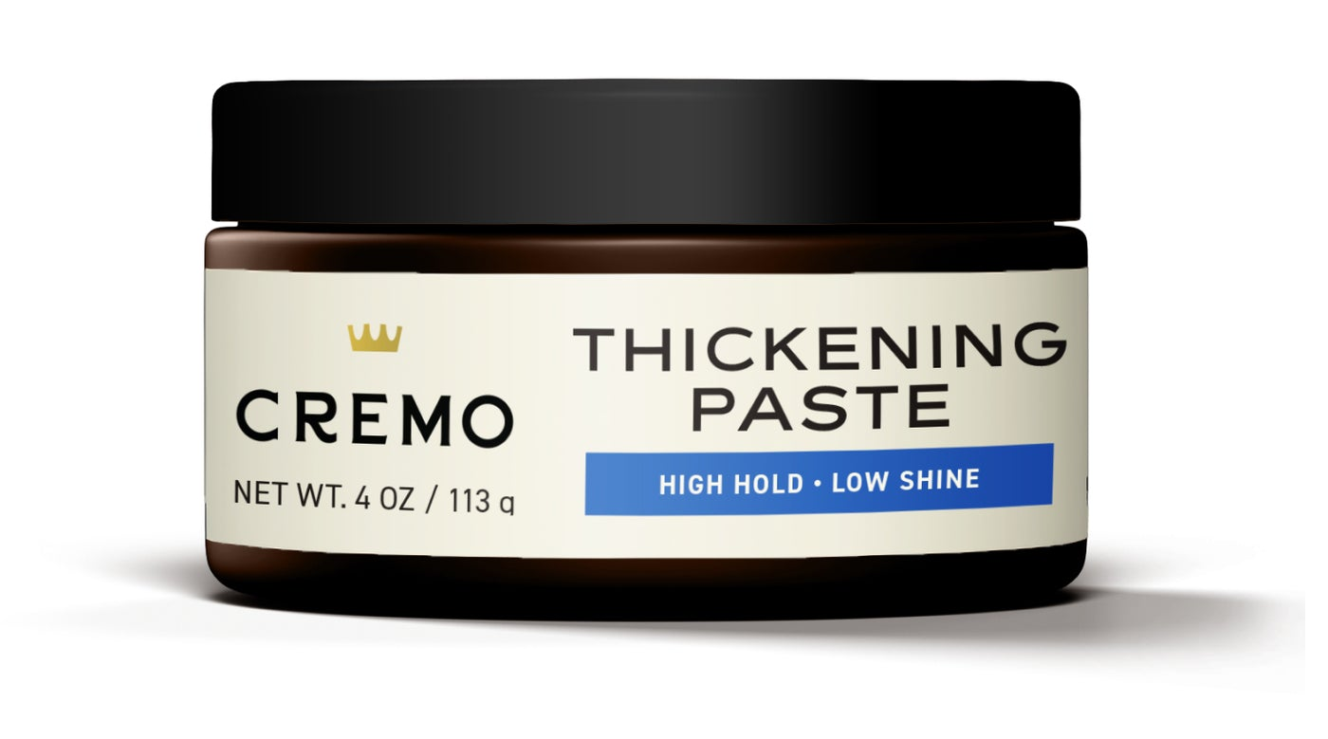
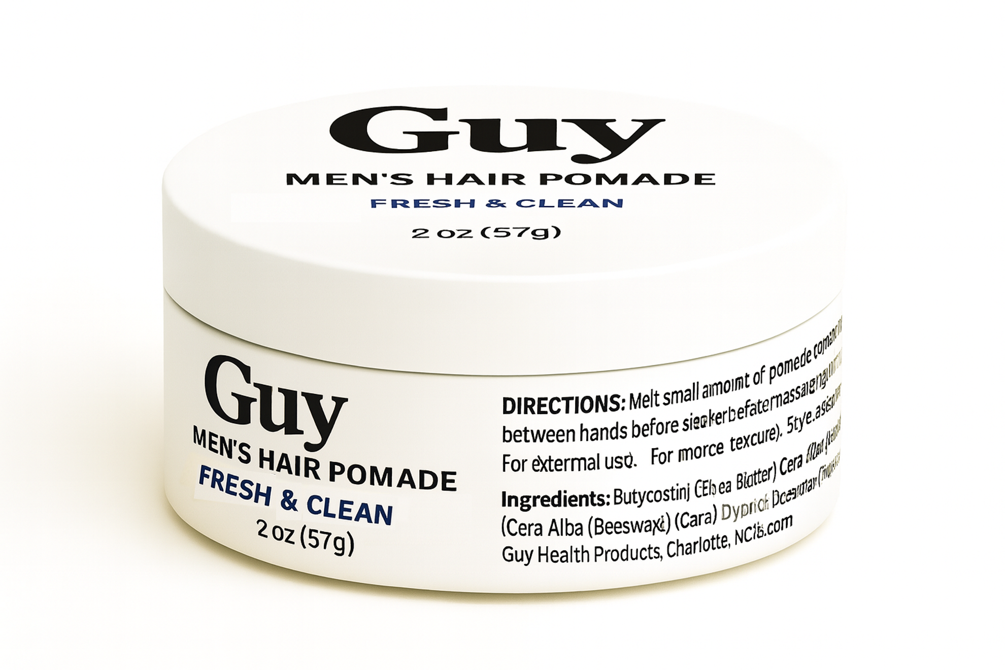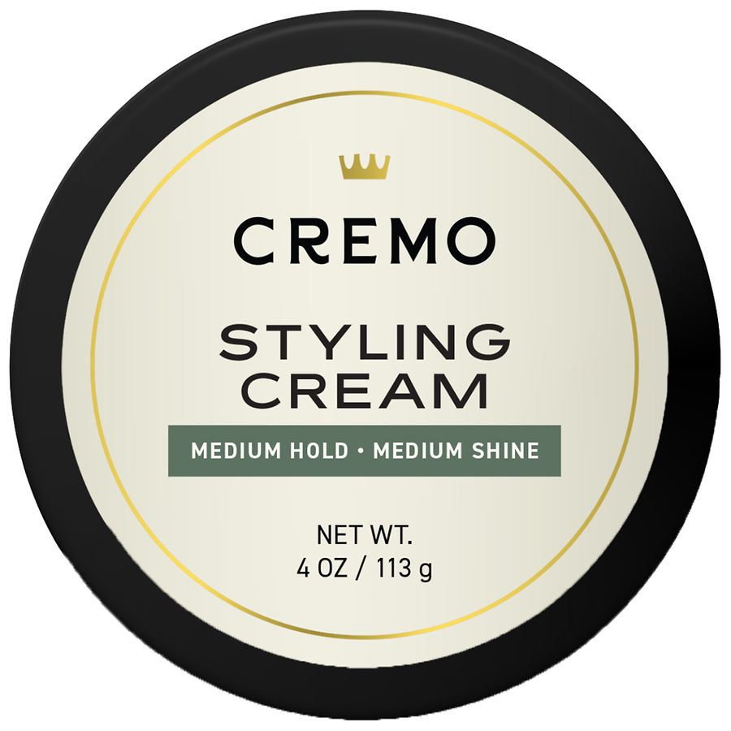
We’re also interested in finding a design concept that allows for simple/logical variations to our products (i.e. “Day” (for fresh/clean scents) vs “Night” (for cologne/evening fragrances)
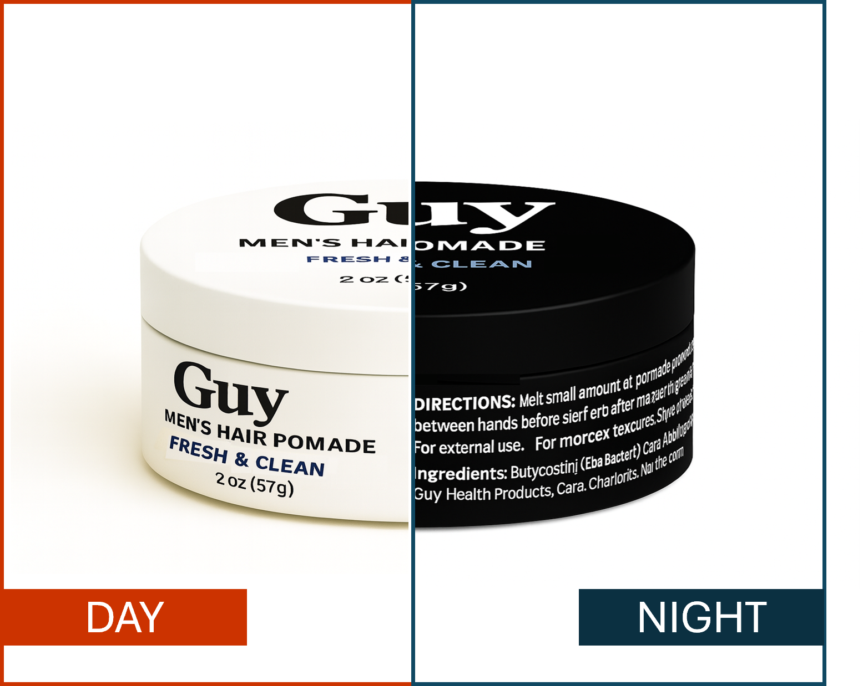

Future Work
We plan to expand the Guy brand into a full men’s wellness line (body wash, shave gel, skincare) and perhaps a sister line in the future (e.g. “Girl”, “Gal”, etc). The winning designer will likely be offered paid follow-up projects to extend the design system to those products.
