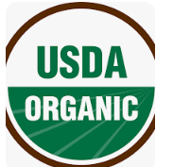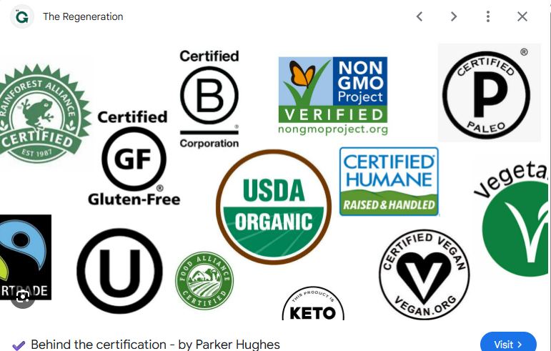
Certified Labels
Organic
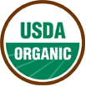USDA’s National Organic Program regulates labeling requirements for organic agricultural products. Organic labels can be found on produce, dairy, meat, processed foods, condiments and beverages. Food products labeled “organic” must contain at least 95% organic ingredients with no synthetic growth hormones, antibiotics, pesticides, biotechnology, synthetic ingredients or irradiation used in production or processing. Products that contain at least 70 percent organic ingredients and are produced without synthetic methods are labeled “made with organic ingredients,” though they cannot use the USDA organic seal on their packaging.
Certified Naturally Grown
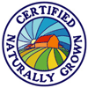This label denotes the food was grown using the same standards as those for organic, but not on a farm actually certified by the National Organic Program of the USDA. Some farmers have criticized the cost and process they need to go through to participate in the USDA’s organic program, so this is an alternative, non-governmental certification system where other farmers act as inspectors in a program administered by a non-profit organization called Certified Naturally Grown. “Natural” is a term present on a lot on food products (some of which you’d hardly call natural at all), so look closely at the label. The Certified Naturally Grown label indicates that someone is certifying that it is indeed natural, rather than just using the word “Natural” for marketing purposes.
Fair Trade
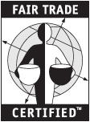Fair trade standards are enforced by the Fairtrade Labeling Organizations International (FLO) (in the U.S. by Fair Trade USA). Fair trade products must be produced in accordance with the following guidelines: Workers must receive fair wages, safe and equitable working conditions and the right to join trade unions; child or forced labor is completely prohibited. Crops must also be grown, produced and processed in a manner that supports social development, economic development and environmental development. Fair trade standards have been established for coffee, tea, cocoa, honey, bananas, juices, cotton, flowers, gold, rice, spices and herbs, sports balls, wine, composite products, fresh fruit and sugar.
Animal Welfare Approved
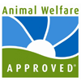Started in 2006, Animal Welfare Approved (AWA) is a division of the non-profit organization Animal Welfare Institute. Its standards cover the way its participating farms raise their animals (including beef and dairy cattle, bison, sheep, goats, pigs, chickens, turkeys, ducks, geese and rabbits). AWA states that the basic premise of their standards is that animals must be able to behave naturally and be in a state of physical and psychological well-being. They only certify family farms (charging no fees to participating farmers) and state that animals must be raised on pasture or range.
American Humane Certified
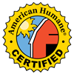The American Humane Certified program (formerly the Free Farmed program) was created by the American Humane Association in 2000 to ensure that animals raised for dairy, poultry, beef, veal, goat, swine, turkey and bison products are raised in a humane manner. These guidelines, created with input from animal science experts, ensure that livestock have access to clean and sufficient food and water as well as a safe, healthy living environment and that staff and managers are thoroughly trained to care for animals in a humane manner.
Non-GMO Project Verified
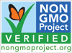The Non-GMO Project is a non-profit organization that provides the only third-party labeling program in North America for products grown without using genetic engineering. They verify that the process products go through, from seed to shelf, are produced according to their rigorous best practices for GMO avoidance.
Food Certification Labels Explained
- January 25, 2023
- No Comments
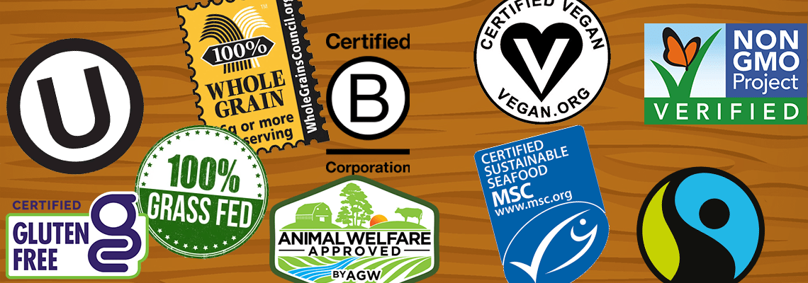
Food certifications and labels are used on nearly every product in grocery stores nationwide. There are many different certification labels on our food that convey information about how it was grown/processed, what ingredients the food contains, or ensuring it meets certain dietary restrictions. These labels also ensure that manufacturers are meeting various food safety standards. Keeping up with all of the different labels can be overwhelming, quite frankly, so here are some examples of common certification labels you may find in the Co-op and what they mean!
USDA Organic

USDA (US Department of Agriculture) certified organic foods are grown and processed according to federal guidelines addressing, among many factors, soil quality, animal raising practices, pest and weed control, and use of additives. Organic producers rely on natural substances and physical, mechanical, or biologically based farming methods to the fullest extent possible.
Non-GMO Project Verified
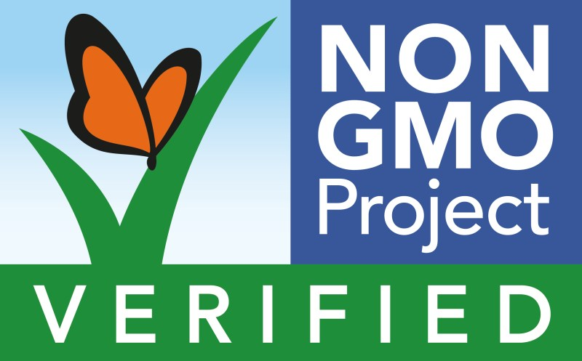
A Non-GMO Project Verified seal on animal products not only means that the animals themselves weren’t genetically engineered but also that the animal feed was tested for major GMO crops (such as corn and soy) and contained less than 5% genetically modified material.
Certified Gluten-Free

The gluten-free certification is a process designed to protect consumers with celiac disease and other gluten-related disorders by confirming that a food, drink, or supplement meets strict standards for gluten-free safety.
Kosher
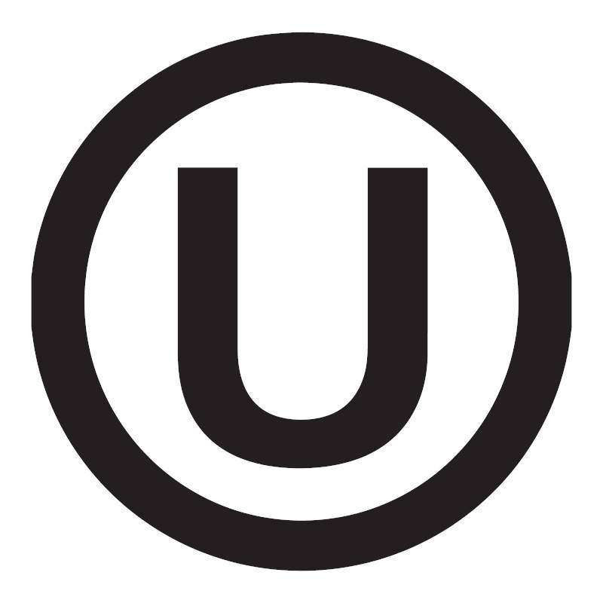
What does it mean to be kosher certified? Kosher supervision means that a qualified Rabbi or Rabbinic organization supervises the production of a food item to ensure that the product is kosher (prepared in accordance with Jewish dietary law). The circled U is only one version of the Kosher certified logo – click here to see more.
Certified Vegan

Products approved to carry the certified vegan logo must not contain ingredients of meat, fish, fowl, animal by-products (including silk or dyes from insects), eggs or egg products, milk or milk products, honey or honey bee products, or be clarified or finished with any animal products.
Fair Trade

Fair trade is an arrangement designed to help producers in developing countries achieve sustainable and equitable trade relationships. The fair trade movement combines the payment of higher prices to exporters with improved social and environmental standards. When products are Fairtrade Certified it means that they were produced in accordance with Fairtrade International’s rigorous environmental, economic, and social standards.
Animal Welfare Approved
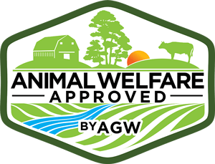
Certified Animal Welfare Approved by AGW is the only label that guarantees animals are raised outdoors on pasture or range for their entire lives on an independent farm using truly sustainable, high-welfare farming practices.
100% Whole Grain

- If a product bears the 100% Stamp, then all its grain ingredients are whole grain. There is a minimum requirement of 16g (16 grams) – a full serving – of whole grain per labeled serving, for products using the 100% Stamp.
- If a product bears the 50%+ Stamp, then at least half of its grain ingredients are whole grain. There is a minimum requirement of 8g (8 grams) – a half serving – of whole grain per labeled serving, for products using the 50%+ Stamp.
- If a product bears the Basic Stamp (right image), it contains at least 8g (8 grams) – a half serving – of whole grain, but may contain more reﬁned grain than whole.
Grass Fed

What does certified grass fed mean? It means the animal ate only grasses and forages (like hay) for the length of its life, starting when it was weaned off its mother’s milk. Meat can also be labeled as certified organic grass-fed, and this would mean the forages that the animal consumed met all organic certifications.
Certified B Corp

B Corp certification is a designation that a business is meeting high standards of verified performance, accountability, and transparency on factors from employee benefits and charitable giving to supply chain practices and input materials. Unlike the traditional corporation that gives priority only to financial profitability, B Corps actually use the power of business to address social and environmental problems.
MSC Certified Sustainable Seafood
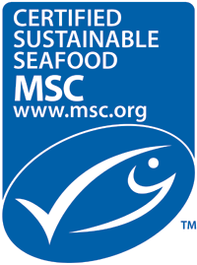
The MSC (Marine Stewardship Council) says its label guarantees that the wild seafood was caught using methods that do not deplete the natural supply. It also guarantees that fishing companies do not cause serious harm to other life in the sea, from coral to dolphins.
