Design Brief — Forest. Açaí Popsicle 60g (75% Açaí)
Overview
The Forest. Açaí Popsicle is a premium frozen snack designed for health-conscious consumers seeking an authentic, low-calorie treat made with real açaí. Containing 75% açaí pulp and only 57 calories per bar, this product offers a genuinely healthy, on-the-go alternative to traditional ice creams.
It will be sold in convenience-style stores and merchandised in freezer cabinets alongside major brands such as Magnum, Cornetto, and Solero. The design must command attention when viewed through the freezer glass and instantly communicate freshness, health, and authenticity while remaining true to the Forest. brand identity.
Creative Direction
Goal:
Make the product stand out immediately as a bold, premium, and healthy alternative, simple, confident, and natural.
Tone & Style:
- Premium but approachable
- Natural, clean, and minimally designed
- Confident, bold typography
- Consistent with Forest. brand book
Front of Pack (FOP) Essentials
Layout:
Use the Magnum-style landscape format as a benchmark, balanced and impactful.
Left Side (Brand Block) | Centre (Product Block) | Right Side (Claim Block)
- Forest. logo (prominent) | “AÇAÍ” in large, bold text | - “57 Calories” (large callout)
- “Product of Brazil” under logo |  | - “Low Fat”  - “75% Açaí  - Organic

Additional notes:
- Maintain brand cues and simplicity. Avoid clutter. If possible we could add an image of the popsicle to FOP but only if it avoids clutter.

Key Messages / Claims
- 75% Açaí
- Only 57 Calories
- Low Fat
- Organic
- Product of Brazil
- “This is Real Açaí.” (Brand slogan — optional FOP or side panel)
Shelf Objective
When viewed through the freezer glass, the pack should:
- Immediately communicate AÇAÍ and low-calorie, healthy indulgence
- Be visually distinct from competitors through simplicity and natural colour palette
- Reinforce Forest. as a premium, authentic, and nature-inspired brand

Ingredients:
Organic açaí pulp (75%), water, sugar, stabilisers (guar gum, xanthan gum, cellulose gum), natural guaraná extract, citric acid, natural flavourings.
Nutritional Information / Technical: (use the 500ml forest. Branded style table).
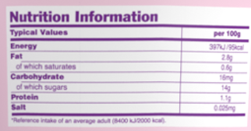

Serving size: 60 g (1 Popsicle)
Average values | Per 100 g | Per 60 g
Energy | 394 kJ / 94 kcal | 236 kJ / 57 kcal
Fat | 2.6 g | 1.6 g
– of which saturates | 0.5 g | 0.3 g
Carbohydrate | 16.9 g | 10.1 g
– of which sugars | 14 g | 8.7 g
Fibre | 1.6 g | 1 g
Protein | 1 g | 0.6 g
Salt | 0.00 g | 0.00 g

Picture of the exact item in another brand and the benchmark :
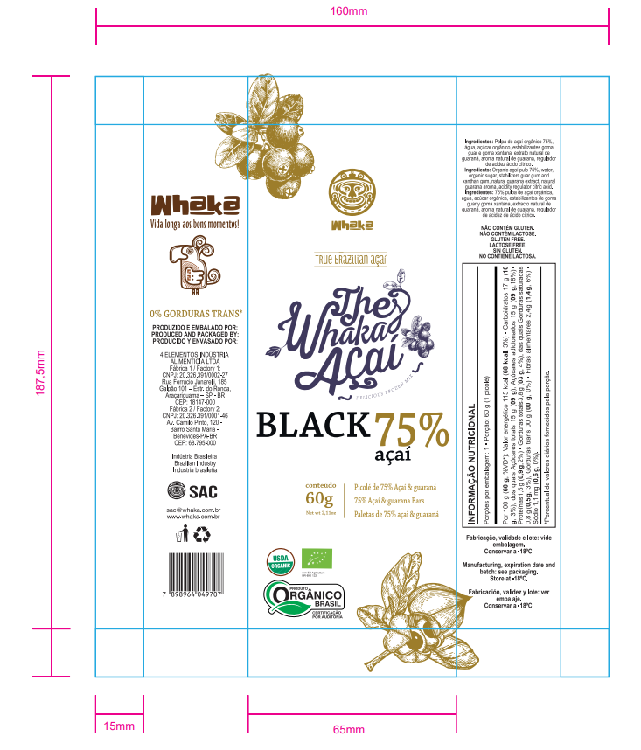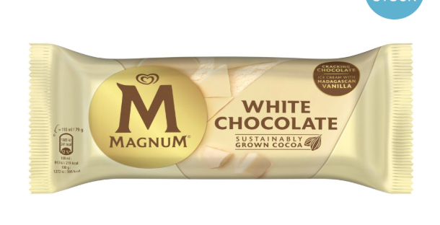

Back of Pack Essentials:

Produced & Packaged By:
4 ELEMENTOS INDÚSTRIA ALIMENTÍCIA LTDA.
CNPJ: 20.326.391/0002-27
Rua Ferrúcio Janarelli, 185 - Galpão 101 – Estr. do Ronda,
Araçariguama – SP - BR - CEP: 18149-020
Imported & Distributed By:
1816 Food Collective Ltd.
PO Box: 13871
Sales Enquiries: info@1816foodbrands.com
Storage & date line
“Keep frozen at −18 °C or below. Once thawed, do not refreeze. Best before / Lot: see pack.”
Essential Logos:

Please copy from 500ml pack.
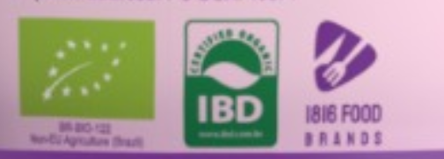
Barcode:


♻️ Recycling Instructions
- Sleeve / Wrapper: Widely recycled (paper/card)
- Stick: General waste

Design Brief — Forest. Açaí Popsicle 3x60g (75% Açaí)
Overview
The Forest. Açaí Popsicle x3 multipack contains three individually wrapped 60g popsicles. It’s a premium frozen snack aimed at health-conscious consumers seeking an authentic, low-calorie treat made with real açaí.
Containing 75% açaí pulp and only 57 calories per bar, it’s a genuinely healthy, on-the-go alternative to traditional ice creams.
The pack will be sold in supermarkets and convenience stores, merchandised in freezer cabinets alongside take-home desserts and other multi-packs. The design must stand out when viewed through the freezer glass, clearly communicating freshness, health, and authenticity, while staying true to the forest. brand identity.
Creative Direction
Goal:
Create immediate shelf impact by presenting forest. as a bold, premium, and healthy alternative, simple, confident, and naturally appealing.
Tone & Style:
- Premium yet approachable
- Natural, clean, and minimal design
- Confident, bold typography and restrained colour palette
- Visual consistency with the Forest. brand book (tone, texture, logo treatment, and hierarchy)

Front of Pack (FOP) — Layout Direction
Use the Magnum-style format as a benchmark for overall layout balanced, premium, and impactful. The layout should be easily recognisable and clearly structured to guide the shopper’s eye across three visual zones.
Top of FOP:
- forest Branding
Middle of FOP:
- 57 calories per bar (Give this the most attention, potentially its own big icon on the top right)
- 75% Acai
- Low fat
- Dairy free
- Organic
Bottom of FOP:
- Product image
- Legal description – x3 75% Acai Popsicles
Side Panels:
- Brand story, copy, and logo
Top Panel:
- Brand Logo
- Description – x3 75% Acai Popsicles

Additional Design Notes
- Maintain simplicity and balance, every element should have a clear purpose.
- Ensure strong contrast and legibility when viewed through frosted freezer glass.
- Background tones should reference natural açaí ques (deep purple, berry tones, forest greens).
- Subtle natural textures (leaf shadow, matte gradients) may be used to convey authenticity.
- Avoid overly “fitness” or “diet” aesthetic, the look should feel natural and indulgent, not clinical.
- The Forest. logo must remain consistent with master brand usage (spacing, colour, proportions).

Key On-Pack Messages / Claims
- 75% Açaí
- Only 57 Calories
- Low Fat
- Organic
- Product of Brazil
- “This is Real Açaí.” (Brand slogan — optional on FOP or side panel)
Copy / Brand Story:

Forest started with a simple idea: bring real açaí to Ireland without cutting corners. We partner with smallholder harvesters in Pará, paying fair prices and taking only what the trees can give. The berries are pulped and frozen at source within hours to preserve flavour, then finished and packed in Sai Paulo for consistent quality. Our recipe is short and transparent, and our brand is built on three commitments: authentic taste, responsible sourcing, and straightforward labelling. We’re Irish-owned, proud of our Brazilian roots, and excited to put a better açaí in bowls, smoothies and spoons across the country.

Shelf Objective
When viewed through the freezer glass, the pack should:
- Instantly communicate AÇAÍ and low-calorie, healthy indulgence
- Be visually distinct from competitors through simplicity and a nature-inspired palette
- Reinforce Forest. as a premium, authentic, and health-forward brand

Ingredients:
Organic açaí pulp (75%), water, sugar, stabilisers (guar gum, xanthan gum, cellulose gum), natural guaraná extract, citric acid, natural flavourings.
Nutritional Information / Technical: (use the 500ml forest. Branded style table).

Serving size: 60 g (1 Popsicle)
Average values | Per 100 g | Per 60 g
Energy | 394 kJ / 94 kcal | 236 kJ / 57 kcal
Fat | 2.6 g | 1.6 g
– of which saturates | 0.5 g | 0.3 g
Carbohydrate | 16.9 g | 10.1 g
– of which sugars | 14 g | 8.7 g
Fibre | 1.6 g | 1 g
Protein | 1 g | 0.6 g
Salt | 0.00 g | 0.00 g

Pictures of the exact item in another brand and the benchmark, AI generated picture for front of pack:
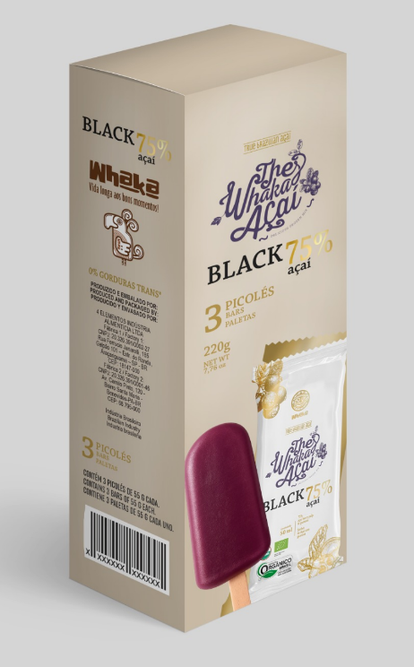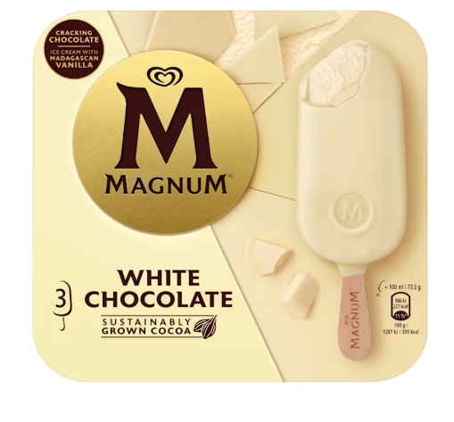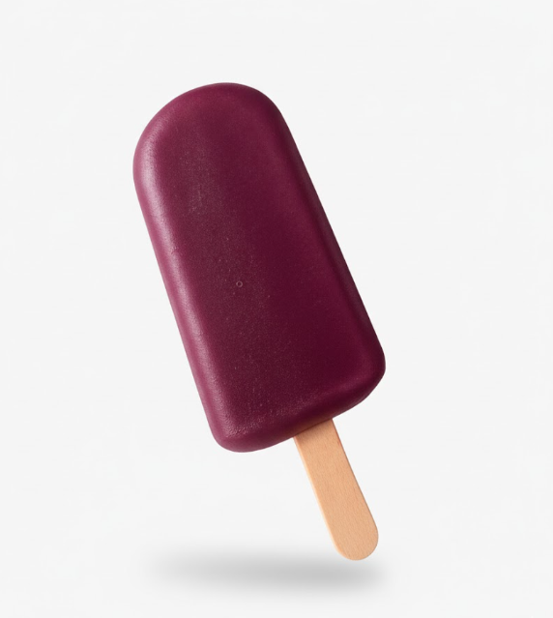
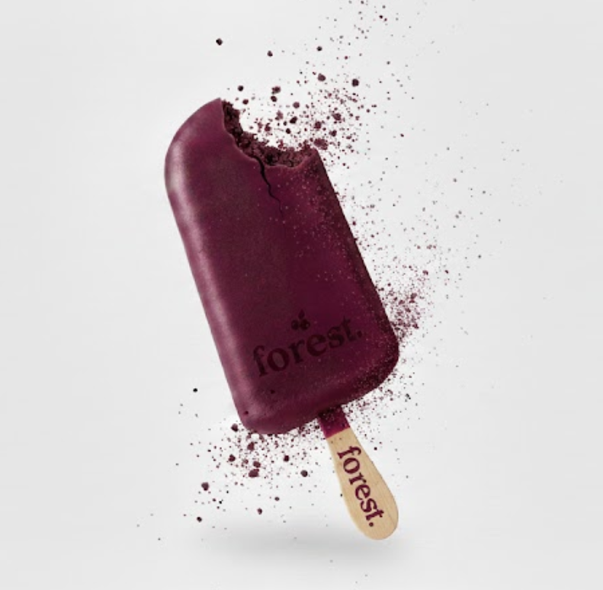
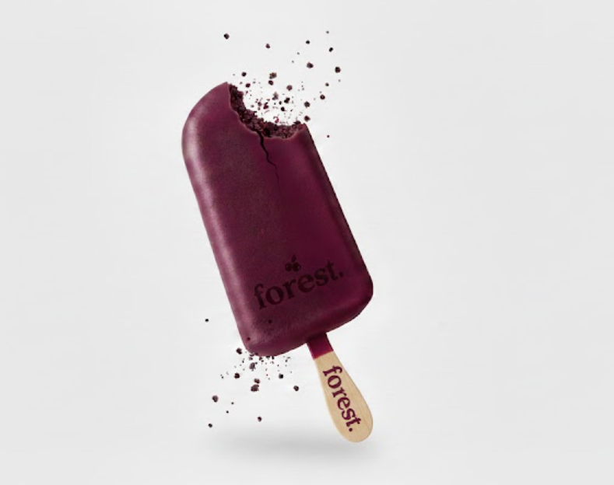
Back of Pack Essentials:

Produced & Packaged By:
4 ELEMENTOS INDÚSTRIA ALIMENTÍCIA LTDA.
CNPJ: 20.326.391/0002-27
Rua Ferrúcio Janarelli, 185 - Galpão 101 – Estr. do Ronda,
Araçariguama – SP - BR - CEP: 18149-020
Imported & Distributed By:
1816 Food Collective Ltd.
PO Box: 13871
Sales Enquiries: info@1816foodbrands.com
Storage & date line
“Keep frozen at −18 °C or below. Once thawed, do not refreeze. Best before / Lot: see pack.”

Essential Logos:
Please copy from 500ml pack.

Barcode:


♻️ Recycling Instructions
- Sleeve / Wrapper: Widely recycled (paper/card)
- Stick: General waste

