Flexible Payment Plan  Three Months - No Interest  Just Text 93888 to 48078  Join the millions of people who choose to shop now, pay later with Snap Finance. Apply online in minutes, get a decision in seconds. Get what you need when you need it – without paying for it all upfront. Snap has your back with approval amounts that range from $300 - $5,000. Apply online now with no impact to your FICO® score.  ==================================  Get Your Gift Card On-line  Just Scan the QR Code Below  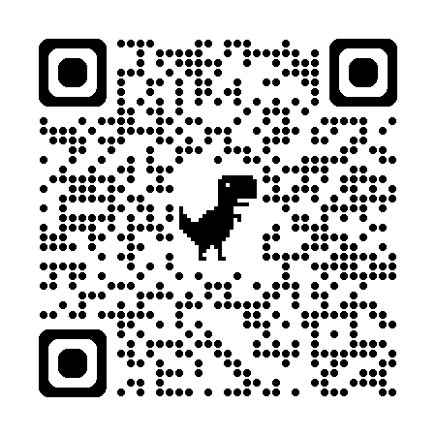 | 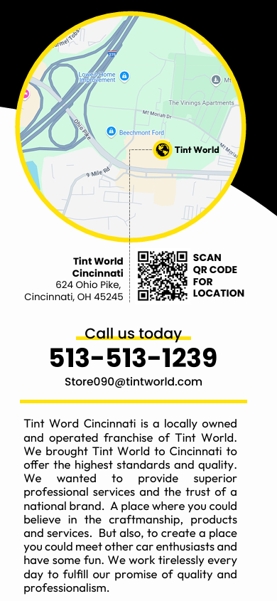 |  Holiday Specials  Three Month  No Interest Payment Plan  Shop Now, Pay Later  Just in Time for the Holidays  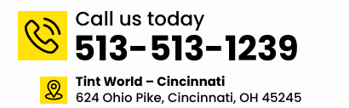

MIDDEL FLAP | BACK FLAP | FRONT

