Change Text to “ Designed For Education”


Change this photo
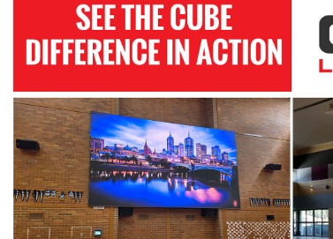
To this photo with emphasis on the scoreboard with enough background to provide scale
