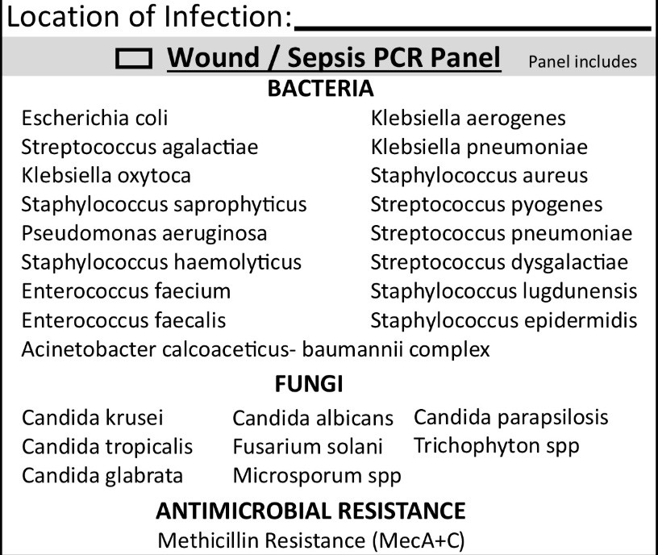
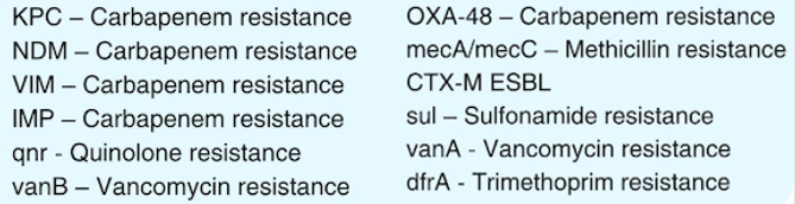

North West Labs
Billing Information (Please include a copy of the front & back of card.)
Biopsy Information
Antimicrobial Resistance Panel
Billing Type: □ Patient □ Insurance □ Client Relation (Req |  | uired): □Self □Spouse □Dependant Insured’s Name (if
not patient):
Insured’s SS#: |  | Insured’s DOB:
Primary Insurance Carrier: | Medicare, Medicaid or Policy ID#:
Claims Address:
Employer/Group Name: | Group#:

ICD10 codes (required):`
Date Collected Req.): ( |  | Time Collected: Collector Si | gnature: No. vials collected:
Type: D Punch Biopsy D D Shave Removal (Ink) DAlopecia Sections Punch Excision (Ink) D D Excision (Ink) D DIF D
Shave Biopsy Currettage
1 Site:
Clinical Findings
D Nevus Atypical D SCC D FEP
D Melanoma DBCC D AK D DF
D SK DVV
2 Site:
Clinical Findings
D Nevus Atypical D SCC D FEP
D Melanoma D AK D DF
D BCC D SK DVV
3 Site:
Clinical Findings
D Nevus Atypical D SCC D FEP
D Melanoma D AK D DF
D BCC D SK DVV
1401 Biopsy (H&E Stain)
1499 Nail with Nail Bed Biopsy with PAS


29580 Northwestern Hwy,
Southfield, MI 48034
(248) 301-6917

Dermatology Test Requisition Form
Patient Information (Please Print)
Sexual Orientation: □Bisexual □Straight □Gay or Lesbian □Something else □ Does not wish to disclose □ Not provided □ Not applicable
Gender Identity: □Male □ Female □Gender nonconforming □Transgender male-to-female
□Transgender female-to-male □ Does not wish to disclose □Not provided □ Not applicable
Ethnicity: □ Hispanic or Latino
- Not Hispanic or Latino
- Unknown
Race: □Alaska Native or American Indian □Asian □ Black or African American □ Multiracial □ Native Hawaiian or other Pacific Islander
- Other race □ White □ Does not wish to disclose □Not provided
- Cell Phone
- Home Phone
Phone Number:
Patient ID#:
Date of Birth (Required):
Assigned Sex at Birth (Required):
□Female □Male
Zip:
State:
City:
Patient Address:
In Care of:
Name (Last, First) (Required):
Ordering Physician/Laboratory
Date:
Physician’s Signature:
Physician to receive additional result report:
(Required: Include the ordering physician’s first & last name, NPI, practice name, complete address, phone number and fax number.)

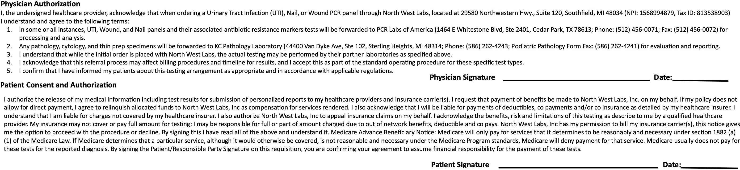
Other Tests/Panels:
ICD10 codes (required):

