
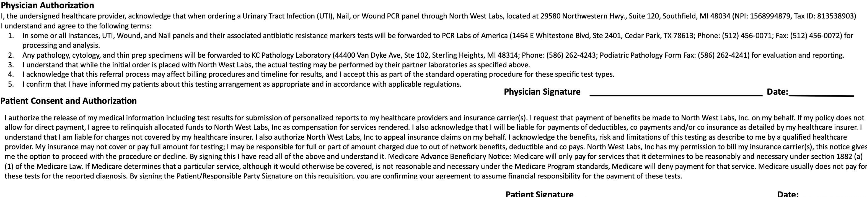

North West Labs
Other Tests/Panels:
For a full menu of testing, please visit www.mdlab
ICD10 codes (required):
29580 Northwestern Hwy,
Southfield, MI 48034
(248) 301-6917
Gastrointestinal (GI) Test Requisition Form
Patient Information (Please Print)
Ordering Physician/Laboratory
(Required: Include the ordering physician’s first & last name, NPI, practice name, complete address, phone number and fax number.)
Physician to receive additional result report:
Physician’s Signature: | Date:

Name (Last, First) (Required):
In Care of:
Patient Address:
City: |  | State: | Zip:
Assigned Sex at Birth (Required):  □Female □Male | Date of Birth (Required): |  |  |  | Patient ID#:
Phone Number: □ □ CHeolml PehPohnoene
RBalaccek: o□r Aflraicsakna ANmateivriecaonr American Indian □ Asian □  □ Multiracial □ Native Hawaiian or other Pacific Islander  □ Other race □ White □ Does not wish to disclose □ Not provided |  |  |  | Ethnicity: □ Hispanic or Latino  - Not Hispanic or Latino  - Unknown
Gender Identity: □Male □ Female □Gender nonconforming □Transgender male-to-female
□Transgender female-to-male □ Does not wish to disclose □Not provided □ Not applicable
Sexual Orientation: □Bisexual □Straight □Gay or Lesbian □Something else □ Does not wish to disclose □ Not provided □ Not applicable

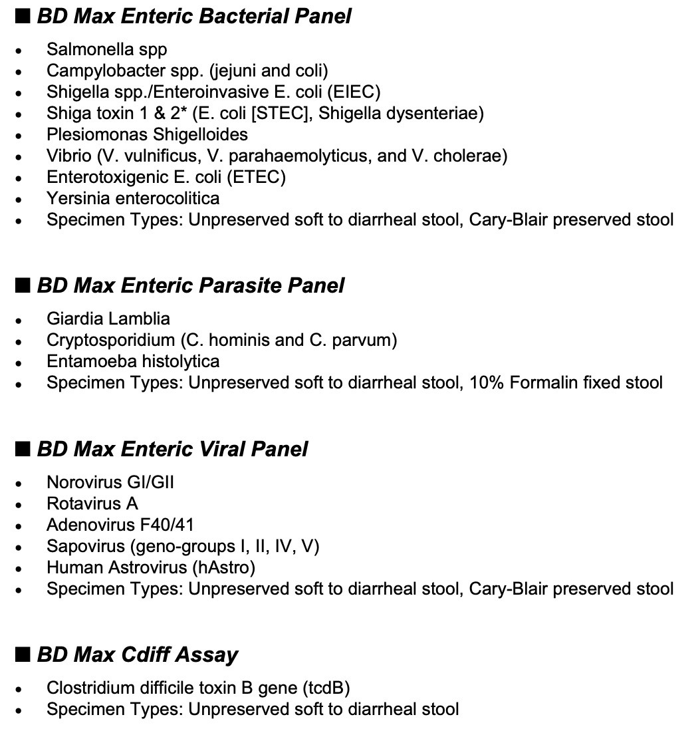

GI Panel
OneSwab® Speci
en Information
Date Collected (Req.): Sp
ecimen Source:  OneSwab®:_____________
Biopsy Information
Billing Information (Please include a copy of the front & back of card.)
Billing Type: □Relation (Required): □Self □Spouse □Dependant Patient □ Insurance □ Client Insured’s Name (if not patient):
Insured’s SS#:
Insured’s DOB:
m
Group#:
Employer/Group Name:
Claims Address:
Medicare, Medicaid or Policy ID#:
Primary Insurance Carrier:
ICD10 codes (required):`
Date Collected (Req.): | Time Collected: |  |  | Collector Signature: |  | No. vials collected:
Type:
□Adenoma □Crohn’s □H. pylori □Microscopic Colitis
□Barrett’s Esophagus □Dysplasia □Hepatitis □Proctitis
□Cancer □Eosinophilic Esophagitis □IBD □Sprue
□Candida □Fungi □Lymphoma □Steatohepatitis
□Other:
Endoscopic Finding Code:
- Normal 6. Friable 11. Hemorrahgic 16. Polyposis
- Edema 7. Abn. Vascular Pattern 12. Erosion 17. Mass
- Barrett’s Mucosa 8. Hyperemia 13. Ulcer 18. Submucosal Nodule
- Granular 9. Telangiectactic 14. Stricture 19. Pseudomembrane
- Nodular 10. Punctate Hemorrhage 15. Polyp 20. Other:
Anatomic Site of Biopsy: Container |  |  | Organ & Site |  | Distance (cm) |  | Endoscopic Finding (see codes above)
1.
2.
3.
4.
5.
6.
7.
8.
Special Stains For:  - H. pylori Fungus |  | - TB Virus Other:

