

Purpose
Excellence
Openness
Passion
Learning
Empathy
Dear Team,
We are pleased to share an important update that marks an exciting new chapter for our organisation. After thoughtful reflection, consultation, and feedback, we are proud to introduce our refreshed Company Values and Mission Statement - with a renewed commitment to placing people at the heart of everything we do.

Why the Change?
Over time, organisations evolve - and so do the people who make them what they are.
Earlier this year, we invited you to share the key values that you believe best represent how we work at Venturi. These are reflected below and have proudly shaped the core values that define who we are as a Company.
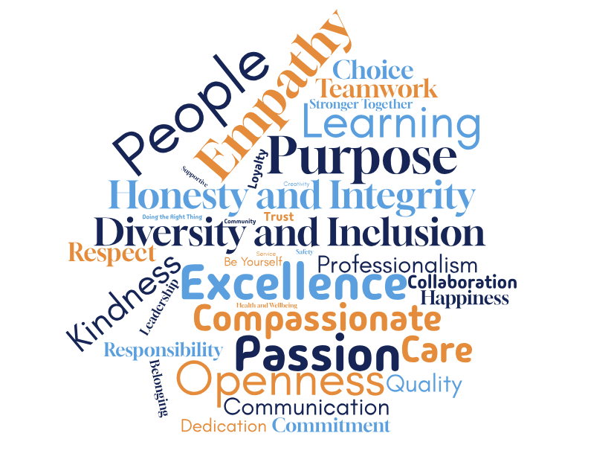

We’ve listened carefully to your voices, looked at how we work and recognised the need to better articulate why we exist as an organisation and which values guide our work every day. This update is about more than words - it’s about our identity, how we support one another, and how we deliver meaningful impact in a way that is truly aligned with our culture and aspirations.
At the core of this change is a clear purpose: to become more people focused.
Within Venturi, we provide life-changing support to our residents and their families. Together, we create a safe and caring environment for individuals with rich histories and experiences. We recognise them as someone’s mother, father, brother or sister; people who have cared for others in the past and helped shape the world we are privileged to live in today. During one of the most challenging times of their lives, our residents deserve nothing less than to be cared for with dignity, compassion and respect.
We believe that:
- Care is a relationship, not a transaction.
- Every resident is someone’s family, and they deserve to feel respected, safe and at home.
- Every staff member deserves an environment where they can thrive and lead with empathy.

Our New Mission Statement:
“Our daily mission is to make each moment meaningful for us and for those around us through acts of kindness, integrity, and connection. We provide compassionate, person-centred care that honours the lives and legacies of our residents and their families, while fostering a culture where our staff feel empowered, valued, and inspired to grow.”

Our Core Values
We are introducing a new set of values that reflect our shared priorities and define how we show up for each other every day:
Purpose
We are driven by a clear understanding of why we do what we do: to enrich lives, honour legacies and make a meaningful difference every day, for our residents, their families, our colleagues and our community.
Excellence
We hold ourselves to the highest standards, delivering exceptional care and creating an environment where both residents and staff can thrive.
Openness
We build trust through honest, respectful communication, welcoming feedback, sharing ideas, and embracing change as a path to continuous growth.
Passion
We are passionate about delivering exceptional care. We take pride in what we do and in making a real difference in people’s lives.
Learning
We are committed to personal and professional growth; empowering each other through ongoing development, reflection, and shared knowledge.
Empathy
We actively listen and seek to understand before being understood, recognising the unique stories, feelings, and needs of others.

We believe these values shape the way we work together, make decisions, and deliver on our mission.
What Happens Next?
Over the coming weeks, we’ll be embedding these values into how we work - from team conversations and recognition programmes to performance frameworks and leadership behaviours. We’ll also be offering sessions where you can learn more about the mission and values, ask questions, and share your thoughts.
We believe this shift will strengthen our culture, clarify our purpose, and create a more connected and supportive workplace.
Thank you for everything you do, and for being part of this journey.

