Bounce Mouthguards Website 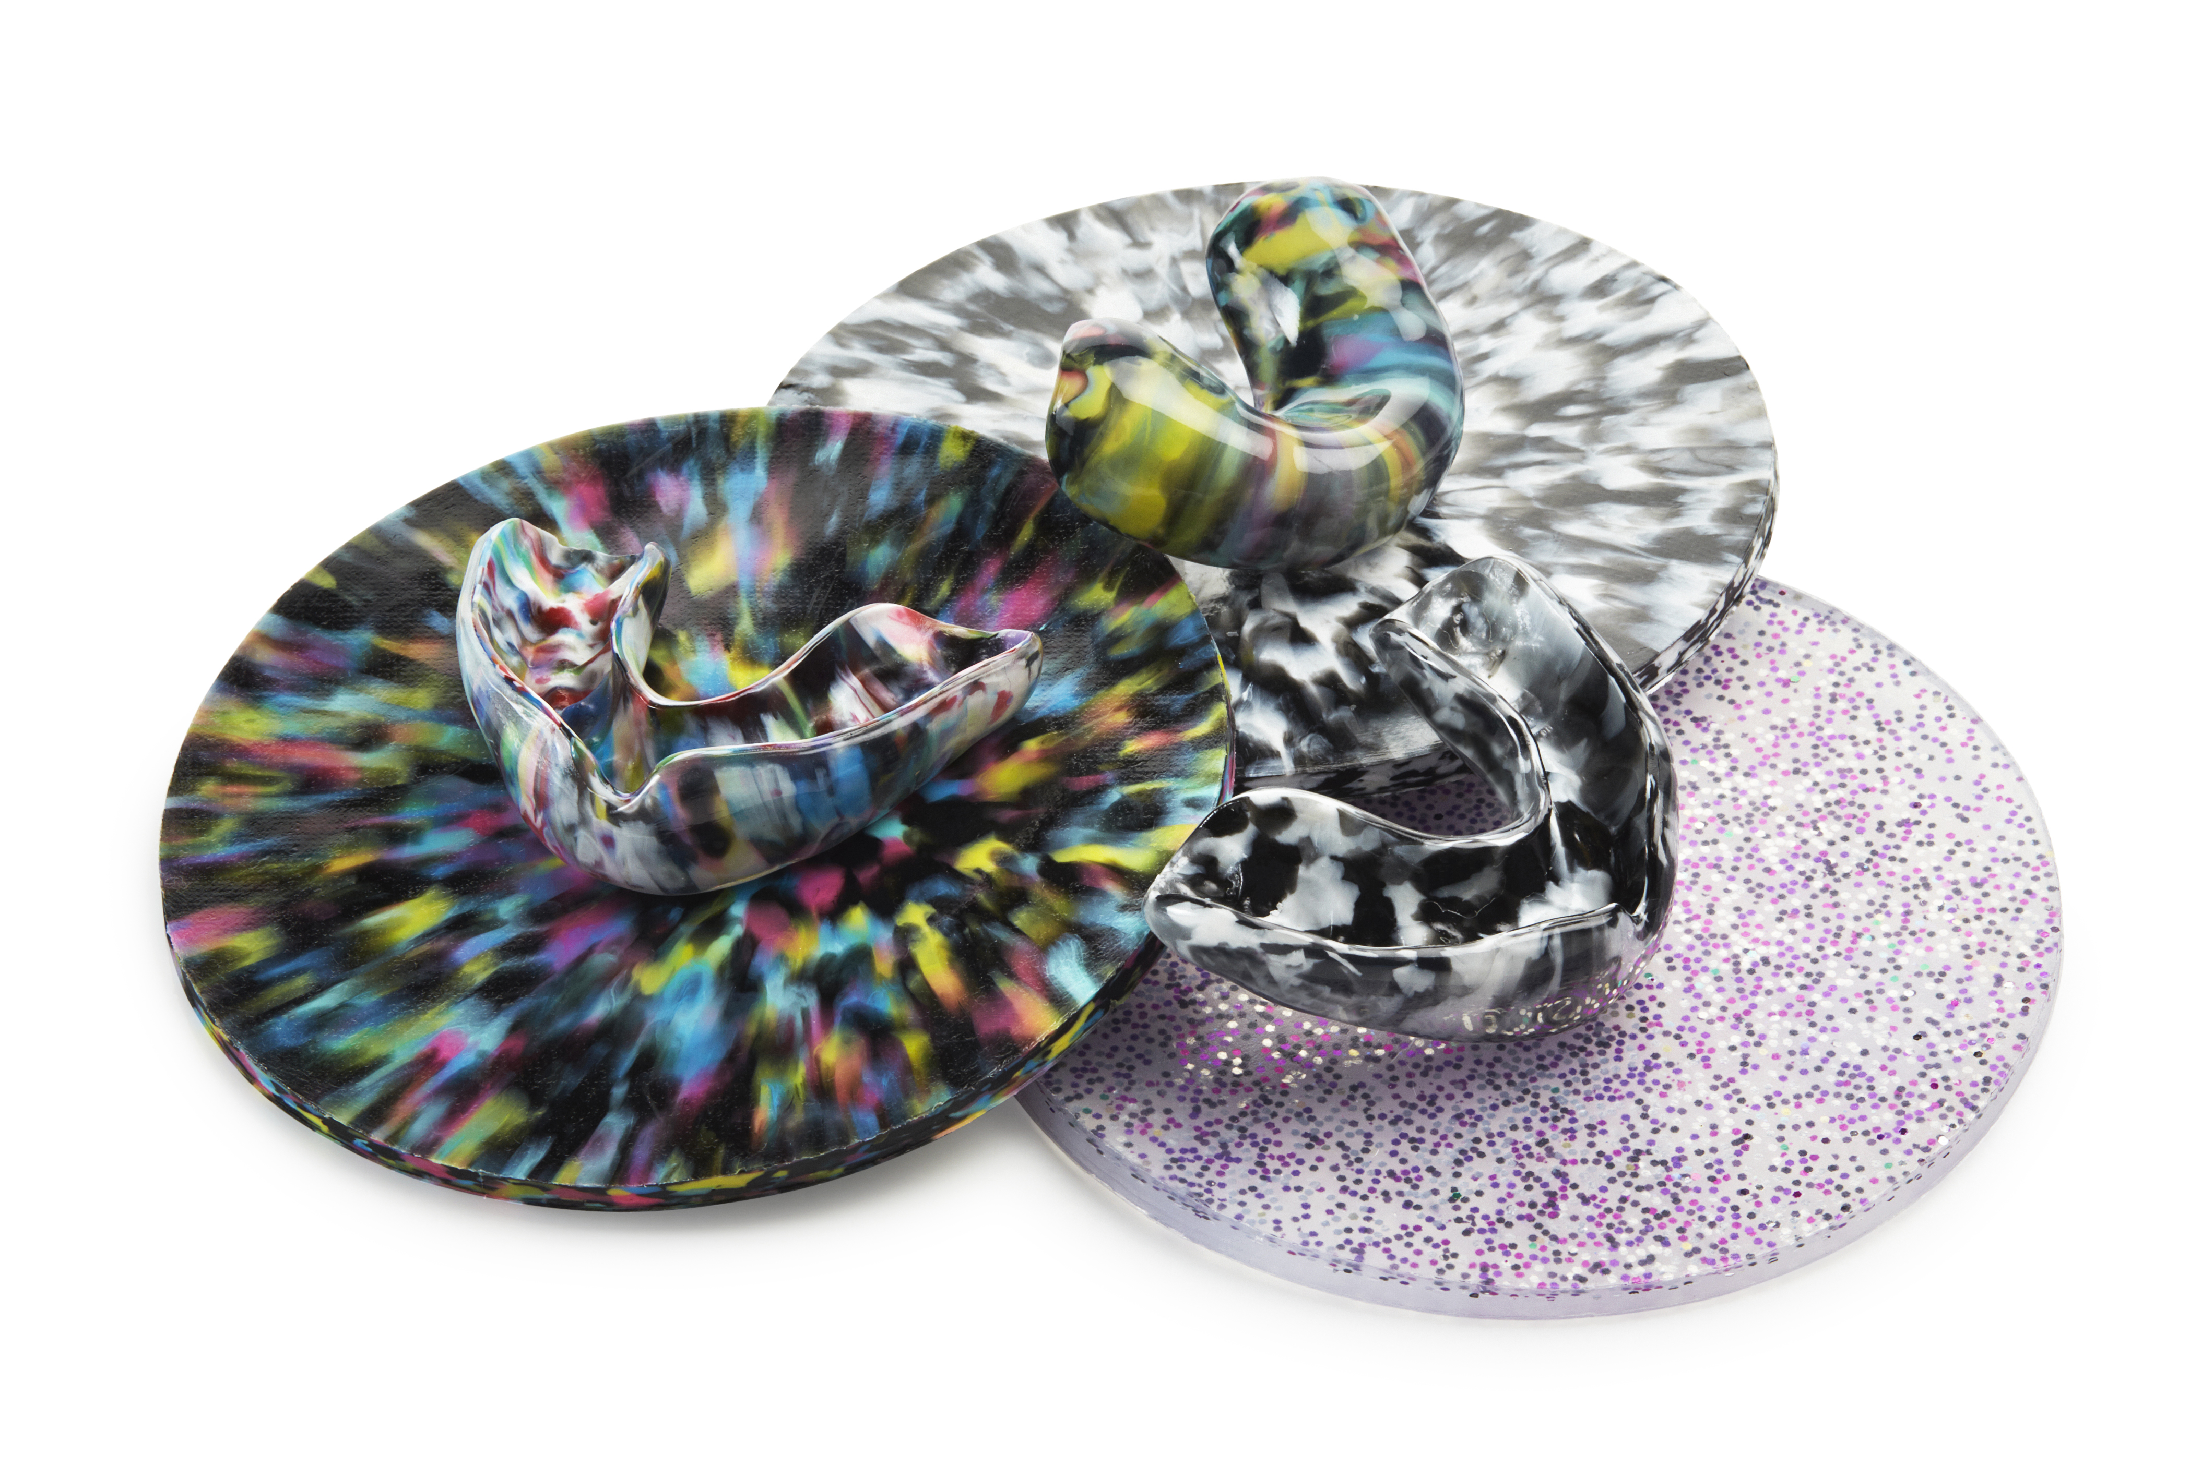

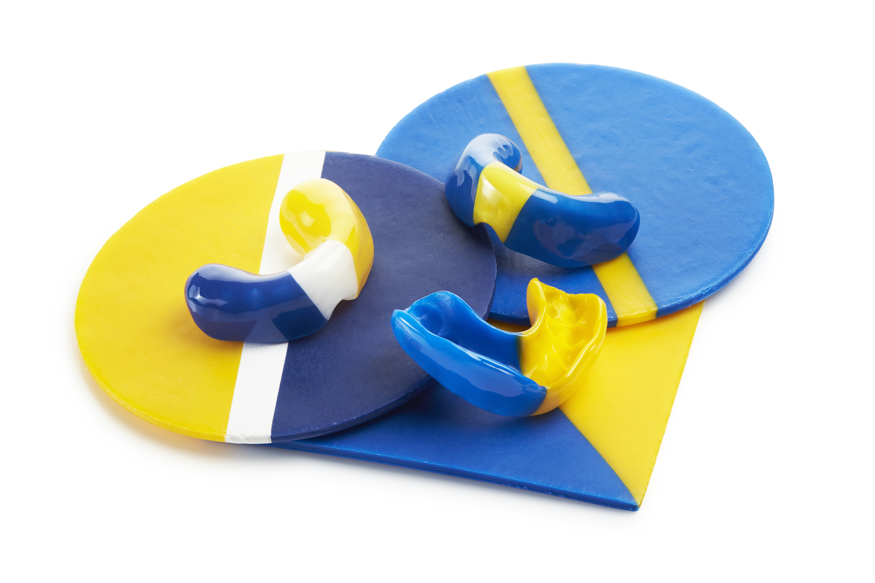

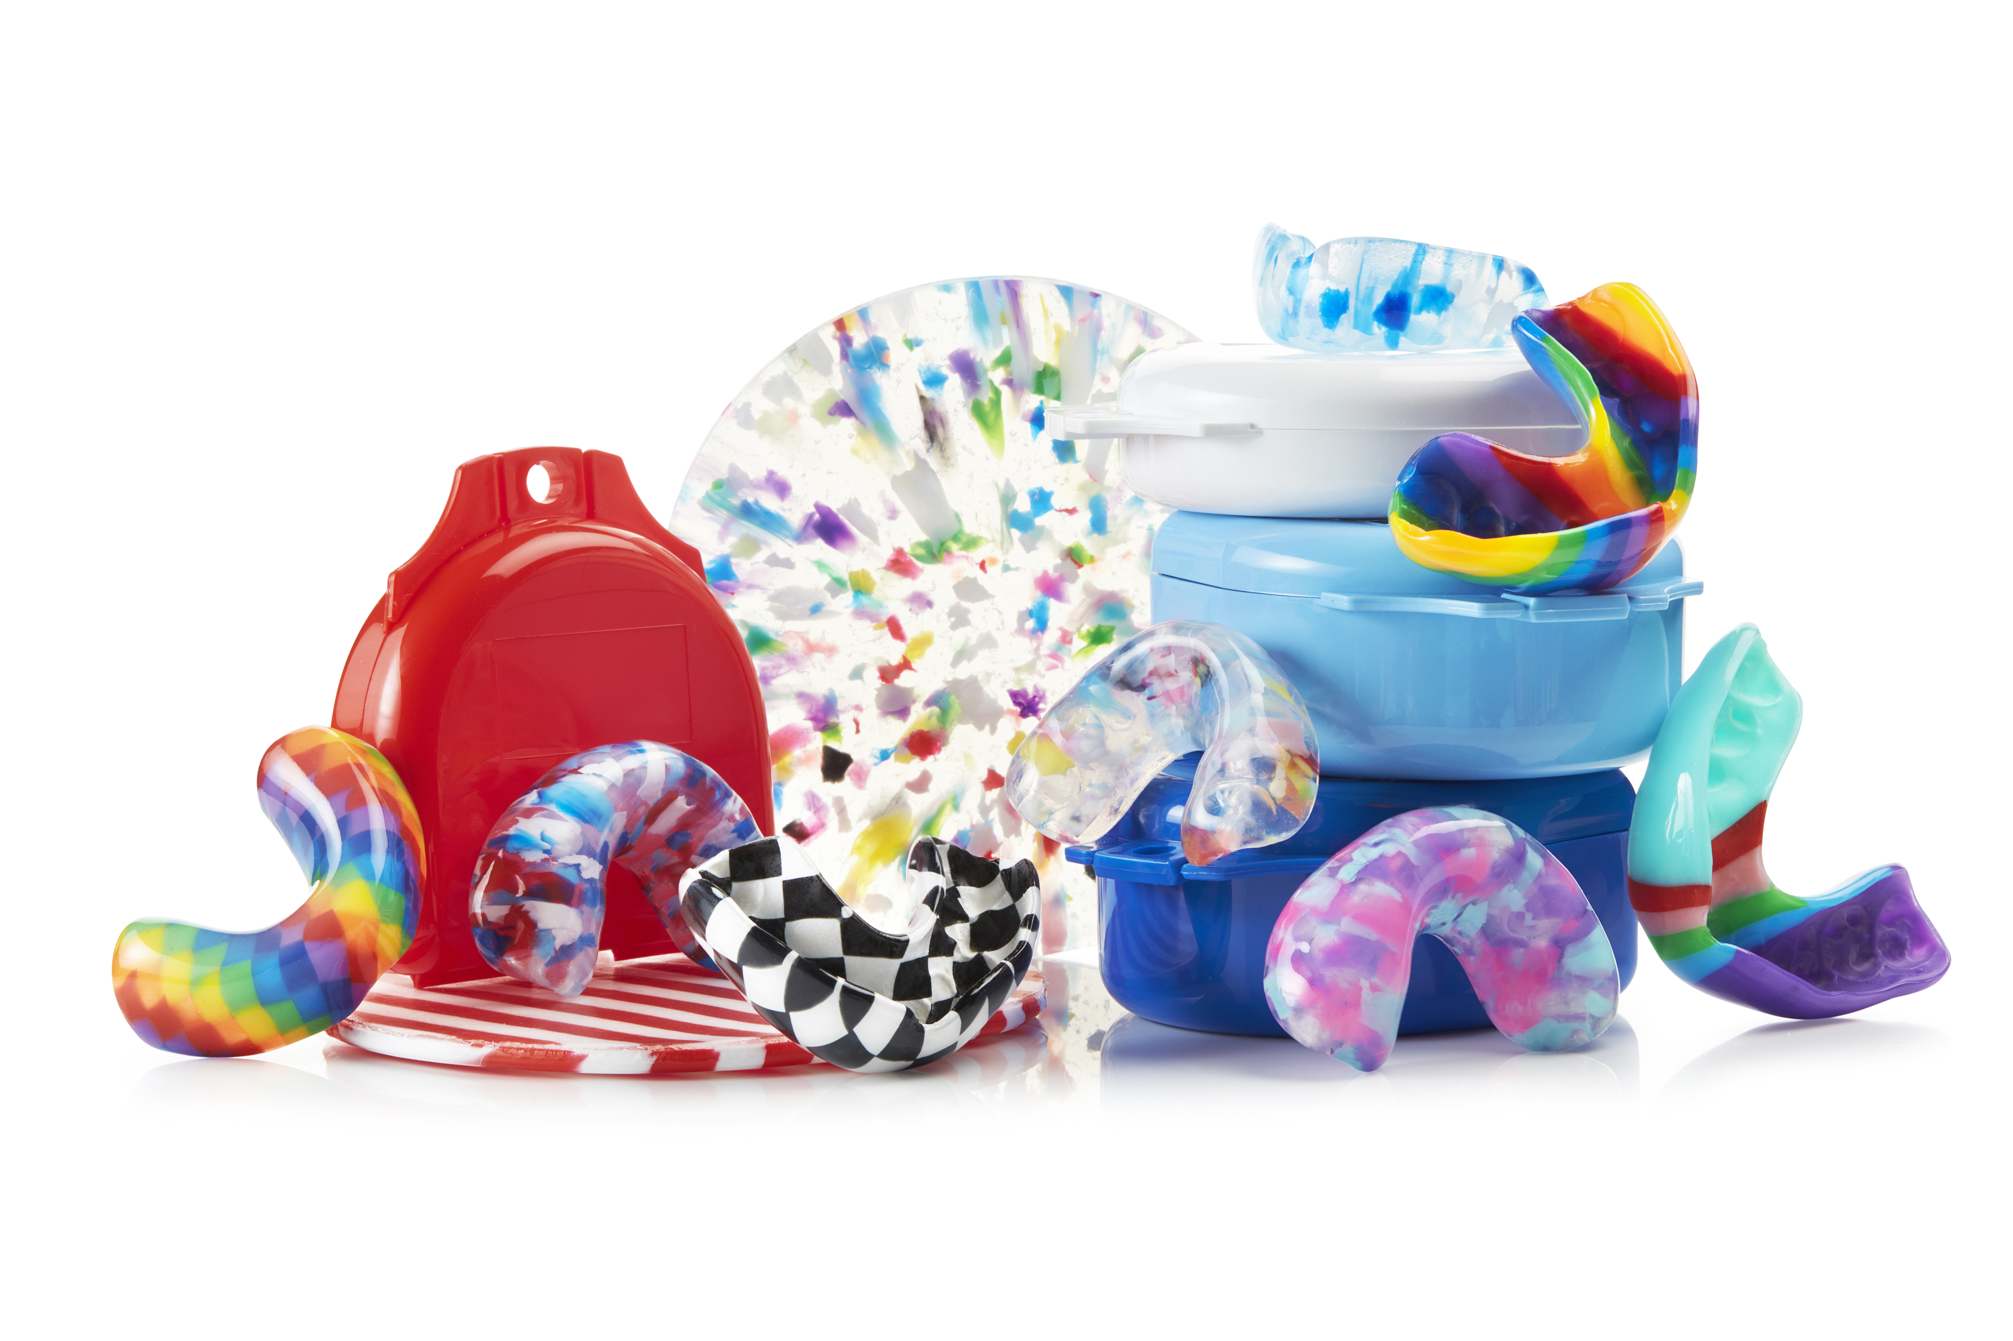
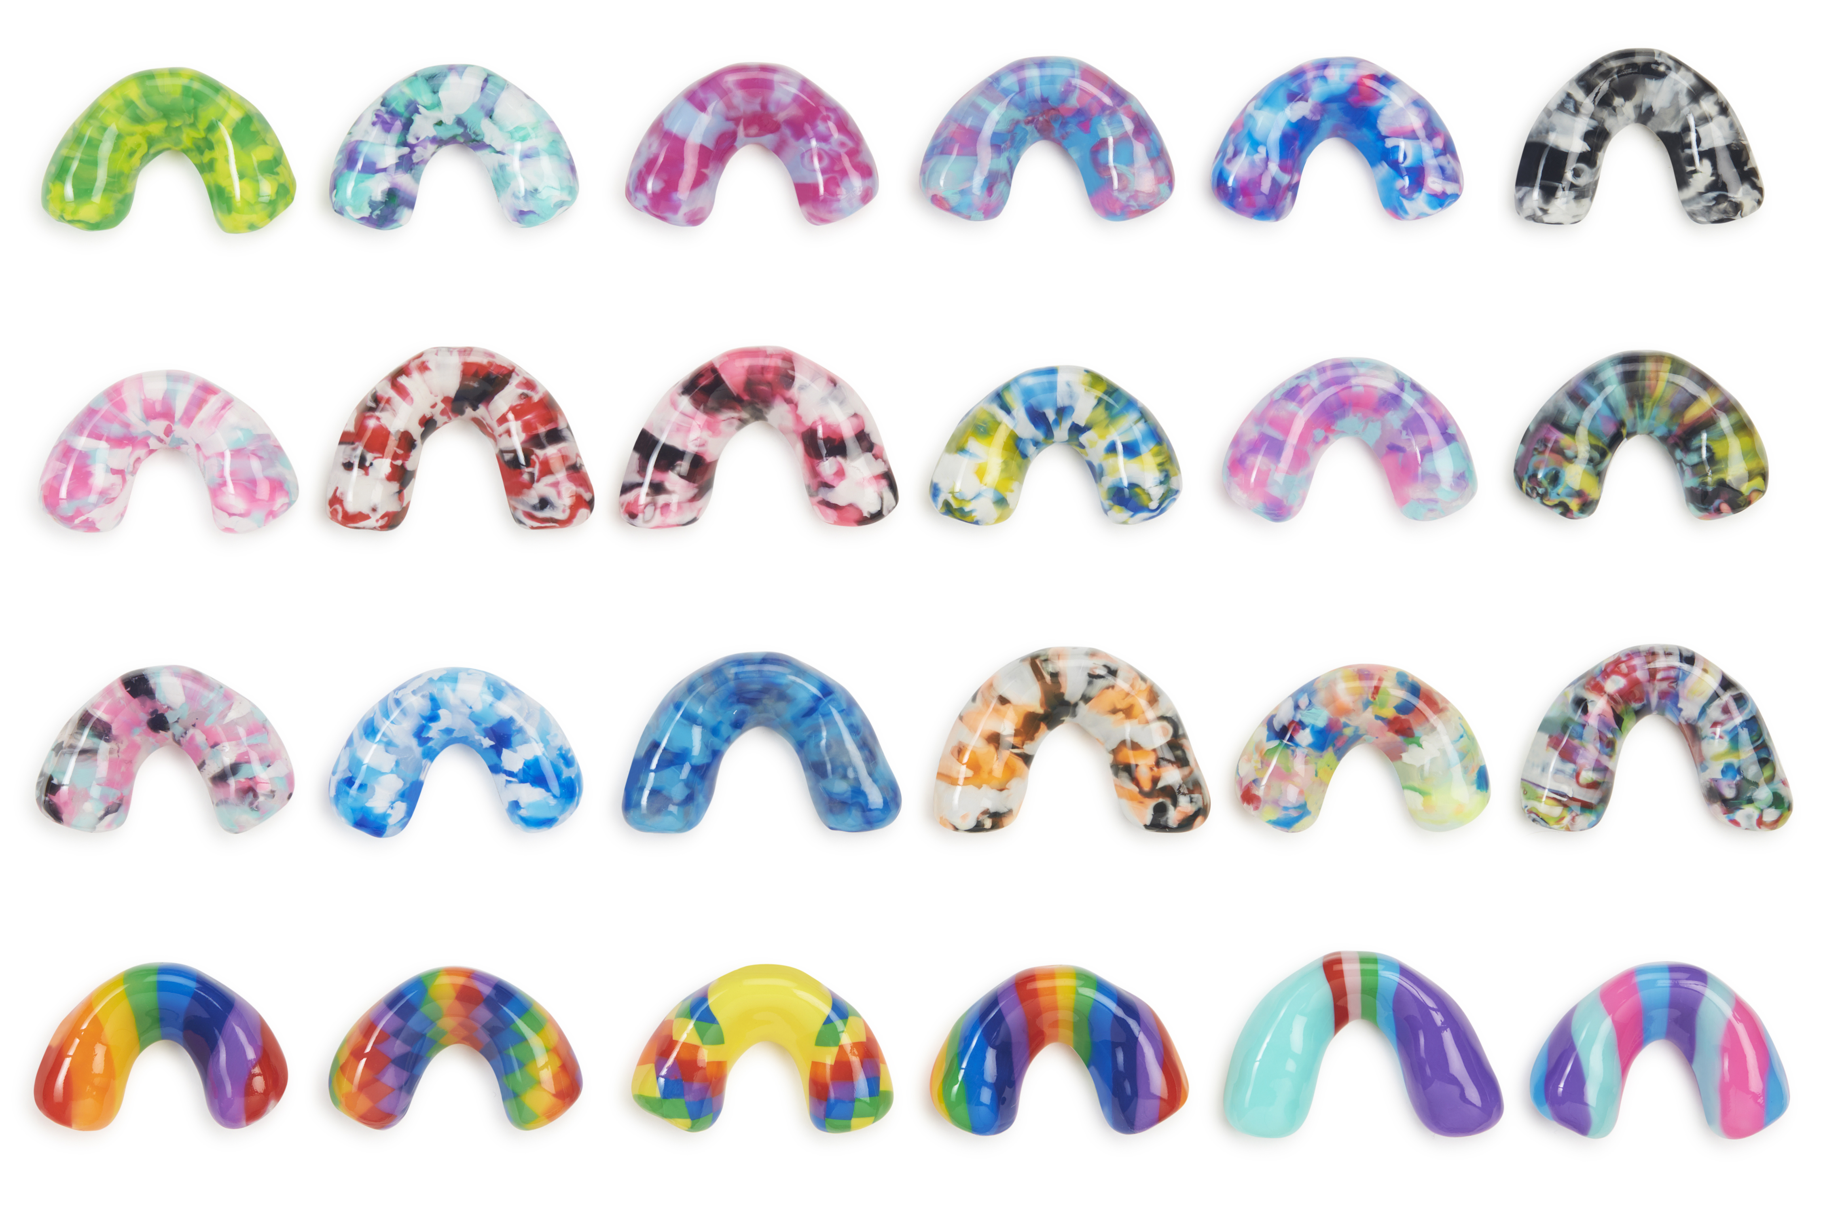

Page 1 - Homepage Banner – (If you can find a similar photo as the kids on the flyer I have provided and also the photos above )
BOUNCE MOUTHGUARDS - Custom-Made Sports Mouthguards in Perth
Protect your smile with a comfortable, professional fit.
[Book Now Button]

Why Choose Us
- Professionally made by a qualified dental prosthetist
- Custom fit for comfort, protection, and durability
- Wide range of colours and designs
- Available for kids, teens, and adults
- Clinic and mobile school/club visits available
Talk to us about our “gap free” mouthguards for eligible private health insurance members.

Page 2 - About Us

I have sent this info through on another file

Page 3 - Our Mouthguards (use a couple of the photos from above)

Protection, Comfort, Confidence

Why our custom mouthguards?

Not all mouthguards are created equal. Chemist-bought “boil and bite” guards might seem convenient, but they often provide poor fit and limited protection. A custom mouthguard, professionally fitted to your teeth and bite, offers:
• Maximum Protection – absorbs impact and helps prevent broken teeth, jaw injuries, and concussions.
• Superior Comfort – designed to fit snugly, making it easier to breathe and talk while playing.
• Durability – crafted from high-quality dental materials that outlast off-the-shelf options
With over 20 years experience in the industry, our dental prosthetist takes care to provide mouthguards that are made with precision and shaped for your comfort and protection.

Types Available:
- Kid’s mouthguards – protective and comfortable for growing dentition
-Single-layer: suitable for low–medium contact sports (children generally will have a single-layer mouthguard)
- Double-layer: recommended for high-impact sports
- Triple-layer: We are able to do triple layer mouthguards for sports that require that little bit of extra protection.

Design Options:
Design your own mouthguard with a choice of nearly 40 colours which you can mix and match into different styles. Choose from team colours, stripes, marbled effects – even harlequin patterns. We can also offer glitter over any colour you choose.
All of our mouthguard colours and styles are locally made, right here in WA. Take a look at the full range of colours and styles you can choose from at -
www.australianmouthguards.com
If you have your colours and a style in mind before your appointment with us you are one step ahead!

The Process
Step 1: Book an appointment or mobile visit with our dental prosthetist.
Step 2: Impressions are taken of the mouth – this appointment will generally take around 15 minutes. You then get to choose your design (if you haven’t already!)
Step 3: Mouthguard is made in-house in our laboratory by our prosthetist and technicians.
Step 4: Fit and collection – you may either pick up from our clinic - or for sporting clubs or schools, we can have them packed and delivered to you.
Now you’re ready for game day!
Our turnaround time is generally 1-2 weeks, however we may be able to accommodate quicker turnaround times. Contact us for more details.
[Book Now]

Page 4 – Photo Gallery

I’ll upload a file with the pictures to put here

Page 5 - FAQ
How long does a mouthguard last?
1–2 years for adults. Children generally will need a new fitting each year as their teeth and size of their mouths are changing month to month.
Are mouthguards covered by health funds?
Yes they are! Please check your coverage to ensure your policy is covered.
We are pleased to offer “gap free” mouthguards to private health members with dental coverage. Contact us for more details.*
Why not buy a mouthguard from the Chemist?
Chemist-bought “boil and bite” guards might seem convenient, but they often provide poor fit and limited protection. A custom guard is just that – custom made for your mouth, providing precision fit and comfort.
Do you visit schools and clubs?
Yes, we provide mobile fitting sessions for schools and sporting clubs. Please contact us for more information or to book.
*Single and double layer mouthguards will be covered fully by private health insurance providing your policy has mouthguard cover. Triple layer mouthguards will incur a gap payment.

NEW PAGE - Contact / Bookings

Please contact us to make a booking for your new custom mouthguard.

Clinic: Bounce Mouthguards at Perth Denture Care
Phone: (08) 6184 4919
Email: info@bouncemouthguards.com.au
Address: Unit 3, 30 Enterprise Crescent, Malaga, Western Australia, 6090
[Book Online Now]

