FRONT/MIDDLE OF LABEL

WILD THYME HONEY

DESCRIPTION OF PRODUCT ON RIGHT HAND SIDE OF LABEL BEFORE NUTRITIONAL INFORMATION

Three generations of expert beekeeping go into producing this 100% pure, wild thyme honey on a traditional apiary nestled in the wild highlands of Aragón, Spain. Master beekeeper Adolfo Cuartero and his family carefully nurture and manage over 3000 hives of healthy honeybees to produce all natural honey at its very best.

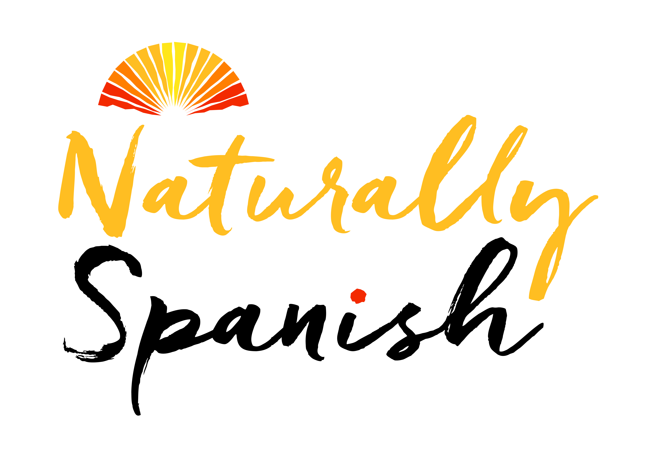
NATURALLY SPANISH
EAST MARTIN
FORDINGBRIDGE
SP6 3LJ
UK
Tel: 01722 580166
sales@naturally-spanish.com

PRODUCT OF SPAIN
23.1828/Z

NUTRITIONAL INFORMATION ON FAR RIGHT OF LABEL

Nutritional information per 100g

Energy 1394 kj/328 kcal
Fat <0.10g
Of which saturated <0.10g
Carbohydrate 82g
Of which sugar 80.6g
Protein <0.5g
Salt 0.017g

INFORMATION ON LEFT HAND SIDE OF LABEL

Best before:
Batch no:
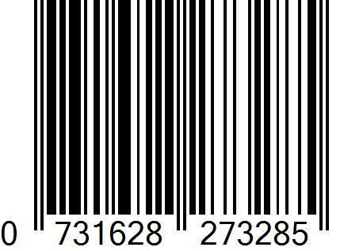
Net weight: 450g

CIRCULAR LABEL ON LID (TAMPER SAFE LABEL)

