Non-Profit Piece for Sport Courts
Version 1: Tech-Focused Innovation Emphasis
Exclusive Tech-Advanced Sport Court Design Experience
Revolutionize Your Outdoor Space with State-of-the-Art Innovation
Elevate your home with a custom sport court powered by cutting-edge technology from Terra Corte. As a dedicated supporter of [Non-Profit Organization/Gala Name], we proudly donate this premium package:
- Expert Consultation & Innovative Design: Collaborate with our specialists to design a high-tech sport court (basketball, tennis, pickleball, or multi-sport) featuring smart LED systems, automated surfaces, and app integration, paired with elegant landscaping.
- Premium Inclusions: On-site evaluation, 3D visualizations, tech specs, and a blueprint redeemable toward installation.
- Tailored to You: Adaptable for any luxury residence, blending performance with aesthetic appeal.
Valued at $2,500, this package showcases Terra Corte's commitment to futuristic athletic solutions. Redeem within 12 months
Bid Today to Unlock the Future of Home Sports!
Retail Value: $2,500
Minimum Bid: $199
Bid Increments: $50
Donated By: Terra Corte
info@terracorte.com | www.terracorte.com
Non-transferable. No cash value. Subject to availability and terms.

Version 2: Luxury Lifestyle Emphasis
Bespoke Luxury Sport Court & Landscaping Design
Craft an Exquisite Private Retreat in Your Own Backyard
Indulge in the sophistication of a personalized sport court from Terra Corte, where elegance meets innovation. In support of [Non-Profit Organization/Gala Name], we offer this exclusive opportunity:
- Personalized Design Consultation: Partner with our elite team for a custom sport court (tennis, basketball, or versatile options) enhanced by premium landscaping, incorporating high-end tech like ambient lighting and smart controls.
- Luxury Features: Detailed site analysis, high-fidelity renderings, material selections, and a comprehensive plan redeemable for your full project.
- Custom Elegance: Designed for discerning tastes, transforming any space into a refined athletic haven.
This opulent package is valued at $2,500. Redeem within 12 months
Place Your Bid for Timeless Luxury!
Estimated Value: $2,500
Starting Bid: $199
Increments: $50
Courtesy of: Terra Corte
Contact: info@terracorte.com | www.terracorte.com
Non-transferable. No cash equivalent. Availability subject to scheduling.

Version 3: Customization and Personalization Emphasis
Custom Sport Court Design & Landscaping Package
Tailor-Made Excellence for Your Unique Vision
Discover the art of personalization with Terra Corte's advanced sport courts. Generously donated to benefit [Non-Profit Organization/Gala Name], this package includes:
- One-on-One Customization Session: Design your ideal sport court (multi-sport, tennis, basketball, or pickleball) with integrated tech features and bespoke landscaping to match your lifestyle.
- Comprehensive Deliverables: Personalized blueprints. & expert recommendations.
- Your Space, Your Rules: Fully adaptable to fit estates, homes, or private venues with seamless tech integration.
Valued at $2,500, redeemable within 12 months.
Bid Now to Make It Yours!
Value: $2,500
Minimum Bid: $199
Increments: $50
Provided By: Terra Corte
Email: info@terracorte.com | Website: www.terracorte.com
Non-transferable. No monetary value. Terms and conditions apply.

Version 4: Philanthropy and Community Emphasis
Premier Sport Court Design Contribution
Supporting [Non-Profit Organization/Gala Name] Through Innovative Design
Terra Corte is honored to contribute to meaningful causes with this high-value sport court package, blending technology and beauty for your home.
- Dedicated Design Partnership: Receive a tailored consultation for a tech-enhanced sport court (basketball, tennis, or custom) with complementary landscaping, featuring smart innovations for effortless enjoyment.
- Inclusive Benefits: Site review, detailed 3D designs, premium material guidance, and application toward your Terra Corte build.
- Community Impact: Bid generously to support [Non-Profit Organization/Gala Name] while enhancing your outdoor living.
This generous donation is valued at $2,500. Redeem within 12 months; fees for consultations beyond 100 miles from urban centers.
Your Bid Makes a Difference—Start Today!
Donation Value: $2,500
Opening Bid: $199
Increments: $50
Donor: Terra Corte
info@terracorte.com | www.terracorte.com
Non-transferable. No cash redemption. Subject to availability.

Version 5: Exciting and Dynamic Emphasis
Ultimate Sport Court Adventure Design Package
Ignite Your Passion for Play with High-Tech Luxury
Thrill to the possibilities of a Terra Corte sport court, donated to empower [Non-Profit Organization/Gala Name]. This dynamic package delivers:
- High-Energy Design Collaboration: Build your dream court (pickleball, multi-sport, tennis, or basketball) with advanced tech like interactive surfaces and lighting, plus stunning landscaping accents.
- Action-Packed Extras: In-depth assessment, immersive renderings, tech upgrades, and a redeemable credit for installation.
- Endless Excitement: Customized for high-performance fun in any backyard setting.
Valued at an electrifying $2,500. Redeem within 12 months
Jump In and Bid for the Win!
Package Value: $2,500
Min Bid: $199
Increments: $50
From: Terra Corte
Contact Us: info@terracorte.com | www.terracorte.com
Non-transferable. No cash value. Availability and terms apply.**

Asset id: 2533398147
Modern luxury house with a basketball court a...
See more
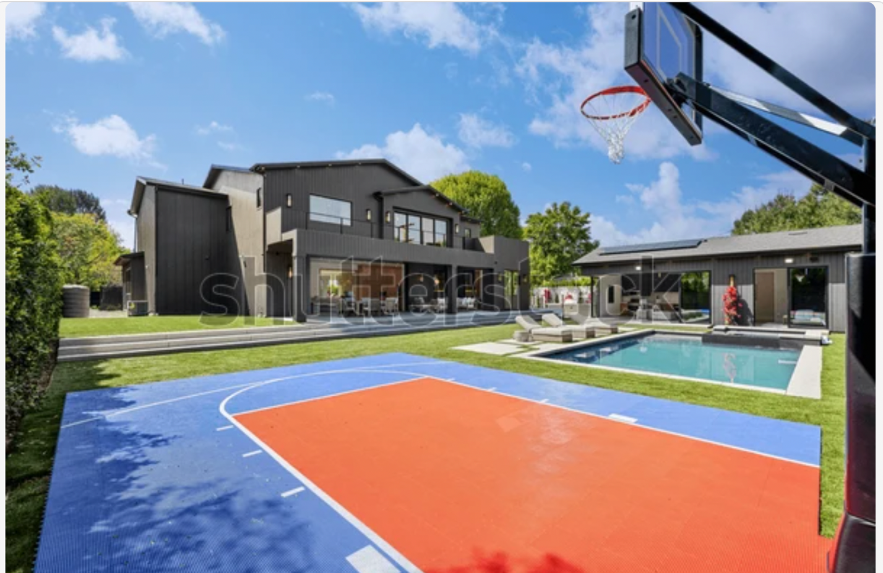

Asset id: 2071286555
Large estate home with sport court backyard s...
See more
Release information: Signed property release on file with Shutterstock, Inc.
Upload date: November 7, 2021
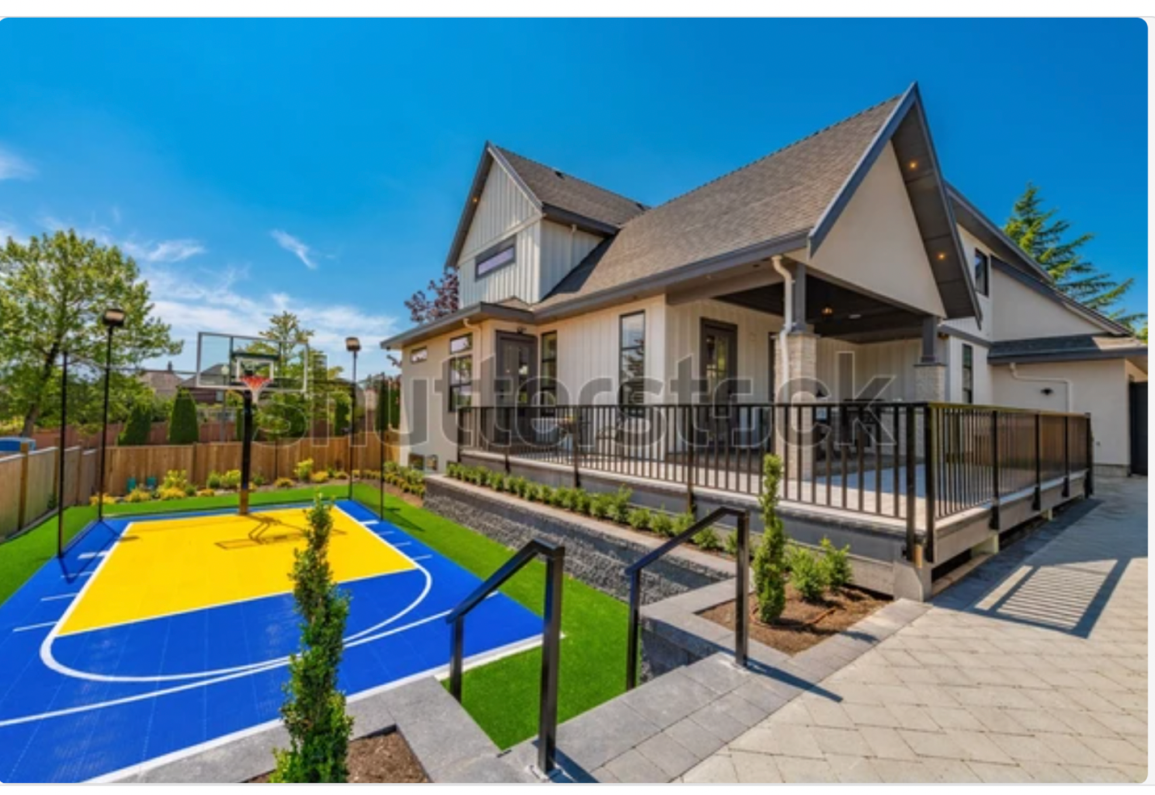

https://www.andyroddickfoundation.org

