COVER

Table of contents

Executive Summary
Purpose of this document

1. Workshop Overview: The Three Phases of AI Discovery
2. Discovery Workshop Preparation
3. Discovery Workshop Session
4. Next steps

Annexes

EXECUTIVE SUMMARY

In today's dynamic business landscape, Artificial Intelligence stands as a pivotal force for innovation and competitive differentiation. However, many organizations find themselves navigating a complex AI labyrinth, struggling to identify tangible applications and realize a genuine return on investment. The challenge isn't just about understanding AI's theoretical capabilities, but about pinpointing its most impactful and viable applications within your unique operational context.
At dataguru, we understand that unlocking AI's true potential requires a strategic, well-defined starting point. Our AI Discovery Workshop is meticulously designed to serve as that foundational step. It's a collaborative exploration, guided by our expert team, aimed at demystifying AI and translating its vast possibilities into concrete business value for your organization.
This report summarizes the key insights and actionable recommendations derived from our joint workshop. It provides you with a clear, prioritized roadmap of the most impactful AI use cases tailored to your business, assessed based on both their potential impact and practical feasibility. Consider this your essential starting point, laying a solid foundation for a successful and strategic AI implementation journey.

PURPOSE OF THIS DOCUMENT

The Purpose of this Document is to provide a comprehensive overview and detailed outcome of the AI Discovery Workshop conducted by dataguru with [Customer Name]. This report serves as a critical deliverable, synthesizing our collaborative efforts to identify, analyze, and prioritize the most impactful and feasible Artificial Intelligence use cases for your business. It is designed to equip your organization with a clear, actionable roadmap, empowering you to make informed decisions and confidently embark on your strategic AI implementation journey.

- Workshop Overview: The Three Phases of AI Discovery

Our AI Discovery Workshop is designed to cut through the complexity of artificial intelligence and pinpoint its most impactful applications for your business. We believe a successful AI journey starts with a clear vision and a structured approach. That's why our workshop is built around three distinct, yet interconnected, phases: Inspire, Discover, and Prioritize. This methodical framework ensures we don't just identify AI possibilities but truly understand their relevance to your operations and map out a viable path to implementation.

Our Approach: The Three Phases of AI Discovery
Inspire: Igniting Possibilities
In this dynamic 60-minute initial phase, our goal is to inspire you by broadening your perspective on AI's potential. We take you on a journey through various AI approaches, from foundational Artificial Intelligence to groundbreaking AI Agents. With a focus on real-world examples and success stories tailored to your industry, we help you envision a future where AI creates tangible value. This isn't just about understanding the technology; it's about seeing how AI can transform your vision into reality.
Discover: Unearthing Core Opportunities
In this 60-minute collaborative session, our team of experts guides you to uncover core AI use cases unique to your business. We organize you into small groups of three to brainstorm and discuss a wide range of possibilities, from optimizing operations to enhancing customer experiences. With our guidance, each group identifies and select the three most impactful use cases that align with your strategic goals. This hands-on phase transforms potential into a concrete, actionable plan.
Prioritize: Defining Your Strategic Roadmap
During this final 90-minute session, each team presents their top three use cases to the entire group. We then facilitate a collective evaluation, using a robust methodology to rank each idea based on its potential business impact and feasibility of implementation. This process is designed to prioritize the most promising opportunities and ensure your efforts are focused where they deliver the greatest return. The result is not just a list of ideas, but a final list of quick wins you can start implementing right away, giving a clear, actionable roadmap for your AI journey.
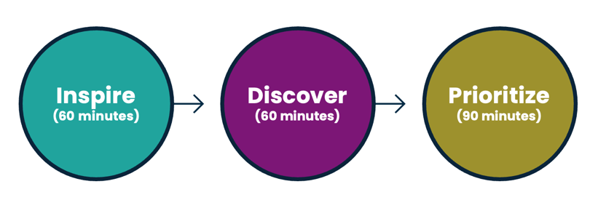
Figure 1. The Three Phases of AI Discovery

- Discovery Workshop Preparation

To ensure a productive and truly impactful session, we've designed a meticulous preparation phase tailored to [Customer Name] organization's unique needs. This groundwork is essential for a collaborative environment where every participant can contribute meaningfully, and the outcomes are directly applicable to your business.
A Foundation of Diverse Expertise
We believe that the best solutions emerge from a variety of perspectives. To that end, we have collaborated with you to identify a diverse group of employees who participated in the workshop. This group included individuals from various roles, functions, and levels of IT expertise. This strategic selection ensures we capture a comprehensive view of your business, from high-level strategic goals to on-the-ground operational realities. A list of these participants is included in Annex 1 for your reference.
Leveraging Participant Insights
Prior to the workshop, each selected participant has been asked to complete a preparatory survey. This detailed questionnaire, which can be found in Annex 2, allows us to gather invaluable insights. We inquired about their specific roles, their expectations for the session, their understanding of the company's strategic goals, and any other relevant information they wish to share. This proactive data collection is a cornerstone of our methodology.
Customizing Your Workshop Experience
The insights we gain from these surveys allow us to fully customize your workshop. The content, real-world examples, and discussion topics will be precisely adapted to your industry and business context, ensuring the session is immediately relevant and engaging. Furthermore, we will adjust the level of technical vocabulary and the pace of the discussion to match the audience's knowledge level. This is crucial for making the workshop understandable for everyone, preventing participants from getting lost in technical jargon, and ensuring that all voices are heard and valued.
Our goal is to create an environment where every participant feels empowered to contribute, resulting in a more collaborative and effective outcome for your organization.

- Discovery Workshop Session

This section details the specifics of the AI Discovery Workshop session that was conducted to initiate your AI journey.
Customer: [Customer Name]
Date: [Insert Session Date Here, e.g., October 26, 2025]
Location: [Insert Session Location Here, e.g., Your company's headquarters in New York City]
dataguru AI Business Leaders: The session was conducted by our expert team of AI Business Leaders, who guided the discussion and activities to ensure a productive and insightful experience.
[AI Business Leader Name 1]
[AI Business Leader Name 2]
You can find the detailed curriculum vitae (CVs) for the dataguru AI Business Leader in Annex 3 of this document.

Discovery Workshop Phase I: Inspire
As described previously, this initial phase is focused on introducing key AI concepts and providing a foundational understanding of the technology and its business application.

The content and real-world examples were specifically tailored to [Customer Name] and the examples are relevant to the [Vertical] industry. This approach ensured that the concepts were immediately relevant and relatable to your business, highlighting potential applications and opportunities within your specific industry. he insights we gain from these surveys allow us to fully customize your workshop. The content, real-world examples, and discussion topics will be precisely adapted to your industry and business

Discovery Workshop Phase II: Discover

During the Discover phase, the workshop shifted to a hands-on ideation session. Participants were divided into [Number of teams] teams, with each team tasked with brainstorming and defining potential AI use cases relevant to [Customer Name]. The goal of this phase was to generate a wide range of ideas based on the challenges and opportunities identified.

The dataguru AI Business Leaders guided the teams to adopt a positive and creative mindset, encouraging the generation of a high volume of ideas without being constrained by the current situation. We also guided the teams by posing the following key questions:

- What business outcomes do you want to improve?
- Are your legacy systems and processes holding you back?
- Are you leveraging your data to better manage your business?
- Have you felt the need to use AI in your business?

Each team successfully outlined a set of three promising use cases, as follows:

Team 1
Use Case 1: Employee assistant
A chatbot capable of answering HR questions such as vacation policy or expense reporting policy
Use Case 2: Customer Support assistant
A chatbot capable of answering product FAQ such as how to set up the product or when my order will be delivered
Use Case 3: Medical appointment reminder
A voice agent that makes automated calls to patients 48 hours in advance to confirm, reschedule, or cancel their appointments.

Team 2
Use Case 1: [NameofUseCase]
[Briefdescriptionoftheusecase]
Use Case 2: [NameofUseCase]
[Briefdescriptionoftheusecase]
Use Case 3: [NameofUseCase]
[Briefdescriptionoftheusecase]

Team 3
Use Case 1: [NameofUseCase]
[Briefdescriptionoftheusecase]
Use Case 2: [NameofUseCase]
[Briefdescriptionoftheusecase]
Use Case 3: [NameofUseCase]
[Briefdescriptionoftheusecase]
Discovery Workshop Phase III: Prioritize

The final phase of the workshop, Prioritize, involved a structured approach to evaluate and rank the identified use cases. We used a two-axis matrix to categorize each use case based on its Impact and Feasibility for [Customer Name], providing a clear visual guide for implementation.

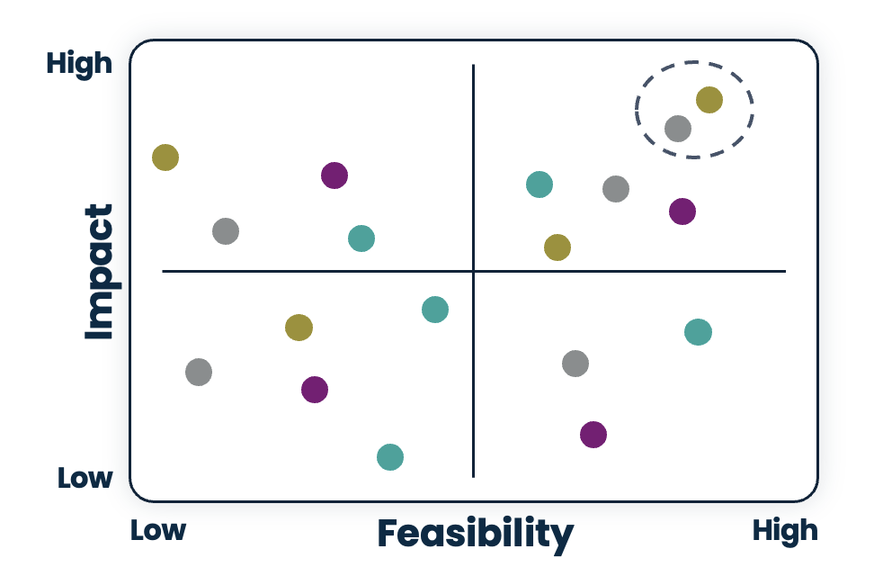
Figure 2. The Prioritized Use Cases Matrix

Impact
The potential impact of each use case was assessed based on four key metrics, ensuring we consider the full scope of benefits:
- Financial Outcome: We evaluated the use case's potential to drive tangible financial results, such as increasing revenue through new product offerings, reducing costs by automating tasks, or augmenting profit margins by optimizing resource allocation.

- Operational Efficiency: This metric focused on how the use case could streamline internal processes. This included the ability to do more with existing resources, accelerate workflows, enhance accuracy, reduce errors, and ensure on-time delivery of tasks.

- Strategic Alignment: We assessed how well each use case aligned with the company's broader strategic objectives. For example, a use case that helps a company grow its customer base or improves employee satisfaction would be highly rated in this category.

- Customer Experience: This metric measured the potential to enhance the customer journey. We considered how a use case could provide the right information at the right time and in the right channel, often using natural language interfaces to create a seamless and personalized experience.

Feasibility:
The practicality of implementing each use case was evaluated based on three critical factors, helping to identify potential roadblocks early on:
- Process Complexity: This factor involved a deep assessment of the business process. We looked at the number of steps, the complexity of business rules, the handling of exceptions, and the likelihood of the process changing over time. We also considered if the company has the right people and the number of people/roles involved.

- Integrations: We evaluated the technical effort required to connect the new AI solution with existing legacy systems. This included determining if new functionality or integrations would be necessary to ensure the use case could function effectively within the existing technology ecosystem.

- Data Availability: A critical component of feasibility was a review of data readiness. We assessed if the right data was available in the correct format and at the right time. This included both structured data (like databases) and unstructured data (like documents or images), and whether new data collection or creation would be required.

As a direct result of this prioritization exercise, an intense and productive debate unfolded among the participants of [Company Name] and the dataguru facilitators. This collaborative effort allowed for the deep exploration of each use case's potential impact and feasibility. Through rigorous brainstorming and thoughtful discussion, we collectively determined the most promising avenues for AI implementation. The outcome of this hard work is the following list of prioritized use cases, serving as a robust foundation for your future strategy.

Prirotized Use Cases:

Medical appointment reminder
A voice agent that makes automated calls to patients 48 hours in advance to confirm, reschedule, or cancel their appointments.
This intelligent voice agent automates appointment management, reducing no-shows and streamlining clinic operations. It proactively contacts patients 48 to 72 hours in advance to confirm, reschedule, or cancel their appointments.
How it Works:
- Appointment Retrieval: The voice agent first queries a Google Cloud Spanner table to fetch all upcoming appointments within the next 48 to 72 hours.
- Automated Patient Outreach: It then makes a series of automated calls to each patient, providing the essential details of their appointment: date, time, doctor, and medical center.
- Interactive Options: After providing the details, the agent prompts the patient to choose an action:
  - Confirm: If the patient confirms, the agent politely ends the call.
  - Cancel: If the patient chooses to cancel, the agent calls the cancel_appointment function. Once the system confirms the cancellation, the agent informs the patient of the successful change and ends the call.
  - Reschedule: If the patient wants to reschedule, the agent offers new available time slots by querying the Google Cloud Spanner table. It guides the patient through a brief conversation to find a new time, confirms the update, and ends the call.
This system ensures that the clinic's schedule is always up-to-date and that patients receive timely, convenient reminders.
Impact: High.
[Customer Name] is facing a significant challenge with last-minute appointment cancellations and no-shows. This lack of patient engagement leads to underutilized medical resources, a direct reduction in operating margins, and increased administrative overhead from manual follow-up calls.

Feasibility: High.
IT assets needed (access to the Google Cloud Spanner table and cancel_appointment API) are already in place and the workflow is easily deployable using AI. No impact in the current [Customer Name] Human Capital.

[NameofUseCase]
[Longdescriptionoftheusecase]

[NameofUseCase]
[Longdescriptionoftheusecase]

The entire session was a resounding success, marked by the participants' positive attitude, their active engagement, and the great ideas they contributed, leading to a set of valuable use cases poised for future implementation.

- Next steps

Building on the momentum and the clarity gained from the workshop, the next phase is to translate the prioritized use cases into tangible outcomes. This collaborative exercise has successfully provided a clear roadmap for your AI journey, identifying not only the most impactful use cases but also those with the highest feasibility. The objective now is to convert these high-priority opportunities into immediate quick wins, demonstrating the value of AI through practical implementation and accelerating your path toward broader business transformation.

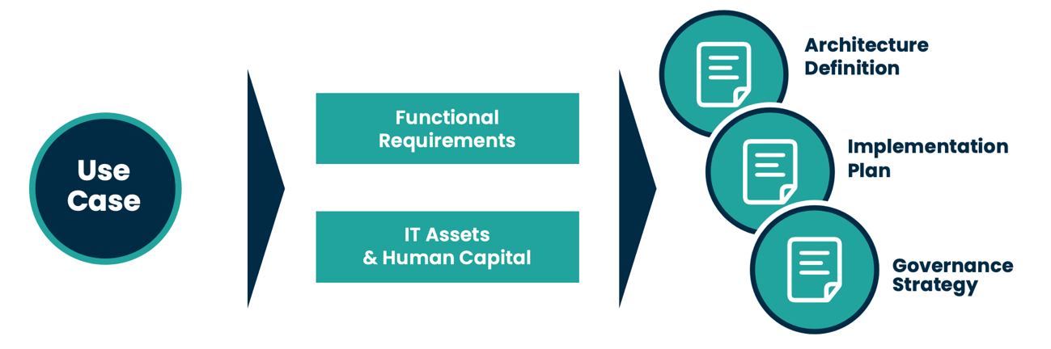 Figure 3. The Prioritized Use Cases Implementation

To achieve this, we propose a joint effort between dataguru and your organization, involving both the IT department and functional participants from your Lines of Business (LoBs). This collaborative team will focus on the following key areas:

- Detailed Functional Requirements: This is a crucial first step where we will collaboratively define the comprehensive functional requirements for each use case. This process goes beyond a simple high-level overview, diving deep to identify the specific business need to be solved, the key performance indicators (KPIs) to monitor the success of the use case, and a detailed workflow definition. We will meticulously document all human interactions with the system, whether they involve customers, providers, employees or other human-like Agentic systems. We will also document the system-to-system interactions, such as calls to ERPs, email services, task-oriented Agentic systems or third-party APIs. Finally, we will clearly outline the rules that govern the process's decision-making and the necessary exceptions to handle.

- IT Asset Assessment: A thorough assessment of your current IT assets is paramount. This will allow us to determine which existing systems and data can be leveraged and what new assets need to be implemented. A key part of this will be the process of "APIfying" existing legacy systems, making them accessible and usable within the new AI-driven workflows. This ensures that the new solutions can seamlessly integrate with your existing technology landscape.
We will also conduct a thorough assessment of your current corporate data to transform it into actionable, ready-to-use AI assets. This comprehensive process involves several key techniques, including data transformations to ensure cleanliness and consistency, as well as the creation of internal documentation regarding existing and new processes, policies, and other critical information. Furthermore, we will assess the need for and the integration of third-party data to augment your internal datasets, ensuring your AI Use Cases leverages the most complete and relevant information available. The goal is to ensure your data is a strategic asset, providing a robust foundation for the success of each implemented use case.

- Human Capital Assessment: We will conduct a comprehensive assessment of your current human capital to determine if you have sufficient in-house talent to support the implementation and ongoing management of the new AI solutions. This assessment will inform our recommendations, guiding whether to train your existing team to upskill or if new talent acquisition is required to fill any gaps.

The culmination of this collaborative process will be a comprehensive set of deliverables, including a well-defined IT Architecture for implementation, a detailed Implementation Plan that outlines the project timeline and resources, and a robust Governance Strategy to guide the project from initial deployment through the entire lifecycle of the implemented use case.

About dataguru

We are a premier Professional Services company, specialized in the design and implementation of cutting-edge technologies in Cloud, Data Analytics, and AI.
With a vision to lead the transformation of businesses worldwide through innovative solutions, we are committed to solving our clients' most complex challenges. Our mission is to design and implement bespoke Data Analytics and AI services, fostering a culture of leadership, innovation, collaboration, and continuous learning. We believe in leading the future with data and intelligence, offering a suite of modular, end-to-end services designed to meet your specific needs.

More information in www.dataguru.cloud

Annex 1: List of Participants

# Participants | Name | Surname | Company Role | email | Telephone
1 | xxx | Quintana | Controller | xxx@wellwo.es | xxx
2 | xxx | Pérez | CEO | xxx@wellwo.es | xxx
3 | xxx | Recio | COO | xxx@wellwo.es | xxx
4 | xxx | Molina | IT Manager | xxx@wellwo.es | xxx
5 | xxx | Román | Marketing | xxx.es@gmail.com | xxx
6 | xxx | Acua | Copy & Content | xxx@wellwo.es | xxx

Annex 2: Preparatory survey

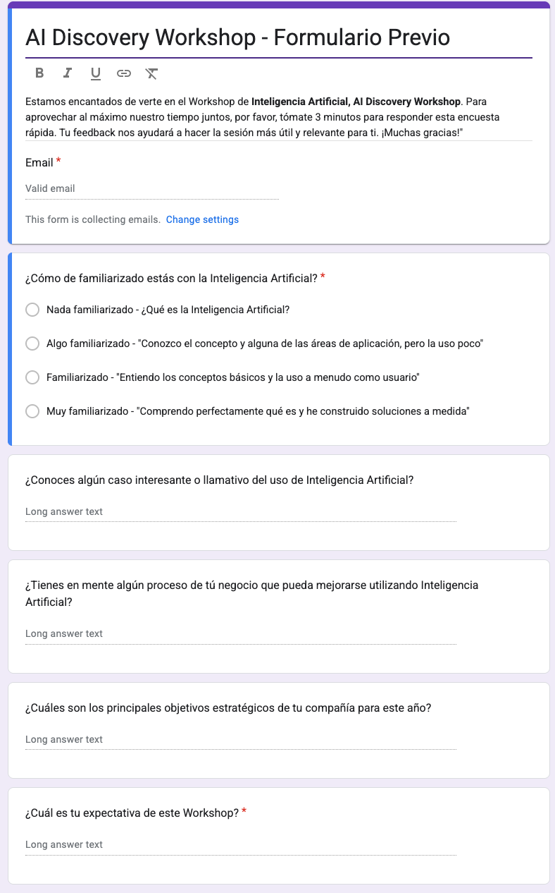

Annex 3.1: dataguru AI Business Leader - Ignacio Bañó

  Ignacio Bañó Oliva | Ignacio Bañó is an experienced leader in the technology sector, with a distinguished track record in business management and leadership.  Prior to Dataguru, Ignacio served for 4 years as Global Google Cloud Service Lead at SoftwareONE, where he was responsible for developing the Google Cloud business worldwide. During this period, he also served on the Google Cloud Global Partner Advisory Council, a group of key partners in charge of providing strategic feedback to Google Cloud on their partner initiatives.  In 2009, he founded Intelligence Partner, one of the first Spanish consultancies specializing in Cloud Computing technologies. Under his leadership, Intelligence Partner grew to become one of the leading Google Cloud business partners in Spain, the Middle East, and Latin America.  Previously, his career began at Microstrategy where he held several prominent positions over 10 years, including Country Manager of Spain and Portugal.  Ignacio is a Telecommunications Engineer from the Universitat Politècnica de Catalunya, holds a Master of Business Administration (MBA) from IESE Business School, and a Master Degree in Image Processing and Television Systems from Télécom Paris.

Annex 3.2: dataguru AI Business Leader - Jordi Simón

  Jordi Simón Martínez | Jordi Simon is an expert leader in Data Analytics and AI. He has a proven track record in driving strategic growth and leading high-performing sales teams within top-tier technology companies.  Prior to dataguru, he held director-level positions at Oracle for over 16 years, including Cloud Sales Director and Business Analytics Sales Director for Spain & Portugal, where he spearheaded initiatives in Cloud infrastructure, Business Analytics, and Big Data solutions. Prior to Oracle, he served as Country Manager at MicroStrategy, with full responsibility and leadership over sales, marketing, and professional services.  Jordi's expertise includes IA and ML, data management and data integration, data visualization and advanced analytics, SOA and BPM technologies, and Cloud Infrastructure. He possesses a solid experience in managing complex sales cycles, developing long-term relationships with key accounts, and implementing strategic transformational projects.  Jordi is a a Telecommunications Engineer from UPC, holds an MBA from IESE Business School, and a Master's Course in Electronic Engineering from Lancaster University (UK).

Annex 3.3: dataguru AI Business Leader - Roberto Miguez

  Roberto Miguez Martínez | Roberto Míguez is a technology leader with a strong track record in directing and managing IT services, specializing in areas such as Cloud Computing, Artificial Intelligence, Data Analytics, and Application Modernization.  Prior to dataguru, Roberto held leadership roles at SoftwareOne as Application, Data & AI Service Delivery Lead and Google Service Delivery Lead for Southern Europe, where he led the this service line, driving innovation and infrastructure modernization on Google Cloud, developing high-performance teams, and consolidating the company's position as a benchmark in digital transformation.  Previously, he was Chief Technical Officer (CTO) at Intelligence Partner for 7 years, where he directed the company's global technology strategy and led a team of over 50 specialists.  His career also includes experience at GFI Informática as Project Manager and Application Architect, where he drove digital transformation and technology architecture projects for leading companies.  Roberto is a Computer Engineer from the Autonomous University of Madrid, holds an EMBA from EAE Business School, and a CITIUS Postgraduate Program from FUE and the Autonomous University of Madrid.

About dataguru

We are a premier Professional Services company, specialized in the design and implementation of cutting-edge technologies in Cloud, Data Analytics, and AI.
With a vision to lead the transformation of businesses worldwide through innovative solutions, we are committed to solving our clients' most complex challenges. Our mission is to design and implement bespoke Data Analytics and AI services, fostering a culture of leadership, innovation, collaboration, and continuous learning. We believe in leading the future with data and intelligence, offering a suite of modular, end-to-end services designed to meet your specific needs.

More information in www.dataguru.cloud

