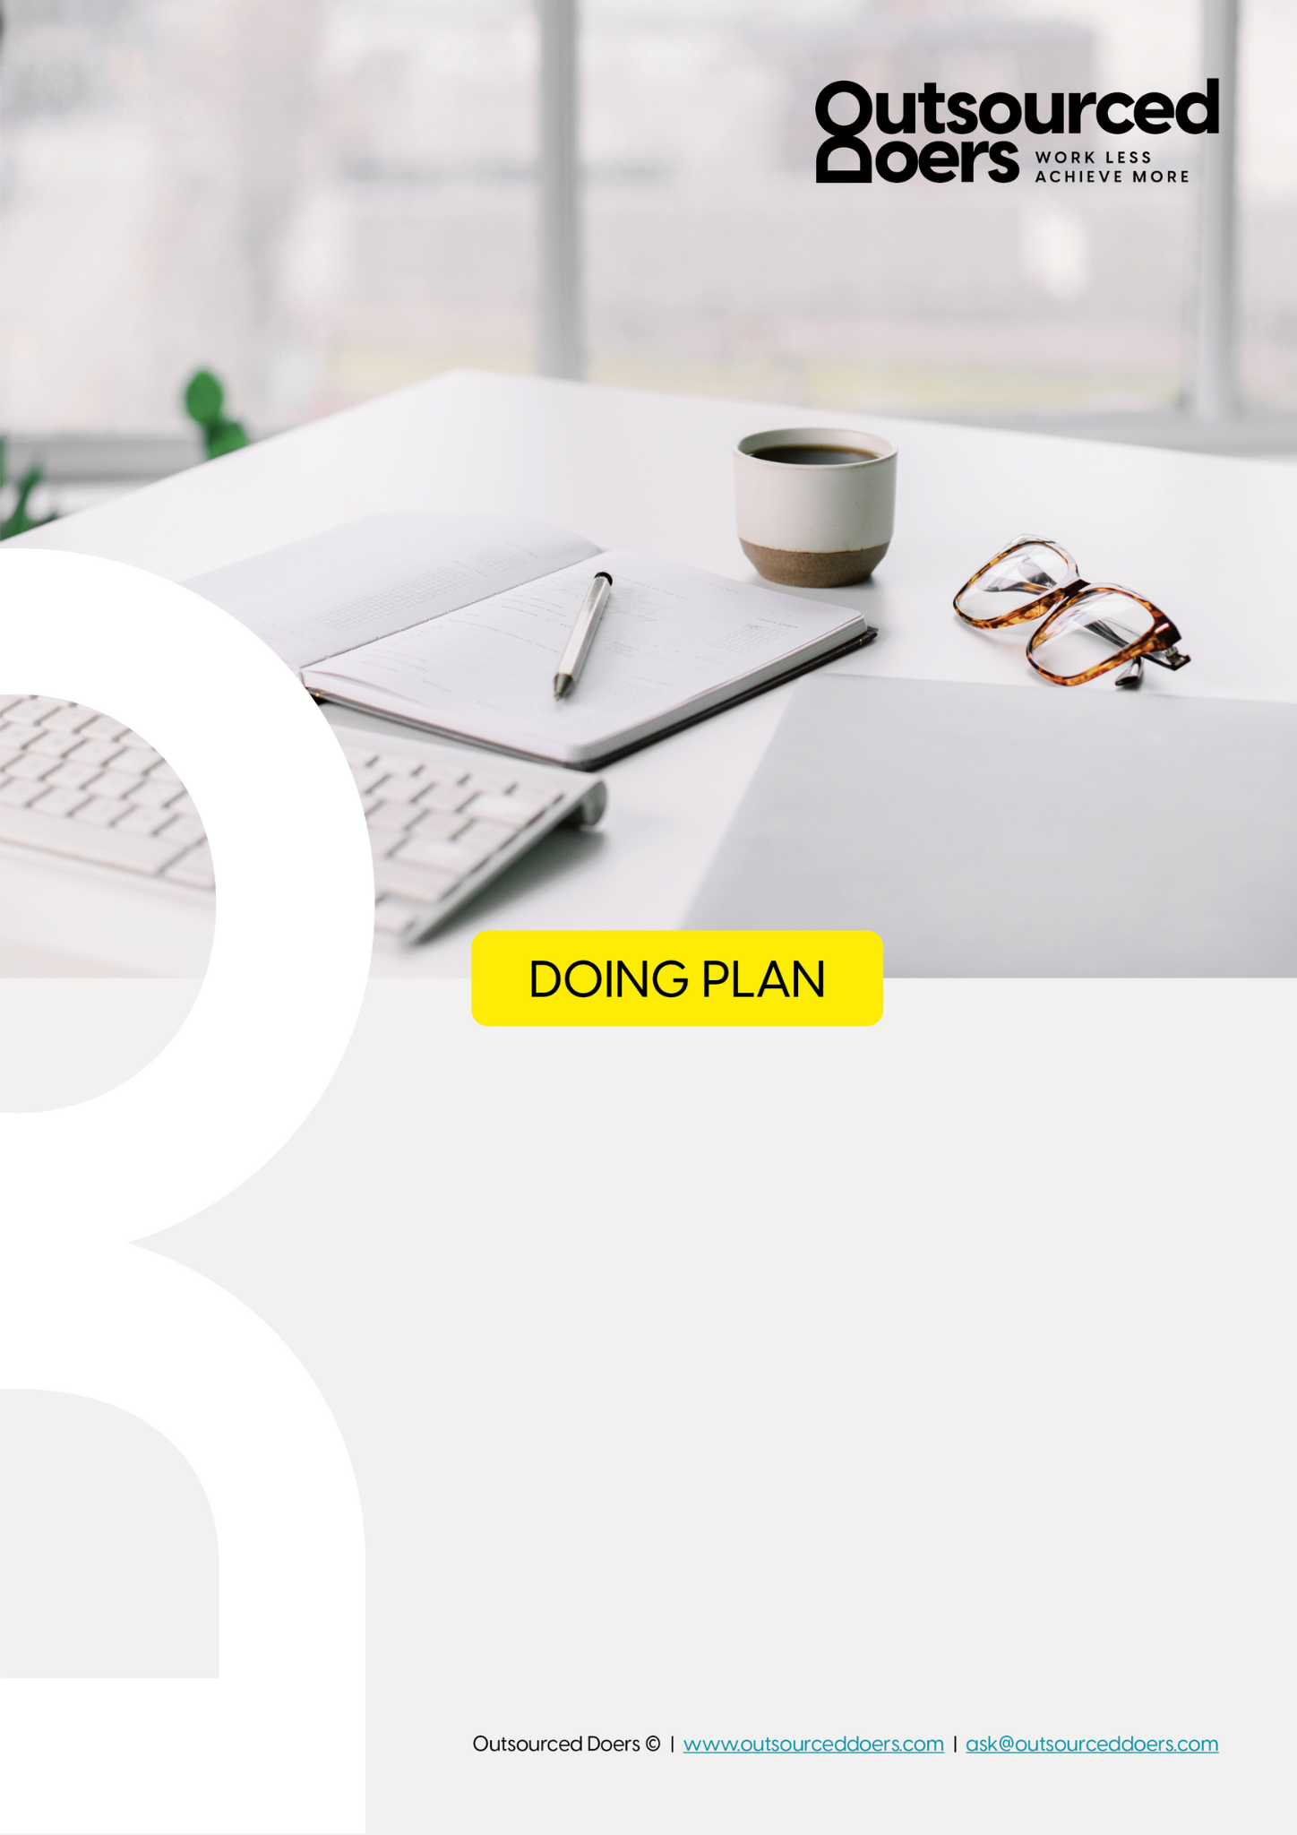

Craft Your Marketing Message

Purpose
It’s time to dismantle the misconception that the challenge lies in acquiring traffic. There are no traffic problems in today’s world, there are only message problems.

This Doing Plan equips you with the strategies and tools necessary to craft your very own unique marketing message. By the end of this Doing Plan, you’ll have a BIG idea for your messaging that you’ll use to stand out and cut through.

Outcome
A strategic, well-crafted and unique marketing message that will cut through the noise and attract your target audience. Being applied to your marketing will result in more leads, more revenue and more overall business growth.

Overview

# | Step Details | Who | Estimated Time | Link
#1 | ‘They Get Me’ Structure | Founder | 1 hour | Click
#2 | Core Desires | Founder | 30 mins | Click
#3 | Confirm Qualifiers | Founder | 30 mins | Click
#4 | Your Unique Angle | Founder | 30 mins | Click
#5 | The Big Idea | Founder | 30 mins | Click
#6 | Your Business Statement | Founder | 30 mins | Click
#7 | Gain Feedback + Adjust | Founder | 30 mins | Click

Step #1 - ‘They Get Me’ Structure

WHO: Founder

The first step when it comes to crafting your marketing message is to dive deep into the fears, frustrations, wants and dreams of your client.
This doesn't have to be complicated...
It is a one hour task with one goal:
"To understand your clients better than they understand themselves"
Right now, we're going to complete the ‘They Get Me’ Structure.

Whether you’re just starting out, or you’ve been doing your business for a while...
It’s always helpful to take a step back and really look at your message again, right!?
So I want to run you through a series of questions that will eventually help you shape (or reshape) that message...
But for now it’s all about getting into your client’s shoes and understanding them.
It also will help ignite more of that passion you have to see your client’s problems solved, thanks to your offer.

When you’re picturing your client avatar, answer these following questions. Try to be specific and don’t rush it...
Take time to braindump all of these words and emotions and feelings...
Force yourself to sit in that hole with them for at least 15 minutes and really articulate what they’re feeling.
Question 1: What is your client STRESSED about?
What keeps them up at night?
What are they trying to avoid?
What pressure are they feeling?
What is worrying them?

Q1 – What is your client stressed about?

What keeps them up at night
- Reliving traumatic moments from service or caregiving roles—scenes, sounds, and decisions looping over and over.
- Lying in bed with a racing mind, calculating the next day’s demands and worrying they won’t have the energy to get through.
- Feeling disconnected from their partner, kids, and friends, but not knowing how to repair those bonds.
- Anxiety about work performance, fearing mistakes or that they’re no longer “good enough.”
- The growing fear that burnout is permanent and they’ll never feel “normal” again.
- Worrying about finances—how to keep up with bills, retirement planning, and emergencies with little margin.

What they’re trying to avoid
- Facing their own emotions—choosing to numb out with scrolling, wine, or work instead of sitting in discomfort.
- Situations, people, or places that bring up painful memories (sirens, certain streets, specific dates).
- Conversations that require setting boundaries or asking for help for fear of being seen as “weak” or “a burden.”
- Looking in mirrors or at photos that reflect exhaustion or physical changes from stress.
- Taking breaks or slowing down, because rest feels unsafe and foreign.

What pressure they’re feeling
- Work Pressure: Constantly expected to overperform, be available, and carry more than their share in high-stress environments.
- Family Pressure: Managing kids, household responsibilities, and often single parenting—while being “the rock” for everyone else.
- Cultural Pressure: The unspoken rule that first responders and caregivers must be tough, unshakable, and self-sacrificing.
- Internal Pressure: Perfectionism, high self-expectations, and the belief that worth is tied to output.
- Time Pressure: No room for recovery between work, caregiving, and household duties—life feels like a constant sprint.

What is worrying them
- That their body is breaking down from years of running on adrenaline—chronic pain, insomnia, and fatigue becoming the norm.
- That they’re missing their children’s formative years by being emotionally and physically unavailable.
- That their career is unsustainable but they have no clear next step or plan B.
- That their relationships won’t survive their current state of burnout.
- That slowing down or seeking help will cause them to lose their identity, status, or the trust of those they serve.
- That even if they try to heal, nothing will actually change.

Voice-of-Client Phrases (Direct from Your Avatar)
- “I feel like I have to hold it all together for everyone else.”
- “If I slow down, I’m afraid everything will fall apart.”
- “Even when I’m home, I can’t switch off ‘work mode.’”
- “No one really understands what I’ve been through.”
- “I don’t deserve rest because I haven’t done enough yet.”
- “I can’t sleep without waking up tense or replaying my day.”
Question 2: What does this make your client FEEL?
Are they lonely, overwhelmed, ashamed, burned out, hopeless, trapped, ignored, frustrated, uncomfortable?
Remember too that I want you to dive deep into these. We don’t just write “they feel alone”...
Instead think “they’re lonely because they’re working really hard and have read so many parenting books but nothing’s worked. They feel like everyone else has it all together except for them.”
Really flesh it out.

Using the box below, jot down exactly where your ideal clients are, what their current state is.
Note: You should have at least 10 points in this section.

Ideal Clients Current State…

Q2 – What does this make your client feel?
- Lonely despite being surrounded by people
She’s in rooms full of coworkers, family, or friends but feels unseen. She can’t talk about what’s really going on because she fears judgment, pity, or the label “weak.” The people she loves most don’t fully understand the world she’s lived in, and that creates an invisible wall between them.
- Overwhelmed by constant demands
Every day feels like she’s being pulled in ten different directions—work deadlines, kids’ needs, household chores, financial worries. Even things that used to be enjoyable now feel like another box to check. She’s living in reaction mode, not creation mode.
- Ashamed for not being able to “handle it” anymore
She used to thrive under pressure, take pride in her ability to do it all, and now even small setbacks feel like a mountain. She compares herself to her old self and wonders if she’s lost her edge—or worse, if she’s broken.
- Burned out to the bone
It’s not just tired—it’s bone-deep exhaustion. No amount of sleep, caffeine, or vacation time seems to restore her energy. Even rest feels like work because her body doesn’t remember how to relax.
- Hopeless about the future
She can’t see a way out of this cycle. The idea of change feels overwhelming, and the thought that “this might just be my life now” creeps in more often than she’d like to admit.
- Trapped in an identity she no longer recognizes
She’s been the strong, dependable one for so long that she doesn’t know who she is without that role. The idea of letting go of that identity is terrifying, even if it’s killing her.
- Ignored and undervalued
At work, her contributions are expected, not appreciated. At home, her sacrifices go unnoticed because she’s set the bar so high for herself that others assume she can handle anything.
- Frustrated with her own body and mind
She’s snapping at people she loves, forgetting things, and feeling emotionally flat. Her body hurts in ways she can’t explain—tight shoulders, clenched jaw, stomach issues—and she’s frustrated that she can’t just “push through” like before.
- Uncomfortable in her own skin
She avoids mirrors and photos because she doesn’t want to see how tired she looks. She feels disconnected from her body, as though she’s living in it but not really inhabiting it.
- Guilty for not being “present enough”
Whether it’s zoning out during a conversation with her child or saying yes to an extra shift instead of a family event, she constantly feels like she’s failing someone. And that guilt weighs heavier than any physical exhaustion.
- Restless and anxious even in stillness
Quiet moments aren’t peaceful—they’re filled with intrusive thoughts, to-do lists, and flashes of memory she’d rather forget. Her nervous system is always braced for the next crisis.
- Afraid of being truly seen
She worries that if people see her cracks, they’ll think less of her—or worse, confirm her own fears that she’s not enough. So she keeps the mask on, even when it’s suffocating her.

Next, we’re going to brainstorm who the villains are in their story.
It’s important to note that your ideal clients can’t be to blame for where they are at the moment.
There has to be external influencers who are causing them to be where they are.
This might be industry guru’s or influencers or it might be widely accepted social norms etc.
Answering the following 2 questions will help provide clarity for this next section of the ‘They Get Me’ Structure.

Question 1: What are your client’s villains?
Just braindump some words for now - is it other providers in your market that frustrate your client that you want to stand against?
Is it culture, norms, pressures, expectations?
Is it their family, friends etc?
Is it their corporate boss?
Note: It’s best not to personally identify people or businesses, but speak to them more generically.

Client’s Villains
- Culture of Overwork & Self-Sacrifice
The “always on” expectation in first responder and caregiving professions, where rest is seen as weakness and self-care is dismissed as selfish.
- High-Pressure Workplace Systems
Staffing shortages, mandatory overtime, unrealistic performance expectations, and leadership that prioritizes productivity over well-being.
- Toxic Hero Narrative
The belief that “strong” people should handle anything without complaint, perpetuated in service industries and reinforced by peers.
- Unspoken Trauma Culture
A systemic lack of mental health support in high-stress jobs; trauma is normalized, brushed aside, or “dealt with” in unhealthy ways.
- Perfectionism & Achievement Addiction
Industry and cultural messaging that worth is tied to output, efficiency, and flawless performance.
- The Martyr Mother Standard
Societal expectations that mothers (especially single mothers) should prioritize children above all else, even at the cost of their health.
- “Hustle” & Grind Culture
Social media glorification of constant productivity, busyness, and side-hustles—making slowing down feel shameful.
- Financial Insecurity & Systemic Gaps
Pension, benefits, and disability systems that make stepping back from work risky, creating pressure to “push through” no matter the cost.
- Unrealistic Wellness Messaging
Quick-fix self-care advice (“take a bubble bath and you’ll be fine”) that trivializes deep, systemic burnout and trauma.
- Isolation by Design
Shift work, long hours, and unpredictable schedules that disconnect her from friends, family, and community support.
- Family & Social Misunderstanding
Well-meaning but dismissive comments like “Just take a vacation” or “You’re strong, you’ll get through it,” which make her feel unseen.
- Fear-Driven Leadership
Supervisors who use intimidation, scarcity, or guilt to push employees harder, reinforcing the cycle of burnout.
- Medical System Time Limits
Short, impersonal appointments and symptom-focused treatment instead of holistic, trauma-informed care.
- Silent Competition in the Ranks
Peer pressure to never be the “weak link,” which discourages vulnerability and support-seeking.
- Invisible Emotional Labor
The unacknowledged, constant energy output required to keep relationships, households, and teams functioning.
Question 2: What angles could you take to throw rocks at these villains?
Flesh out these villains a little more by writing down the specific pain that they’re causing your market.
Who or what is causing them to be stuck in their problem?
What’s something or someone they’re forced to interact with that’s difficult to manage or understand?
What features or industry issues do they regularly complain about in related programs/services?
Using the box below, brainstorm who their villains are and define the negative impact they are having on your market.
Note: You should have at least 10 points in this section.
Who are the villains and what is their influence

Angles to Throw Rocks at the Villains
- Culture of Overwork & Self-Sacrifice
Pain: Forces them to wear burnout like a badge of honor. Makes slowing down feel like failure. Conditions them to believe their needs come last, so they run on fumes for years.
- High-Pressure Workplace Systems
Pain: They’re caught in an impossible cycle — more work with fewer resources. Leadership pushes quotas and “productivity” at the expense of mental and physical health, leaving them in survival mode 24/7.
- Toxic Hero Narrative
Pain: Trains them to swallow pain, grief, and trauma to “stay strong” for others. Punishes vulnerability. Makes it unsafe to say, “I need help.”
- Unspoken Trauma Culture
Pain: Traumatic calls, cases, or experiences are treated as “part of the job,” with no real outlet to process. Creates a silent, festering emotional wound that worsens over time.
- Perfectionism & Achievement Addiction
Pain: Sets an unattainable bar that only gets higher the harder they work. Leads to chronic self-criticism and the inability to celebrate wins or rest without guilt.
- The Martyr Mother Standard
Pain: Society praises mothers who sacrifice everything, yet offers no real support. Creates guilt for even wanting time away from kids to heal, and shame for not “enjoying every moment.”
- “Hustle” & Grind Culture
Pain: Social media glorifies burning out for success. Makes them feel behind or lazy if they aren’t constantly achieving, even when their bodies and minds are screaming for rest.
- Financial Insecurity & Systemic Gaps
Pain: The systems meant to support them (pension, disability, insurance) are slow, complicated, or unreliable. Forces them to stay in unhealthy environments out of financial fear.
- Unrealistic Wellness Messaging
Pain: Mainstream wellness spaces push surface-level self-care tips that feel insulting to women carrying trauma and exhaustion. They’ve tried these “quick fixes” and felt even more broken when they didn’t work.
- Isolation by Design
Pain: Shift work, long hours, and unpredictable schedules slowly cut them off from the people and activities that once filled their cup. They feel forgotten and disconnected, even in their own homes.
- Family & Social Misunderstanding
Pain: Friends and family can’t relate and offer platitudes like “Just take a vacation” or “It’ll get better,” which only deepen the sense of isolation and being misunderstood.
- Fear-Driven Leadership
Pain: Supervisors use guilt, intimidation, or scarcity to push harder, making it unsafe to voice concerns or ask for time off without retaliation.
- Medical System Time Limits
Pain: Traditional healthcare treats symptoms in 10-minute appointments, ignoring the root cause — chronic stress, trauma, and nervous system dysregulation.
- Silent Competition in the Ranks
Pain: Creates an environment where vulnerability is equated with incompetence. No one admits they’re struggling, which makes everyone feel like they’re the only one barely holding on.
- Invisible Emotional Labor
Pain: The constant, unacknowledged effort of managing emotions — their own and everyone else’s — drains them daily. They carry the mental load for their family, workplace, and community with no relief.

Lastly, it’s time to dive into their Brand New Day.
This is where we are going to define what it is exactly that your ideal clients wants.
Knowing where your clients are trying to get to is critical to ensure that you are able to help them get there.
Use the following questions to help you get clear on what this brand new day looks like for your ideal clients.

Question 1: What are your client’s WANTS?
What is the result that they want your business to provide for them?
What is that outcome that they desperately want help to get to?
What do they want for themselves?
What do they want for the people around them?
What do they aspire to be?
What are their “secret” desires?

Q1 – What Your Client Wants (Their Brand New Day)
- To Feel Like Herself Again
She wants to wake up without dread in her chest, with enough energy to enjoy her morning coffee, greet her kids, and look forward to the day ahead. She wants the calm, confident, grounded version of herself back.
- Emotional Stability & Peace
She craves the ability to handle life’s curveballs without melting down, snapping, or shutting down. She wants to trust her own reactions and feel in control of her emotions again.
- A Regulated Nervous System
She wants the internal safety that allows her to rest, laugh, and be fully present — not just run on autopilot. She wants to feel her body exhale and stay there.
- Real Connection
She dreams of deep, authentic relationships where she can be herself without the mask — people who understand her without her having to explain every detail.
- A Stronger Bond With Her Kids
She wants to be more patient, present, and playful. She longs to make memories without the constant shadow of exhaustion and irritability.
- Health That Feels Sustainable
She wants to sleep through the night, have energy during the day, feel good in her body, and see herself in the mirror without flinching.
- Clarity & Purpose
She wants to know what’s next for her beyond the job title or caregiving role — something that excites her and feels aligned with her values.
- The Confidence to Set Boundaries
She wants to be able to say “no” without guilt, protect her energy, and create space for herself without fearing judgment or backlash.
- Freedom From Guilt & Self-Criticism
She wants to believe she’s doing enough — to stop replaying mistakes or questioning if she’s failing the people she loves.
- Time for Joy & Creativity
She wants to hike, paint, read, or simply sit in the sun without feeling like she’s stealing time from something “more important.”
- To Model Wellness for Others
She wants to show her kids, peers, and community that it’s possible to thrive after burnout — that strength includes rest and self-care.
- Financial & Emotional Stability
She wants to feel secure in her future — enough to step away from unhealthy environments and invest in her own growth without fear.
- A Sense of Hope
She wants to believe that her best days aren’t behind her — that this next chapter will be lighter, freer, and more fulfilling than the one before.
- Her Own Community of Belonging
She wants a supportive circle that she can lean on — women who remind her she’s not alone and cheer for her wins.
- To Stop Surviving and Start Living
At her core, she wants to feel fully alive again — engaged, connected, joyful, and able to handle life without being consumed by it.
Question 2: What are your client’s NEEDS?
You know what your client wants, but what do they actually NEED in order to get there?
Using the box below, brainstorm your ideal clients wants and needs.
Note: You should have at least 10 points in this section.

Q2 – What Your Client Needs
- A Safe, Judgment-Free Space to Slow Down
She needs to step away from the environment that’s been keeping her in survival mode so her body and mind can reset without pressure or expectations.
- Nervous System Education & Regulation Tools
She needs to understand why she feels the way she does and have simple, daily practices (breathwork, somatic movement, grounding) to keep her system in balance.
- Guided Emotional Processing
She needs a way to work through trauma, guilt, and shame safely — using trauma-informed practices like Internal Family Systems (IFS) so she can release old patterns.
- Rest That Feels Safe
She needs to re-train her body to feel okay in stillness without the anxiety or restlessness that’s made rest uncomfortable.
- Authentic Connection & Support
She needs a trusted community of women who “get it” so she can share openly, receive encouragement, and not feel alone in her journey.
- Clear Boundaries & Communication Skills
She needs to learn how to say no, set limits, and protect her energy without guilt or fear of disappointing others.
- Daily Structure & Habits That Support Healing
She needs consistent, realistic routines for sleep, nutrition, movement, and mental well-being that fit her life instead of adding pressure.
- Permission to Put Herself First
She needs validation that her needs are worthy of time, energy, and resources — without having to justify them.
- Reconnection to Her Body
She needs to learn to listen to her body’s signals, respond with care, and rebuild trust with herself.
- Clarity About Her Next Chapter
She needs space, tools, and guidance to rediscover her purpose and set goals that excite and inspire her.
- Integration Support After the Breakthrough
She needs ongoing accountability and coaching to ensure that the insights from retreats and workshops translate into lasting change.
- Healing on Multiple Levels
She needs physical restoration, emotional release, mental clarity, and spiritual alignment — not just a one-dimensional “fix.”
- Freedom From the “Strong One” Identity Trap
She needs to unlearn the belief that her worth is tied to how much she can endure and start embracing strength in rest and vulnerability.
- Practical Tools for Crisis Moments
She needs quick, on-the-go strategies to ground herself during triggering situations at work or home.
- Opportunities for Creativity & Play
She needs outlets (art therapy, nature time, movement) that bring joy and allow self-expression without pressure or performance.

Step #2 - Core Desires

WHO: Founder

Now it's time to get very clear on the specific Core Desires your market wants to achieve.
You’re going to want to start pulling out the most important core desires...
For example at Outsourced Doers, our client's core desires are:
- Work less hours
- Build a team affordably
- Launch new products and marketing campaigns
- Only do the tasks she's good at and enjoys
- Convert more clients
- Grow her revenue
So, what are your market's core desires?
You’ll want to get as specific as you can and try to brainstorm 5-7 core desires in the box below.
Feel free to draw inspiration from the last section in the ‘They Get Me’ Structure too.
Insert Core Desires

Core Desires – Rekindled Retreats Client
- Feel Calm, Centered, and In Control
Experience a regulated nervous system so they can respond to life instead of reacting from stress or survival mode.
- Be Fully Present in Their Relationships
Show up patient, connected, and emotionally available for their kids, partner, and friends without being distracted by burnout.
- Reclaim Energy and Vitality
Wake up rested, energized, and ready to engage in the day without relying on caffeine, adrenaline, or sheer willpower.
- Live Authentically Without the “Strong One” Mask
Drop the need to constantly perform strength and instead live from a place of self-trust, vulnerability, and inner peace.
- Have a Sustainable Self-Care & Resilience Plan
Maintain consistent habits and boundaries that protect their energy and well-being long after the retreat or program ends.
- Find a Community That Truly Gets Them
Belong to a supportive network of women who understand their experiences, offer encouragement, and walk alongside them in healing.
- Rediscover Joy, Purpose, and Creativity
Feel excited about life again, pursue passions, and create a future that aligns with their values and desires.

Step #3 - Confirm Qualifiers

WHO: Founder

Before we get to the final step, there's one more thing we need to be able to formulate your Big Idea...
You've got your list of core desires that your market wants...
But there are criteria attached that we need to be sure to talk about.
Sure, they want the core desires...
But they need to achieve these with or without certain criteria...
I call these qualifiers.

So, to complete this for the Must-Avoid column, I like to think of each core desire...
Then add the word "Without..." and finish the sentence.
For example, at Outsourced Doers in the “Must-Avoids”, I'd write:
- I want to launch new products and marketing campaigns…
  - without getting overwhelmed by tech
- I want to grow my revenue…
  - without spending a fortune on consultants or agencies
  - without drowning in all the admin
  - without neglecting my clients
For the Must-Have column, just do the opposite and think of some of the core values...
Then add the word "with..." and finish the sentence.
For example, for "Must Haves" I'd write:
- I want to do what I'm good at and enjoy
  - with confidence other things are being done well
- I want to work less hours
  - with more revenue being generated

Use the boxes below to brainstorm a list of 3-4 ‘Must Haves’ and 3-4 ‘Must Avoids’ that are non-negotiable criteria that your market have when considering their core desires.

must Avoid
What are the things your client needs to avoid in achieving their transformation?

Must Have
What are the non-negotiables that your client must be able to have/keep in achieving their transformation?
Must Avoids
(They want their transformation without these pitfalls)
- Without sacrificing their family or personal time
They want to heal without disappearing from their kids’ lives or missing precious moments.
2. Without adding another overwhelming “to-do” list
No complicated programs or rigid schedules that make life feel even heavier.
3. Without being judged or misunderstood
They don’t want to be in spaces where they have to explain or defend their struggles.
4. Without feeling like it’s “just another quick fix”
They want lasting change, not a temporary high that fades after the retreat ends.
Must Haves
(They want their transformation with these essential supports)

With a safe, judgment-free environment
They must feel seen, heard, and supported by people who truly “get it.”

With tools they can actually use in real life
Simple, adaptable practices they can integrate into busy days, not just during the retreat.

With genuine community connection
They want ongoing relationships and check-ins that extend beyond the event itself.

With space for rest and self-discovery
Time to reflect, reset, and explore what they really want for their next chapter.

Step #4 - Your Unique Angle

WHO: Founder
Before we are able to finish off your Big Idea, we need one more thing:
A creative, unique angle.
This is something that we will use to capture people's attention...
And get them to turn their heads and listen to you!
It will help us build a better funnel and achieve higher conversion rates...
Needless to say - it's important!
There are some great ways to find a unique angle, but first, you need to be clear on your keyword or what you help people do.

The best way to discover this is to think about what your client would search for in Google to find you...
For example at Outsourced Doers it would be:
- Virtual Assistant;
- Outsourcing
- Growing a team
Once you've got 1-3 keywords brainstormed, it's time to jump into a new browser and get big idea inspiration!

There are 4 main ways to do this:
- Go to news.google.com and type in your keyword do
- Search your keyword + statistics
- Search your keyword + research study
- Search your keyword + crazy story
For example, for Outsourced Doers, when you go to news.google.com and type in "virtual assistant", these were some results:
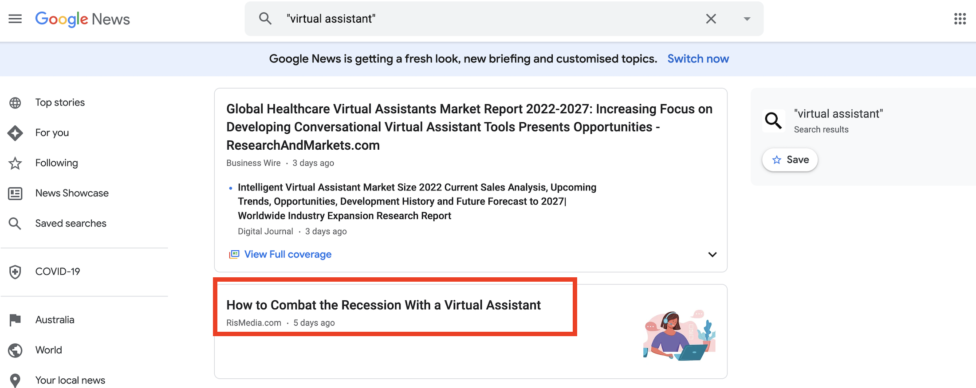

This is a great angle...
With many potential clients worried about recessions, it's super important keep business costs low and virtual assistants have never looked so attractive.
Great angle.

Or in Google when typing in Virtual Assistant Statistics...
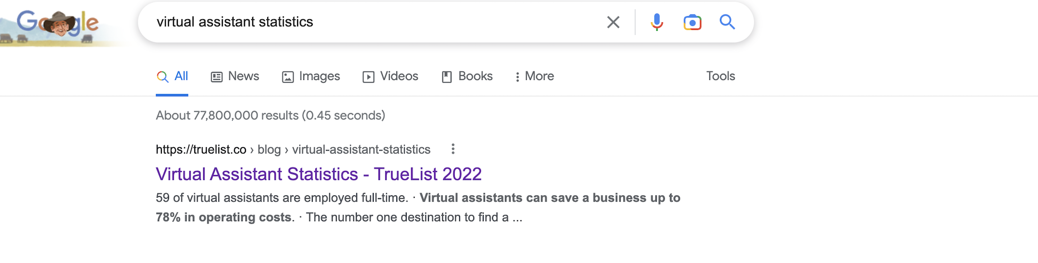
You'll see that statistic from a research study saying businesses "save up to 78% on operating costs"...
So it looks like there's more data supporting that recession-proofing angle...
Or just a general "start-up growth on a budget" angle.

I love these searches as they get the creative juices flowing...
And will help you brainstorm a huge list of different angles or unique approaches you can take in your market.
Once you've researched Angles for about 20-30 minutes...
Choose the most unique and enticing angle from your list and you're ready for the final step!

Let’s get started…
Open a new tab to start researching with news.google.com and Google search to identify a unique angle that will stand out in your market.
Use the box below to list out the different angles you discovered in your research
Insert Unique Angle / Hooks

Unique Angles to Stand Out

1. The Embodied Shift — Healing Anxiety from the Body, Not the Mind
Recent coverage highlights how anxiety is fundamentally a physical, not just cognitive, experience. Breathwork, body-based therapies, and somatic practices are now grounded in neuroscience—and gaining mainstream credibility.
Instagram+4vikarawellness.com+4vikarawellness.com+4The Australian
Angle Idea:
“Healing starts in your body—not your head.”
Lead with body-first healing as more authoritative and science-backed than just “mindset work.”

2. Rewild Your Nervous System with Nature + Somatics
Studies show that retreating into nature—paired with tools like extinction diets, TRE, breathwork, and qigong—supports real nervous system restoration.
Condé Nast Traveler
Angle Idea:
“Rewild your system: Nature isn’t just a backdrop—it’s your healing landscape.”
Emphasize nature immersion as integral to transformation rather than a luxury setting.

3. Avoiding the Wellness Dark Side
Wellness retreats are booming, but there’s growing scrutiny around practices that trigger trauma, foster cult-like environments, or are run by unqualified leaders. Safety and integrity are now central.
vikarawellness.com+4Wikipedia+4People.com+4The Times
Angle Idea:
“Healing without the hype—or harm.”
Be the trauma-informed, trustworthy alternative that clients can truly rely on.

4. Shaking Medicine + Somatic Release as Reset
Vikara Wellness is offering “Shaking Medicine” retreats—a visceral, body-led reset that differs dramatically from passive relaxation.
supyoadventures.com+3vikarawellness.com+3Wikipedia+3vikarawellness.com+1
Angle Idea:
“Let your body shake it off—literally.”
Highlight full-body release as a raw, effective way to reset—from the inside out.

5. Power of Retreat Immersion to Rewire Your Brain & Body
Retreats foster nervous system rewiring, emotional clarity, and behavioral shifts—but only when they go beyond surface-level relaxation.
Wikipedia+15Bay Area CBT Center+15People.com+15
Angle Idea:
“Rewire your life—through deep immersion, not quick fixes.”
Position your retreats as transformational immersion, with long-term impact.

6. Somatic Healing with Real Impact: PTSD Recovery Stats
Somatic therapies have shown to significantly reduce trauma symptoms—even PTSD—in many participants after regular sessions.
WikipediaWikipedia
Angle Idea:
“Somatic healing that works: Most participants report real relief—often in one session.”
Stand behind the effectiveness and promise of embodied healing.

7. Integrity in Healing Spaces: The Missing Piece
Retreats powered by integrity, certification, and authentic guidance stand out—especially in a field with growing concerns about unregulated healing spaces.
The Times+1
Angle Idea:
“Healing anchored in integrity.”
Be the retreat that prioritizes ethical, certified, trauma-informed leadership.

The Most Distinct & Resonant Angle:
“Healing starts in your body—not your head.”
Why this works:
- Bridges science and somatic healing—distinguishes you from purely psychological or spiritual offerings.
- Instantly hooks people exhausted by “mindset-only” approaches.
- Aligns with deep transformation, nervous system regulation, and embodied presence.

Step #5 - The Big Idea

WHO: Founder

Ok, it's time to turn all of your hard work into a Big Idea - this is the fun step!

Your Big Idea is going to consist of 3 parts:
- Did You Know That... [Insert Your Angle]
- Which Means... [Insert Your Core Desire + Qualifier]
- And therefore, you must... [Call-To-Act: Lead Magnet]
We'll dive into your Lead Magnet in another Doing Plan, so you don't need to worry about that yet, but we've already got steps 1 & 2 sorted!

Based on the examples I've been using for Outsourced Doers, my 3 parts might be:
- Angle: Virtual Assistants let you grow in a recession
- Core Desire + Qualifier: Grow an affordable team, launch new projects, grow revenue + avoid consultants/agencies
- Call To Action: Download free guide: "Top 10 Things All Online Coaches must Outsource"

And when you put it all together, my Big Idea could be:
- Did you know that: with looming recessions, running your business at low cost is essential to make sure your business survives and thrives…
- Which means: now is the time to build an affordable team so you can launch new projects and grow your revenue without spending a fortune on expensive consultants and agencies…
- And therefore you must: download my free guide on the Top 10 Things you can outsource in your coaching business to grow your revenue while working less!
Time for you to pull together your chosen angle, core desire and qualifier to create your Big Idea
Did you know that…
[Insert your unique angle]
Which means…
[Insert your core desire + qualifier]
And therefore you must…
[Insert Call-to-action for Lead Magnet (if you know it)]

1. Emotional Connection Angle
Did you know that…
the real transformation of a retreat isn’t just what happens while you’re there—it’s the tools, connections, and support you bring home that keep you growing for life?
Which means…
you can finally feel anchored, supported, and connected every day without slipping back into old habits or feeling alone—and with a community that walks beside you long after you leave.
And therefore you must…
join the Ultimate Retrieval of Self Retreat—where the breakthrough is just the beginning, and the integration lasts a lifetime.

2. Science + Sustainability Angle
Did you know that…
lasting nervous system regulation happens when body-based practices are woven into your daily life—and that’s only possible with ongoing support?
Which means…
you can retrain your body and mind for calm, energy, and presence without the “retreat high” fading in weeks—and with the lifelong integration coaching, tools, and relationships that make change stick.
And therefore you must…
experience the Ultimate Retrieval of Self Retreat—and return home with a roadmap, practices, and people who keep you supported for the long haul.

3. Urgent Invitation Angle
Did you know that…
most retreats give you a weekend escape—but don’t give you the tools to transform your life after you leave?
Which means…
you can break that cycle, finding the deep connection you’ve been searching for without going home to the same patterns—and with a lifelong circle and proven practices you’ll use every day.
And therefore you must…
claim your spot at the Ultimate Retrieval of Self Retreat—where your healing continues long after you pack your bags.

Step #6 - Your Business Statement

WHO: Founder

Ok, in order to better help your Doer with creating different copy drafts in the future, it’s important to detail who you help and what you do for them in a clear, simple and strategic way.
The structure will be either:
My business helps ____[WHO]____ to ____[GOAL]____
OR
My business provides ____[WHAT]____ to ____[WHO]____
For example:
- My business helps female entrepreneurs to build a profitable, lifestyle business
- My business helps time-poor, burned-out business owners to outsource with a Virtual Assistant
- My business provides nutrition coaching to people with a gluten intolerance
- My business provides accounting services to tradespeople and contractors
Enter your Business Statement below - be clear and specific:
Insert Business Statement

Original Statement
My business helps women recovering from burnout, trauma, and life transitions to regulate their nervous system, rediscover themselves, and build lasting connection through immersive retreats, somatic practices, and lifelong community support.

Emotional Tone
My business helps women who feel disconnected, exhausted, and unseen to reclaim their sense of self, feel safe in their own body again, and find a lifelong circle of support through transformative retreats and everyday integration tools.

Professional Tone
My business provides trauma-informed retreats, nervous system regulation programs, and ongoing integration coaching to women seeking sustainable recovery, personal growth, and a supportive community network.

Step #7 - Gain Feedback + Adjust

WHO: Founder

Ok, it's time to head on over to the Facebook group and share the work you’ve done here with your Doing Incubator coaches.
Their insight and know-how help fine-tune every piece of your message, ensuring it grabs your target audience's attention and packs a real punch.
This part of the process is about perfecting your message.
The goal?
A clear, captivating message that genuinely showcases the awesome value you bring.
It's also about positioning your business in a way that fosters trust and creates a connection with your audience.
Remember, feedback isn't a sign of doubt, it's a stepping stone to a marketing message that not only stands out from the crowd, but also drives powerful results for your business.
After all, an on-point message means more engagement, stronger relationships with clients, and ultimately, a thriving business.
Be sure to tag the relevant marketing message coach, so that they can review and provide you with feedback.

