Supplement Re-branding: New Bottle Design
We want to rebrand our current health supplements (see below). We do want it to be modern, vibrant and appealing supplement bottles. Very upscale and elegant as it targets primarily women.
Bottle size: We are totally open to the bottle size and shape, as long it's a typical supplement bottle size to handle 90-120 capsules; what we mostly need is new bottle design/packaging. YOU DON’T HAVE TO USE THE CURRENT WHITE BOTTLE SHAPE, BUT ANYTHING MORE MODERN WOULD WORK!
Current bottles: So ideally, we’d keep the core color on each bottle with a new branding and bottle design. But we're open to your suggestion. Current colors:
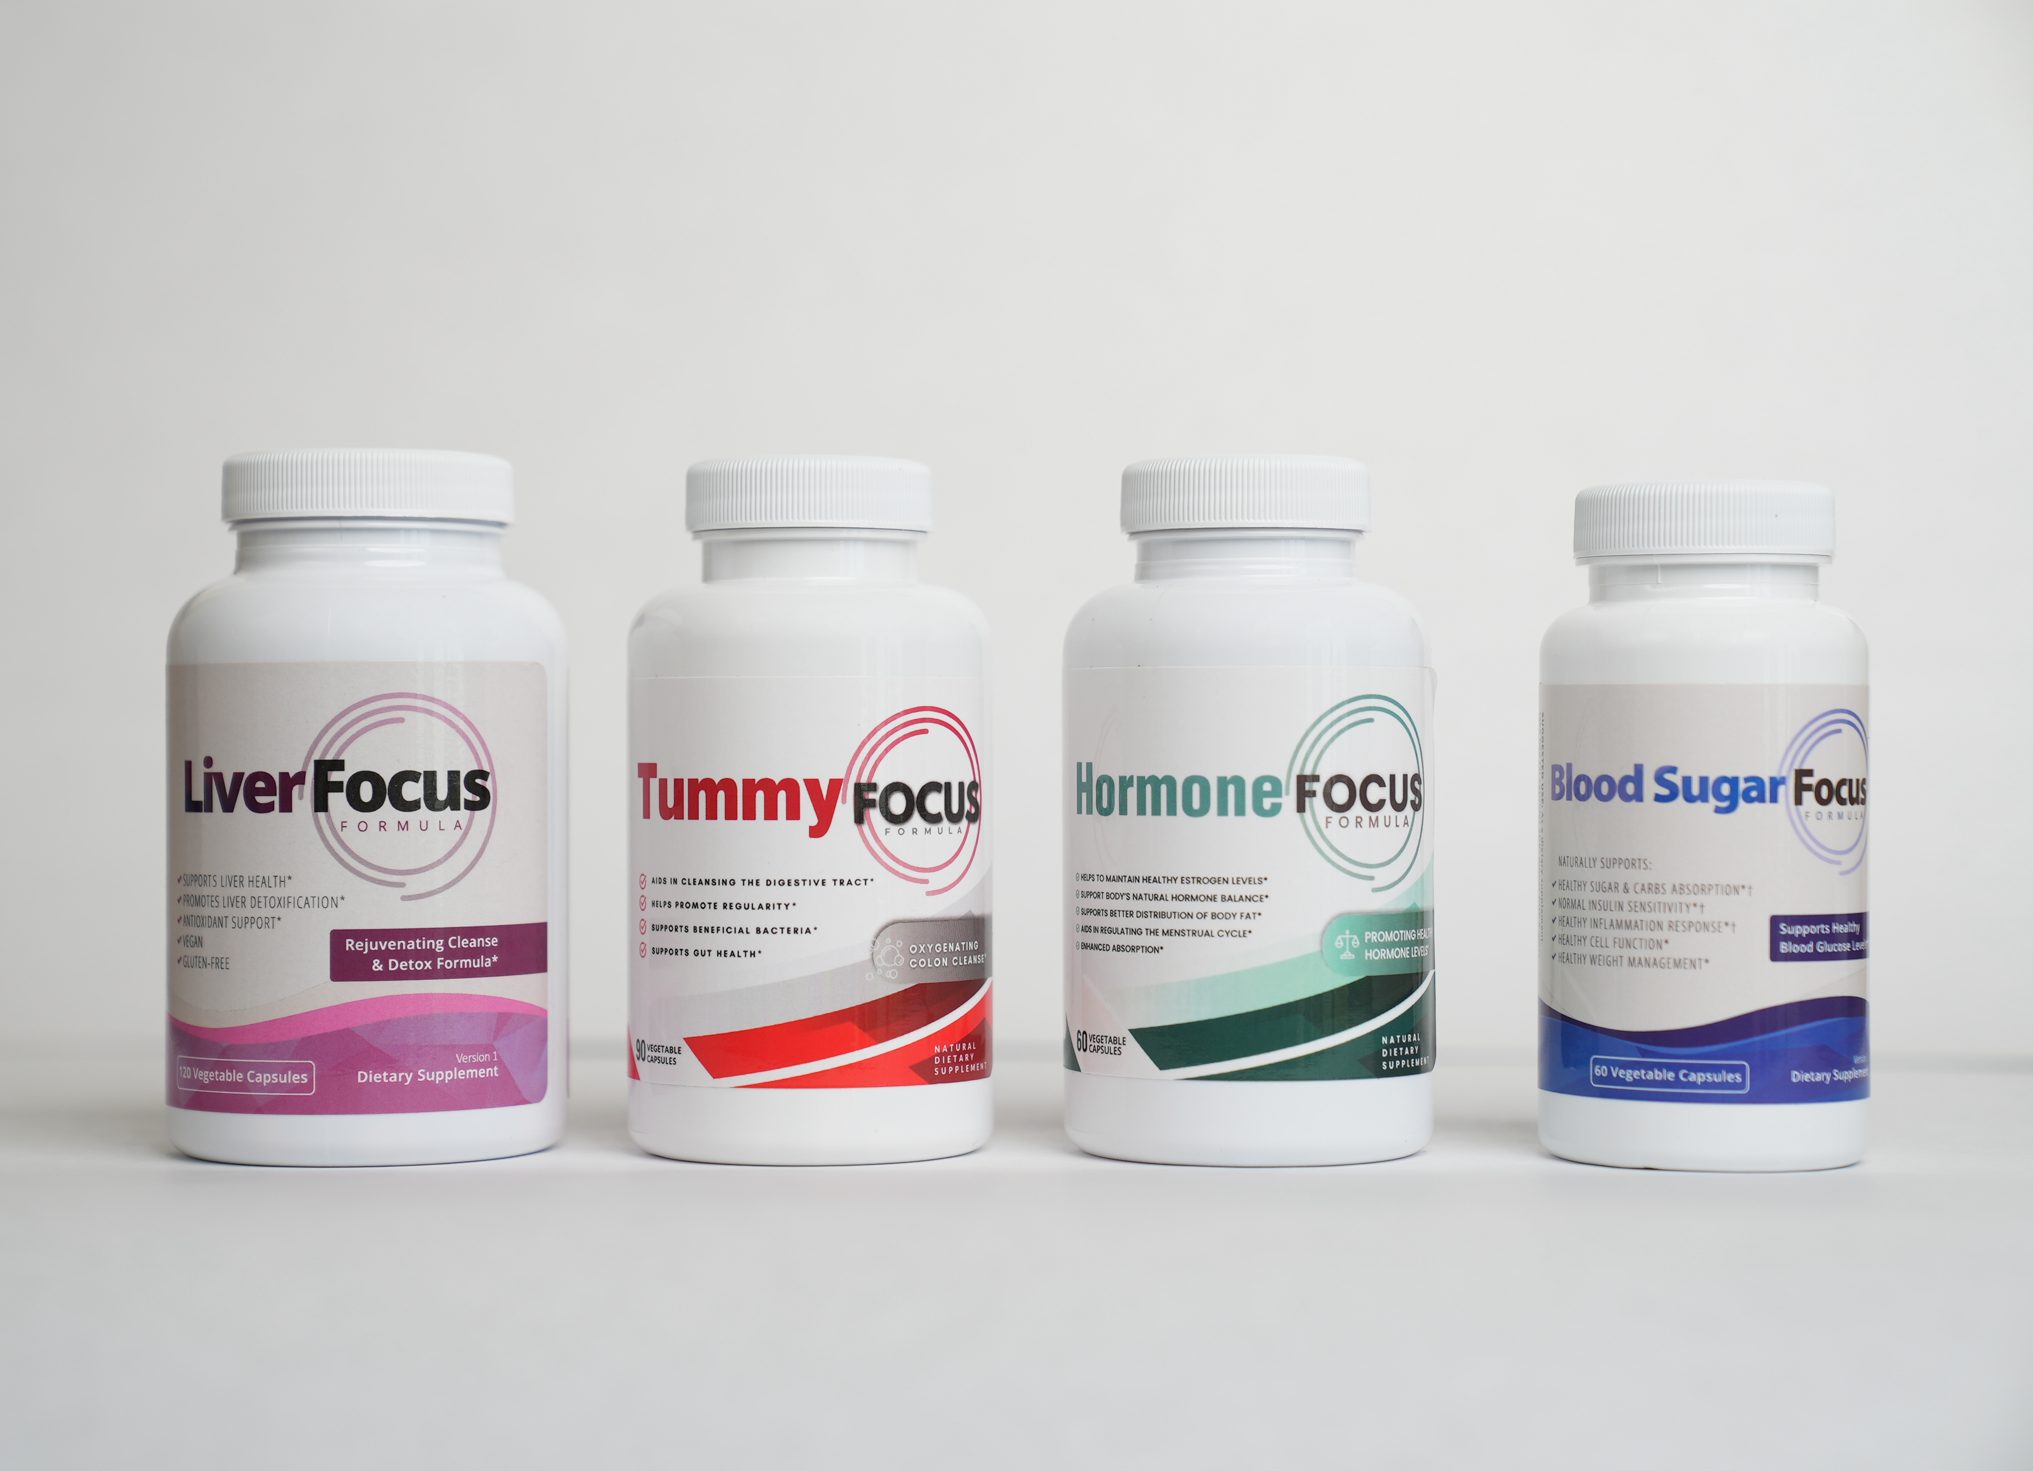
Current colors:
Liver Focus: Purple
Tummy Focus: Red
Hormone Focus: Green
Blood Sugar Focus: Blue

We are only focused on the front of the bottle design, not the nutrition information on the back right now.
So the main text for the front of the bottle is:
Liver Focus
Rejuvenating Cleanse & Detox Formula*
Dietary Supplement
120 Vegetable Capsules

Tummy Focus
Oxygenating Colon Cleanse*
Dietary Supplement
90 Vegetable Capsules

Hormone Focus
Supports Healthy Hormone Levels*
Dietary Supplement
60 Vegetable Capsules

Blood Sugar Focus
Supports Healthy Blood Glucose Levels*
Dietary Supplement
60 Vegetable Capsules

