Supplement Re-branding
We want to rebrand our current health supplements (see below). We do want it to be modern, vibrant and appealing. Very upscale and elegant as it targets primarily women.
Bottle size: see pictures for bottle size, along with sample bottles that we like; we’re open to any bottle similar to the ones attached.
Current bottles: So ideally, we’d keep the core color on each bottle with a new branding/bottle design. But we're open to your suggestion. Current colors:
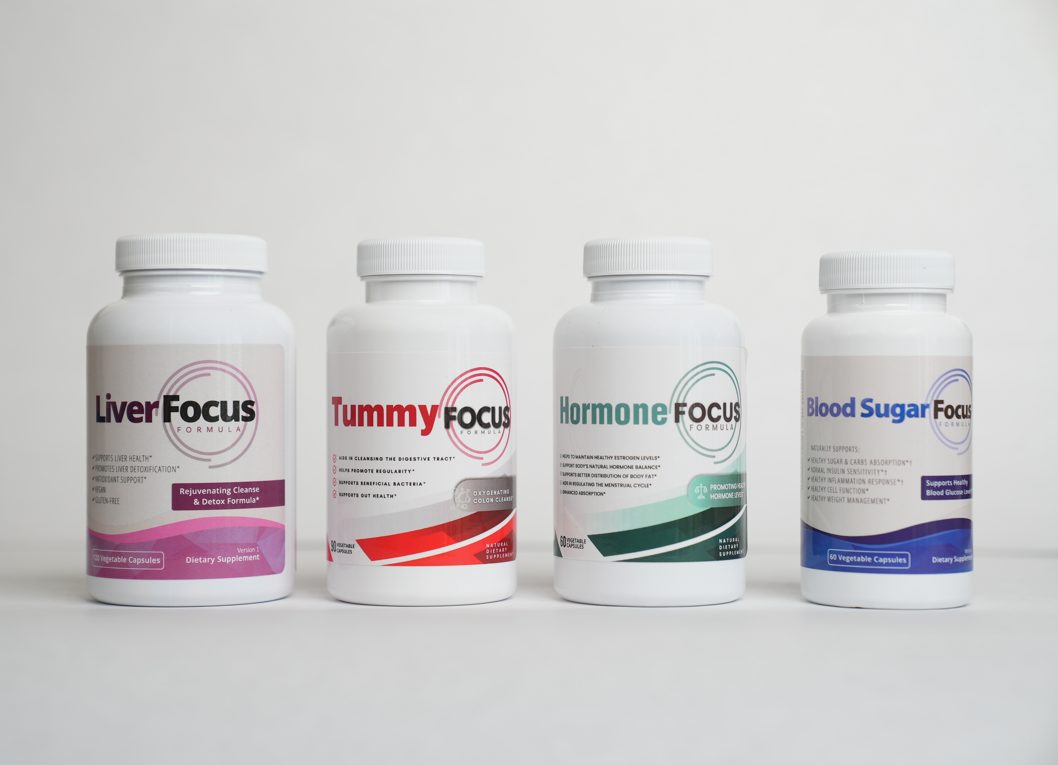
Current colors:
Liver Focus: Purple
Tummy Focus: Red
Hormone Focus: Green
Blood Sugar Focus: Blue

We are only focused on the front of the bottle design, not the nutrition information on the back right now.
So the main text for the front of the bottle is:
Liver Focus
Rejuvenating Cleanse & Detox Formula*
Dietary Supplement
120 Vegetable Capsules

Tummy Focus
Oxygenating Colon Cleanse*
Dietary Supplement
90 Vegetable Capsules

Hormone Focus
Supports Healthy Hormone Levels*
Dietary Supplement
60 Vegetable Capsules

Blood Sugar Focus
Supports Healthy Blood Glucose Levels*
Dietary Supplement
60 Vegetable Capsules

BOTTLE DESIGNS: Here are 3 bottle designs that we like (pick any or all bottle sizes)
- Bottle 100 ml (20X30X25 cm)/frosted matte
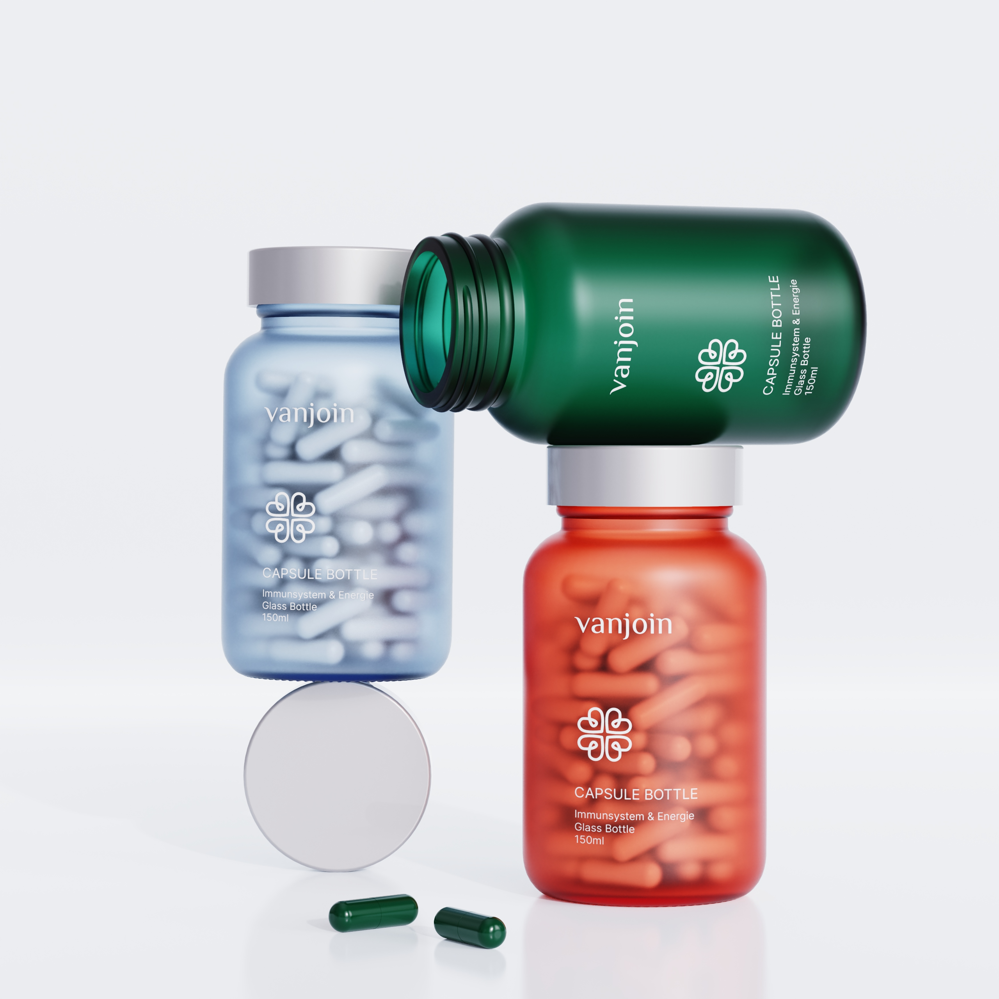

- 200 ml (40X20X30 cm) frosted matte
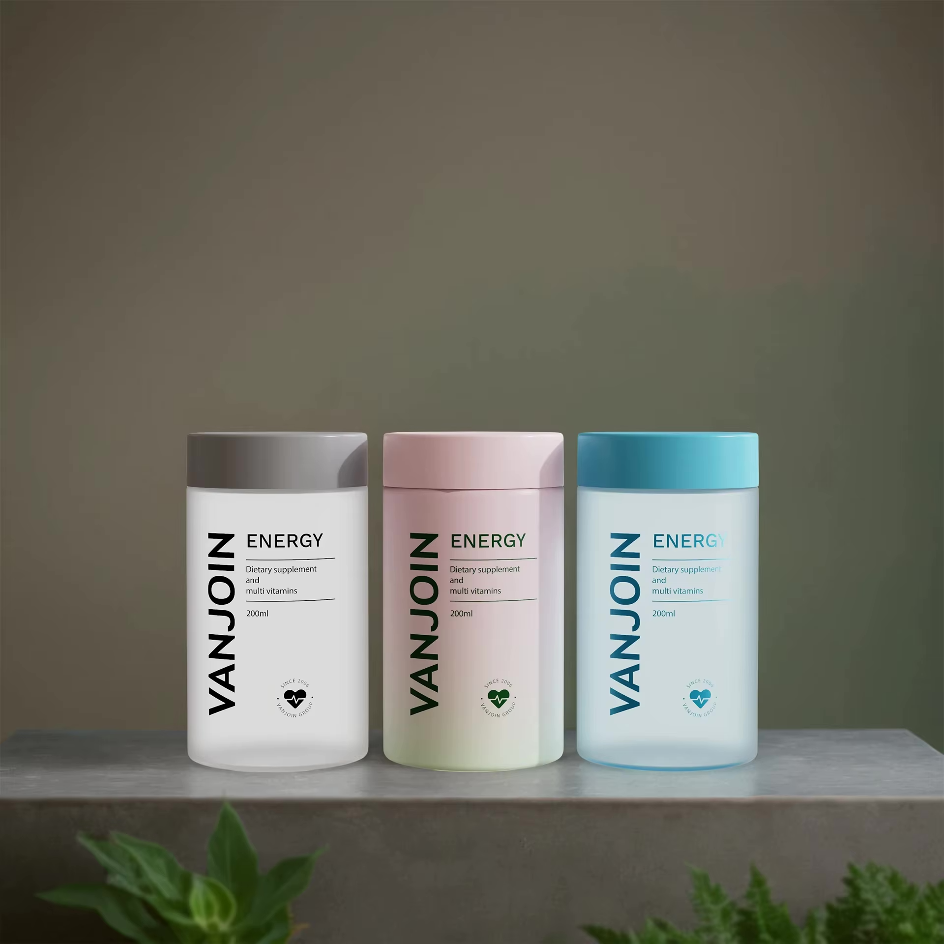

- 100ml (30X20X15 cm)
