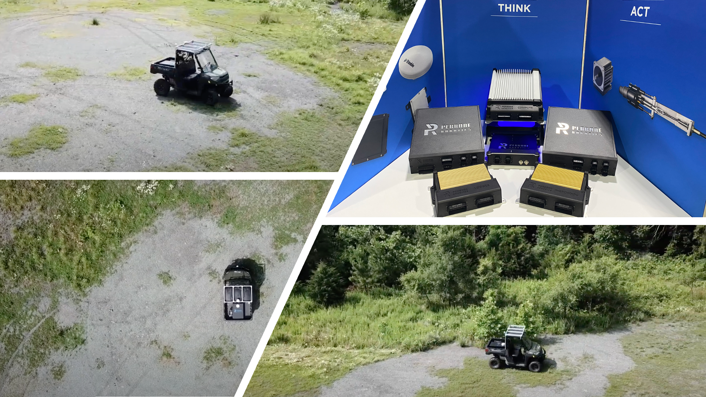
TONY - Warrior Wayfarer
Empowering Defense with Scalable, High-Tech, Cost-Effective Autonomy.

The Warrior Wayfarer is a powerful fusion of the TONY AV Kit and Polaris Ranger utility vehicles, delivering advanced autonomy tailored specifically for modern military operations.

Advanced Operational Features
- Waypoint Navigation: Autonomous, precision-guided navigation.
- Obstacle Detection & Avoidance: Real-time sensor-driven safety.
- Batched Missions: Execute multiple coordinated missions concurrently.
- Teleoperation: Remote control for precise maneuvers.
- Convoy/Platooning: Coordinated fleet movements for optimal logistics.
- Coordinated Formations: Execute complex, precise tactical formations.
- Terrain Versatility: Capable across off-road and urban terrains.

- Day/Night Capabilities: 24/7 operational readiness.

Economic Scalability
Deploy a large fleet of Warrior Wayfarer vehicles economically, enabling extensive and coordinated tactical maneuvers without burdening budgets.
- Strategically Disposable: Ideal for high-risk operations, preserving costly assets.
- Self-Protective Watchdog: Continuous threat monitoring for enhanced security and safety.
Multi-Unit Tactical Impact
Leverage synchronized multi-unit operations to amplify effectiveness and strategic depth, dramatically enhancing defensive and offensive capabilities.
Tactical Edge Accessibility
Enjoy cutting-edge military technology affordably. Warrior Wayfarer combines advanced features with cost-efficient scalability, ushering in a new era of strategic military planning and budget management.
Multi-Unit Tactical Impact
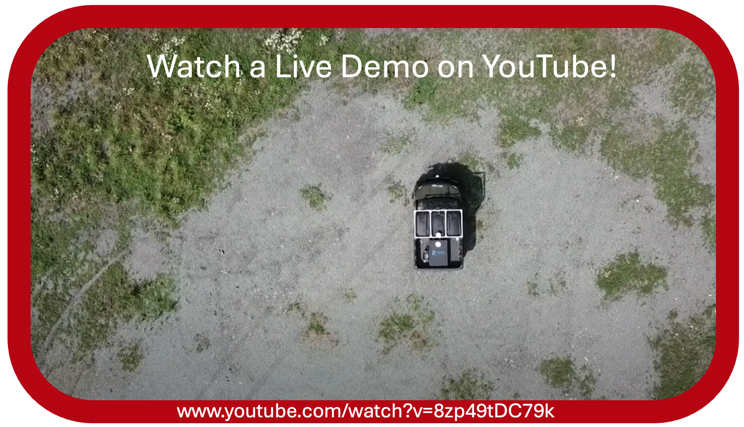
Leverage synchronized multi-unit operations to amplify effectiveness and strategic depth, dramatically enhancing defensive and offensive capabilities.
Transform Military Operations!
Contact Perrone Robotics to experience how The Warrior Wayfarer can revolutionize your operational capabilities.
Perrone Robotics - 1000 Research Park Boulevard, Suite 106 - Charlottesville, VA 22911
www.perronerobotics.com | sales@perronerobotics.com | +1-434-260-8550

