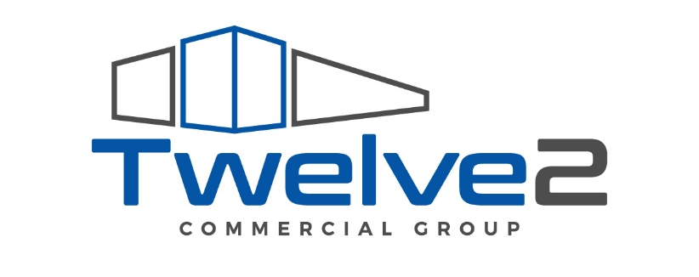

Twelve2 Commercial Group
Branding Guide
June 2025

Color Palette

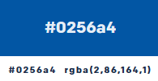
Main Color:
- Blue
  - HEX: #0256a4
  - RGB: (2,86,164)

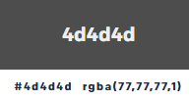
Additional Colors:
- Grey
  - HEX: #4d4d4d
  - RGB: (77, 77, 77)

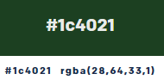
- Green
  - HEX: #1c4021
  - RGB: (28, 64,33)

Logos
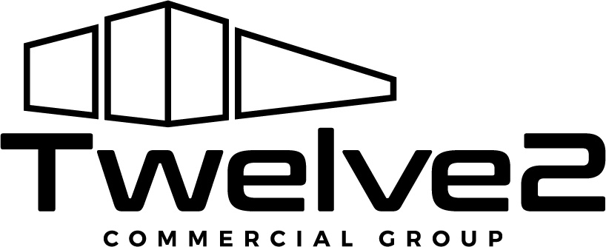
Black
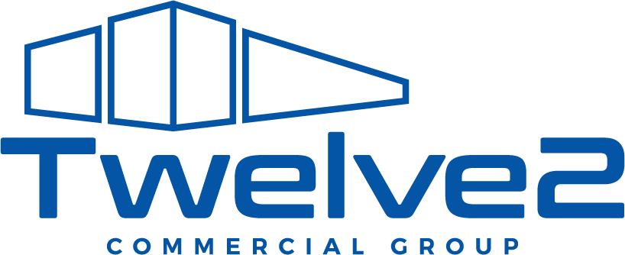
Blue
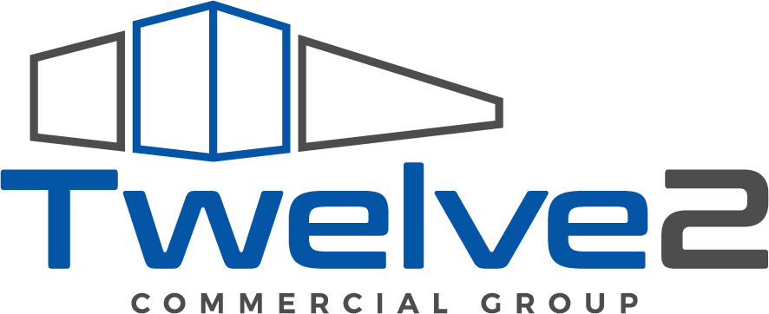
Full Color

Typography
The main font will be Aptos, however when certain graphic elements are needed, we recommend the following:
- Calibri Light
- Source Sans Pro Semibold
- Open Sans

Below are the necessary heading styles:

Heading 1

Heading 2

Heading 3

Heading 4
Body text

Table Style
Table Heading | Table Heading | Table Heading
Table Text FC | Table Text | Table Text
Table Text FC | Table Text | Table Text

