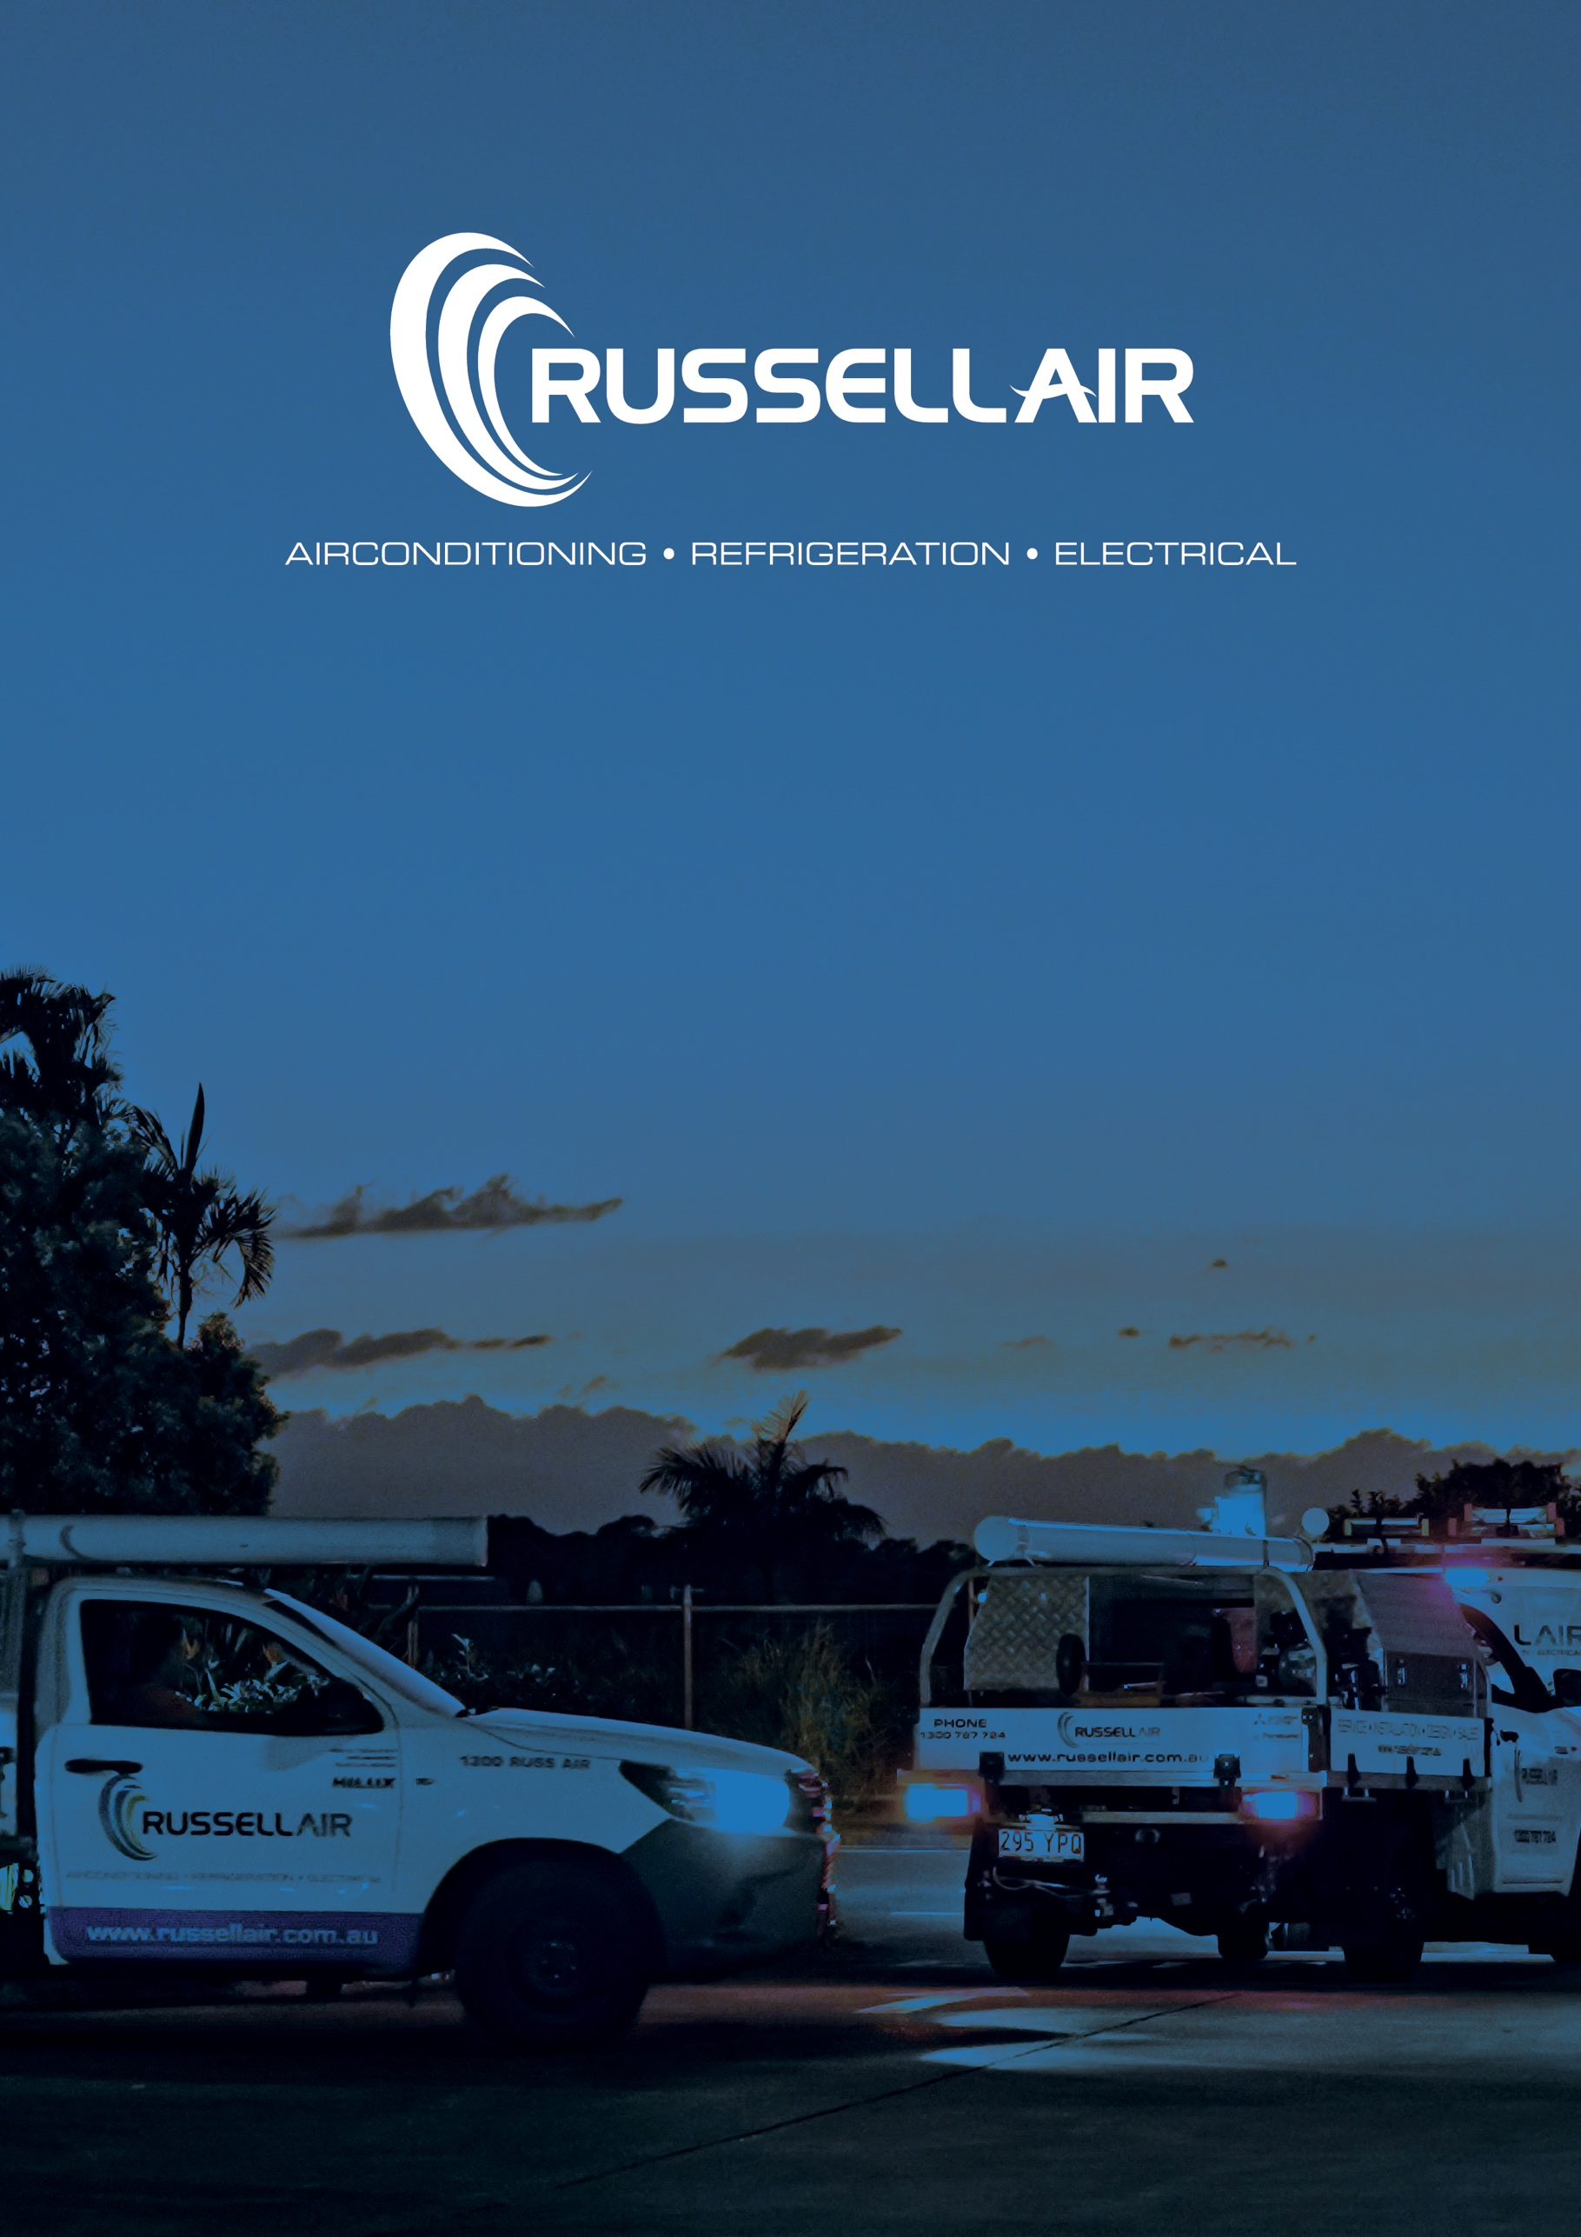
tender
submission
26th may 2025
st catherines
proserpine

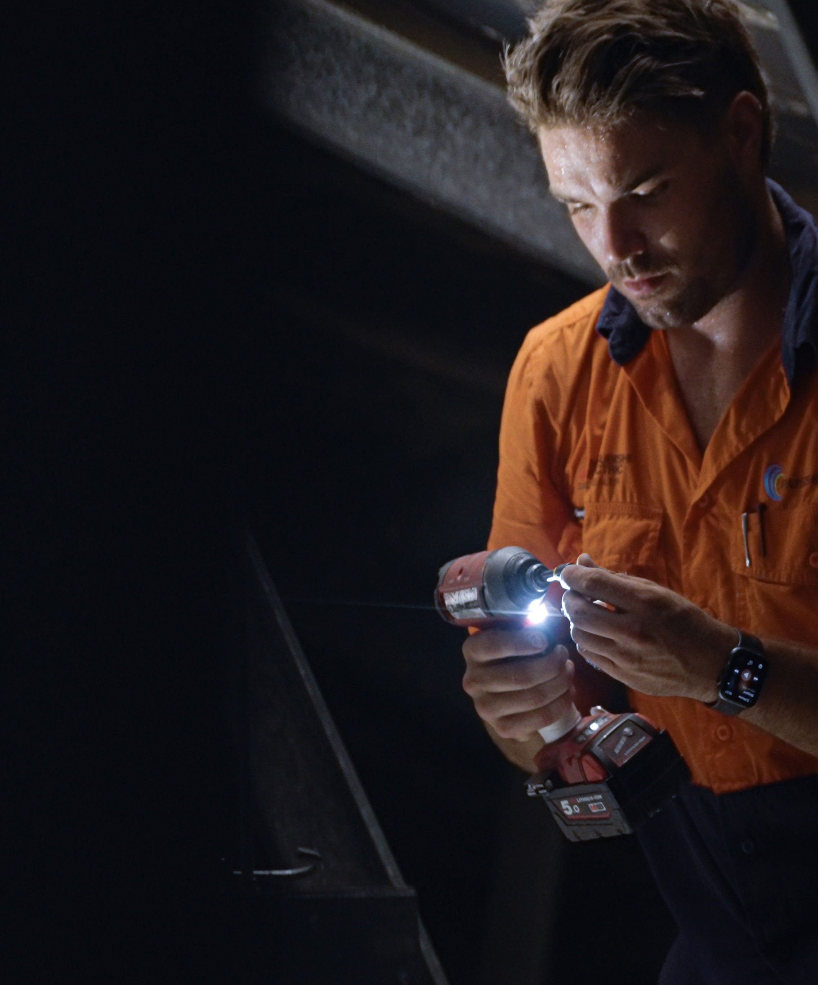

About Us /
Russell Air provides the full range of air conditioning and mechanical services solutions. From system design right through to installation, commissioning and maintenance our team have wide experience across the commercial, industrial, government, and infrastructure sectors throughout Queensland.
We have successfully delivered projects for retail precincts, offices, education facilities, airports and hotels, health and aged care, hotels & clubs, and more.
We’re proud of the long-term relationships we’ve built over the years with our commercial clients. Our attention to detail, comprehensive service offering, and outstanding customer service have helped us build a reputation for reliability and adaptability.
Since our inception in 2015 we have assembled an expert team whose knowledge and skills are matched by their can-do outlook and approachability. They bring decades of experience to their roles yet they’re flexible enough to adapt to and overcome the challenges which are inevitable on any large project.
You can rest assured our team is always working safely and to the highest standard using only quality brands and materials that meet Australian Standards.



We offer for your consideration our proposal for the supply, delivery, installation and commissioning of new Air Conditioning and Mechanical services.

Drawings –
Specification –

breakdown | Price (ex GST)
Air Conditioning Equipment | $32,454.00
Ductwork Grilles & Installation | $18,909.00
Pipework & Installation | $22,378.00
Mechanical Electrical | $37,012.00
Fans | $3,012.00
Blygold Treatment | $6,500.00
Testing & Commissioning | $2,600.00
Warranty & Maintenance | $1,850.00
Documentation, Drawings & Project Management | $6,298.00
Total Ex GST | $131,013.00

Total in words:
ONE HUNDRED AND THIRTY-ONE THOUSAND AND THIRTEEN DOLLARS + GST

Inclusions:
- Supply, delivery, and installation of new Mitsubishi Electric Air Conditioning systems.
- Allowance has been made for the condensing units to be installed on concrete plinths provided by builder.
- Allowance has been made for all new refrigerant pipework between the indoor fan coil and the external condensing units.
- Allowance has been made for new condensate pipe work from each fan coil unit to a tundish provided by others.
- Allowance has been made for associated Air Conditioning ducting and grills.
- Allowance has been made for one (1) wired proprietary controller per system.
- Allowance has been made for one (1) central controller.
- Supply, delivery and installation of one (1) MSSB.
- Allowance has been made for wiring from MSSB to mechanical equipment.
- Allowance has been made for associated mechanical controls and interlocks.
- Supply, delivery, and installation of new Fantech fans.
- Allowance has been made for outside air, exhaust ducting and grills.
- Allowance has been made seismic restraints.
- Allowance has been made for commissioning and air balancing.
- Provide workshop drawings, as builts, form 12 and Manuals.
- Provide 12 months defects liability period and servicing.
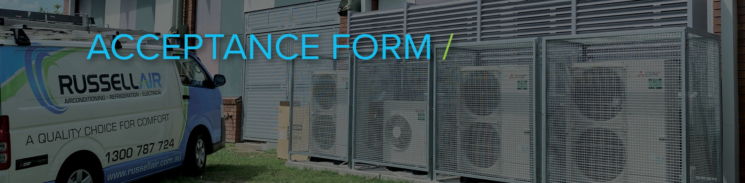
Exclusions:
- No allowance has been made to carry out any of the required building works to facilitate the installation of the air conditioning or ventilation equipment.
- Suitable ceiling access panels are to be provided by others for the ongoing maintenance of the air conditioning units and mechanical equipment.
- No allowance has been made for concrete plinths or plant decks.
- No allowance has been made for core holes or concrete cutting.
- No allowance has been made for mains supplies to isolators.
- No allowance has been made for scaffolding or edge protection.
- No allowance has been made for temporary fencing, skip bins or site offices.
- No allowance has been made for cages or screens.

QUOTE TOTAL:
COMPANY NAME:
ABN:
ADDRESS:
PHONE NUMBER:
ACCOUNTS EMAIL:
I/We accept the terms and conditions as outlined in this quote proposal:

SIGNATURE:

DATE:
PRINT NAME:



Progress payments shall be made monthly for the value of work completed and accrued. Payment of progress invoices to be paid strictly within thirty (30) days of invoice date.

We warrant the cost of the equipment supplied by us to the full extent of the Supplier’s / Manufacturer’s warranty terms and conditions only.

The warranty does not apply in respect of neglect, damage by fire, flood, abrasion, erosion, corrosion or deterioration due to changes in temperature, exposure to chemicals, energy, radioactivity or other parts or components in the client’s systems failing.

Equipment warranty would commence on the date of commissioning or as specified by the manufacturer.

We shall undertake the works and rectify any defects in same to your reasonable satisfaction.

In the event of non-payment of monies owing to us we shall retain ownership of all goods and materials supplied by us for the works and we shall have an unconditional and unfettered right to enter upon premises where equipment and materials are located, retake possession of, resell any equipment and materials redeemed and retain the proceeds of such sale.

3 Your terms
3.1 If you submit your terms and conditions to us, whether with an order for products or otherwise, they are not agreed, and this Agreement will apply unless we notify you directly in writing that any alternate terms and agreed. In any of your terms are agreed, this Agreement will prevail to the extent of any inconsistency.

4 Contract Price
4.1 The Supplier will provide the Goods and/or Services to the Buyer in return for the payment by the Buyer of the Contract Price specified in the Agreement Details.
4.2 All amounts referred to in this Agreement are in Australian Dollars, unless otherwise stated.

5 Invoicing and payment
5.1 Payment for the Goods and/or Services must be made by the Buyer in accordance with this Agreement and any written instructions given by the Supplier.
5.2 The Supplier will submit invoices to the Buyer following the end of each month. Within the period specified in the Agreement Specifics the Buyer must pay the Supplier the undisputed amount of the invoice, provided that the Supplier has delivered the Goods and/or performed the Services that are the subject of the invoice in accordance with this Agreement.
5.3 All amounts payable to the Supplier under this Agreement will be paid in full without any deduction or withholding other than as required by law, and the Buyer will not be entitled at any time to assert any credit, set-off or counterclaim against the Supplier in order to justify withholding payment of any such amount in whole or in part.
5.4 No payment will be deemed to have been received until the Supplier has received cleared funds.
5.5 The Buyer may at any time before, or at the time of, payment under clause 5.2 dispute the amount claimed by the Supplier in an invoice. The obligation to pay any amount that is the subject of such a dispute will be suspended until the dispute is resolved or the parties agreed on the payment of an alternative amount instead of the amount in dispute.
5.6 If the Supplier delivers a claim for payment pursuant to the BCIP Act, then any notice to the Supplier provided by the Buyer disputing an amount the subject of such a claim will be deemed to be a “payment schedule” under the BCIP Act.
1 Definitions, interpretation and precedence
1.1 Definitions
Terms defined in the Agreement Details on page 1 have the meaning given there. All other capitalised terms have these meanings:
Agreement means this supply agreement, its attached annexures, and the Quotation.
BCIP Act means the Building and Construction Industry Payments Act 2004 (Qld), or equivalent legislation in force at the Place of Delivery.
Business Day means a day which is not a Saturday, Sunday or public holiday in the place where the act is performed.
Intellectual Property Rights includes all copyright and related rights, trademarks, service marks, trade, business and domain names, rights in trade dress or get-up, rights in goodwill or to sue for passing off, rights in computer software, database rights, topography rights, moral rights, rights in confidential information (including know-how and trade secrets) and any other intellectual property rights.
Quotation means the proposal or quotation issued by the Supplier containing an offer of Goods or Services to the Buyer attached at Annexure A.

1.2 Interpretation
References to “we”, “us” and “our” mean the Supplier.
A reference to “you” and “your” means the Buyer named in the Agreement Details.

1.3 Order of precedence
In the event of any inconsistency, the following order of precedence will apply:
(a) Special Conditions;
(b) Terms and Conditions of Supply;
(c) Quotation.
2 Quotations and orders
2.1 A Quotation issued by the Supplier to the Buyer is an offer from us to you to enter into a contract for the provision of Goods and/or Services. You may accept this offer:
(a) expressly, either orally or (preferably) in writing; or
(b) by your conduct.
2.2 A Quotation is valid for 60 days, and the Supplier has the right to amend the Quotation at any time before acceptance of the Quotation by the Buyer.

2.3 All drawings, descriptive matter, specifications and advertising issued by the Supplier and any descriptions or instructions contained in catalogues or brochures are issued or published
for the sole purpose of giving an approximate idea of the goods described in them. They will not form part of this Agreement.
6 Failure to pay
6.1 If the Buyer fails to pay any sums payable to the Supplier by the date upon which they become due, then, without prejudice to any other remedies available to Supplier, the Supplier may:
(a) charge interest on all such unpaid sums, from the date when payment becomes due until the date of payment on all unpaid sums at the rate of 2% per annum;
(b) withhold further performance of any obligations under this Agreement until all such unpaid sums, together with any interest thereon, have been paid in full;
(c) sell the Goods and apply the proceeds of sale in reduction or elimination of any amounts due from the Buyer to the Supplier. Any surplus proceeds remaining after such application will be paid by the Supplier to the Buyer;
(d) recover the Contract Price together with interest from the Buyer as liquidated damages in a court or tribunal of a competent jurisdiction irrespective of any claim that the Buyer has against the Supplier for anything or matter related to the Goods and/or Services. The Buyer agrees that that amount is a reasonable and genuine pre-estimate of the loss that the Supplier would suffer as a consequence of the Buyer’s default under this clause 6.1.
6.2 The Seller’s rights under clause 6.1 are subject to suspension of the Buyer’s obligation to pay pending dispute resolution under clause 5.5.

7 Delivery
7.1 Delivery of the Goods and/or Services will take place at the Place of Delivery.
7.2 Any delivery times made known to the Buyer are estimates only.
7.3 The Supplier is not liable for any loss, damage or delay occasioned to the Buyer or its employees, agents or contractors arising from late or non-delivery or late installation of the Goods and/or provision of the Services.
7.4 The Buyer will take delivery within 7 days of the Supplier giving notice that the Goods are ready for delivery unless other arrangements are agreed.
7.5 If delivery of the Goods or the performance of the Services is delayed due to any event of force majeure, act of God, or any cause beyond our control, we will not be liable for any direct or indirect damage or loss due to such delay. We will use reasonable efforts to provide the Goods and/or Services within the time specified.
7.6 All conditions, guarantees and warranties as to the time or date for the delivery of Goods or the performance of Services by the Supplier, whether implied by statute or by common law or otherwise, are hereby excluded. Nothing in this clause affects the Buyer’s rights for any alleged failure of a guarantee under the Competition and Consumer Act 2010 (Cth).

8 Buyer’s obligations
8.1 The Buyer must:
(a) ensure that the Supplier and its employees, agents and contractors have reasonable access to the Place of Delivery for the purpose of delivering the Goods and/or performing the Services; and
(b) comply with all laws to the extent necessary to enable the Supplier to supply the Services and/or Goods, including applicable workplace health and safety laws and regulations.

9 Risk
9.1 Risk in the Goods and/or Services passes to the Customer immediately upon delivery to the Place of Delivery.
9.2 If the Buyer will not accept delivery of the Goods when they are ready for delivery, or the Supplier is unable to deliver the Goods on time because the Buyer has not provided appropriate instructions, documents, licenses or authorisations:
(a) risk in the Goods will pass to the Buyer;
(b) the Goods will be deemed to have been delivered; and
(c) the Supplier may store the Goods until delivery whereupon the
Buyer will be liable for all related costs and expenses (including, without limitation, storage and insurance);
9.3 The Supplier is not required to deliver the Goods until the Buyer has paid for them in accordance with clause 5.

10 Title
10.1 Goods sold or supplied by the Supplier to the Buyer will remain the Supplier’s sole and absolute property as legal and beneficial owner until such time as the Buyer has paid to the Supplier:
(a) the Contract Price for such Goods; and
(b) all other sums due from the Buyer to the Supplier, including those arising under any other agreement between the Buyer and the Supplier.
10.2 Until such times as the property in Goods sold or supplied by the Supplier passes to the Buyer:
(a) the Buyer will hold such Goods and each of them on a fiduciary basis as bailee for the Supplier; and
(b) the Buyer will keep such Goods:
(i) in its own exclusive possession;
(ii) separately from its own goods and the goods of any other person; and
(iii) in a manner which makes them readily identifiable as the Goods;
(c) the Buyer will keep such Goods properly stored and protected; and
(d) the Buyer will at its own expense insure and keep insured such Goods against all risks to a value equal to the full price payable by the Buyer for the Goods. When requested by the Supplier, the Buyer must produce a copy of the policy of insurance for the Supplier’s inspection. Without prejudice to the Supplier’s other rights, if the Buyer fails to insure the Goods, all sums owed to the Supplier by the Buyer will immediately become due and payable.

11 PPSA
11.1 The Buyer agrees that, unless full payment is received for the Goods and/or Services supplied by the Supplier:
(a) title to the Goods and/or Services will not pass to the Buyer;
(b) that a security interest is created in those the Goods and/or Services by this clause; and
(c) the Supplier is authorised and directed by the Buyer to register its security interest on the Personal Property and Securities Register against the Buyer (grantor).
11.2 The parties hereby agree to contract out of any obligations requiring the provision of notices or other positive actions by the Supplier under the Personal Property Securities Act 2009 (Cth) (PPSA).
11.3 Non-compliance by the Buyer with this clause will constitute a breach of this Agreement.
11.4 Words or expressions used in this clause which have a particular meaning in the PPSA have the same meaning, unless the context otherwise requires.

12 Confidentiality
12.1 The Buyer will keep in strict confidence all technical or commercial know-how, specifications, inventions, processes or initiatives, which are of a confidential nature and have been disclosed to the Buyer by the Supplier, its employees, agents or contractors, and any other confidential information concerning the Supplier’s business or its Goods and Services which the Buyer may obtain.

13 Intellectual Property Rights
13.1 Subject to clause 13.2, despite anything in this Agreement, all Intellectual Property Rights in the Goods and/or Services will be owned by the Supplier.
13.2. Where the Supplier agrees in writing before providing Goods or Services that certain Intellectual Property Rights will be owned by the Buyer, those Intellectual Property Rights will vest in the Buyer upon and subject to payment by the Buyer of all amounts owing to the Supplier for the Goods and Services provided:

(a) the Buyer has paid all other amounts then owing by the Buyer, or any person through the Buyer;
(b) the Buyer will grant the Supplier an irrevocable, freely assignable, royalty-free, global licence with the rights to sub- licence, to use those Intellectual Property Rights vesting in the Buyer by operation of this clause for any purpose the Supplier sees fit; and
(c) the Buyer will produce all waivers of Moral Rights and give original executed waivers to the Supplier immediately upon request.

14 Supplier warranties
14.1 The Supplier makes the warranties in respect of the Goods and/or Services set out in Annexure B.

15 Liability and indemnity
15.1 To the maximum extent permitted by law:
(a) no statement or recommendation made or advice, supervision or assistance given by the Supplier, its agents or representatives whether oral or written must be construed as or constitutes a warranty or representation by the Supplier or a waiver of any clause of this Agreement;
(b) all conditions, guarantees and warranties that can be lawfully excluded in relation to the supply of Goods or Services by us are excluded, other than those which are expressly provided for in this Agreement;
(c) where conditions, guarantees and warranties implied by applicable law cannot be excluded (such as the consumer guarantees implied by the Competition and Consumer Act 2010 (Cth)), (Non Excludable Condition), we limit our liability for any breach of such Non Excludable Condition as follows (at our option):
(i) if the breach relates to Goods: the replacement, repair or resupply of the Goods or the payment of the costs of doing any of those actions;
(ii) if the breach relates to Services: the supply of those Services again or the payment of the cost of having those Services supplied again;
(d) we will not be liable to you under or in connection with this Agreement for any indirect or consequential loss, loss of revenue or profit, or loss of goodwill however caused (whether by negligence or otherwise), except where the Buyer is a consumer and such loss cannot be excluded under the Competition and Consumer Act 2010 (Cth).
15.2 If any legislation changes the Buyer’s rights or obligations under this Agreement so that the Supplier’s rights or obligations are adversely affected, the Buyer waives its rights under that legislation to the extent that the waiver is not prohibited or made ineffective by law.

16 Disputes
16.1 The Supplier and the Buyer agree to work together to quickly settle disputes or differences that may arise. In the event that that any such difference cannot be negotiated and amicably resolved between the parties within 30 days after the dispute was first raised.
16.2 All disputes, other than disputes for payment, must be referred to the Australian Commercial Disputes Centre.

17 Termination
17.1 The Supplier may suspend performance of, or terminate this Agreement, without any liability, if:
(a) the Buyer breaches this Agreement and fails to remedy that breach within 30 days of written notice from the Supplier to do so; or
(b) the Buyer’s business fails.
17.2 The Buyer’s business will be treated as having failed if:
(a) the Buyer makes any voluntary arrangement with its creditors;
(b) (being an individual or a firm) the Buyer becomes bankrupt;
(c) (being a company) the Buyer becomes subject to an administration order;

(d) any third party takes possession of, or enforces rights over any
of the Buyer’s property or assets under any form of security;
(e) the Buyer stops or threatens to stop carrying on business;
(f) the Buyer suffers any process equivalent to any of these, in any jurisdiction; or
(g) the Supplier reasonably believes that any of the events mentioned above is about to occur and the Supplier notifies the Buyer accordingly.
17.3 All amounts payable to Supplier will become due immediately upon termination of this Agreement despite any other provision.
17.4 Any right of cancellation or suspension under this clause is in additional to any rights available to the Supplier under the law of any relevant jurisdiction.

18 GST
18.1 If any supply made under or in connection with this Agreement is a taxable supply, the consideration that the recipient of that taxable supply must otherwise pay or provide for that taxable supply is increased by the amount of any GST payable in respect of that taxable supply, subject to a valid tax invoice being delivered to the recipient.
18.2 Words or expressions used in this clause and Agreement which have a particular meaning in the A New Tax System (Goods and Services Tax) Act 1999 (Cth) have the same meaning, unless the context otherwise requires.

19 Waiver
19.1 A party waives a right under this Agreement only if it does so in writing. A party does not waive a right simply because it fails to exercise a right or only exercises part of the right. A waiver of one breach of a term of this Agreement does not operate as a waiver of another of another breach of the same term or any other term.

20 Entire agreement
20.1 This Agreement compromises the entire agreement between the Supplier and the Buyer. The provisions of this Agreement will prevail over any terms and conditions of the Buyer whether or not any inconsistency arises.

21 Variations
21.1 Alterations or variations to this Agreement or any other specifications or documents will not be legally binding upon the Supplier unless agreed in writing.

22 Notices
22.1 All notices served by the Supplier or the Buyer will be in writing and sent to the address in the Agreement Details.
22.2 A notice will be regarded as given and/ or received
(a) if it is delivered by facsimile;
(b) delivered by hand;
(c) delivered by mail, 3 days after posting.
22.3 Any notice sent by facsimile or by hand after 5.00pm on a Business Day or on a non Business Day delivery will be 9.00am on the next Business Day.

23 Governing law
23.1 This Agreement will be governed and construed in accordance with the law of the State of Queensland, Australia, and the parties submit to the exclusive jurisdiction of the courts of Queensland.

24 Subcontracting and assignment
24.1 The Supplier may assign or subcontract all or any part of its obligations under this Agreement without the prior written agreement of the Buyer.



PH: 1300 787 724 E: info@russellair.com.au  A: 28/388 Newman Road, Geebung QLD 4034  A: 6/1 Packer Road, Baringa QLD 4551 | ARCtick licence: AU42861  QBCC licence: 15043367  QLD Electrical licence: 82506 | 

