Brief:
To create two new adverts for Bishop sports equipment catalogue. Below are the ads from the last two years, we want something completely new, keeping the brand colours and logo.
Great Athletes offer inspirational athlete visits, from Olympic to Paralympic athletes, to primary schools with an aim to inspire the children and raise money for sports equipment. We want the advert to convey this – it might feature a background image of children being inspired/ looking engaged, a GB athlete showing off their skills/ medal, or have a “Team GB” feel.
To create 1 x size as below and one full A4 page ad.
To change the offer to say:
ENTER THE PRIZE DRAW TO WIN…
- A free summer event with an athlete and…
- A £500 sports equipment voucher for your school!
Scan the QR code and enter your school’s information
Small print at the bottom: *t&c’s apply. Visit www.greatathletes.org for more information
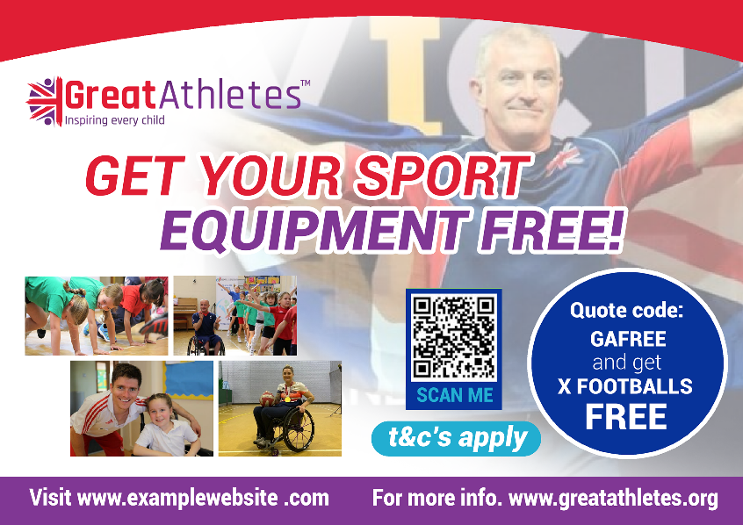
Add a QR code (to be suppled but can use a dummy for initial design)

