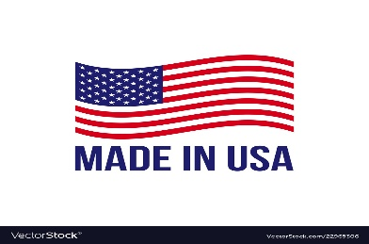
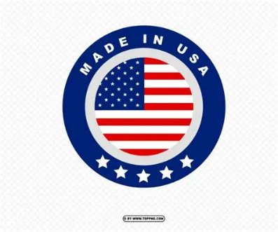
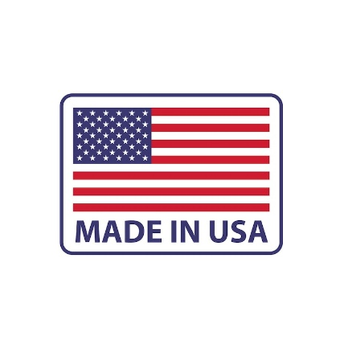
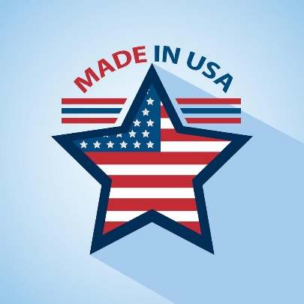

Above are some of the Made in USA logos that I like. I’m open to others as well if others will work better with your design. I definitely want a logo on the front of the card. The back of the card can just have “Made in U.S.A.”

