
Please include an outline for a hang hole similar to what is above see below the criteria, and make sure this hole punch will not interfere with the artwork on front or back.
Hanghole should start approx. .8cm from the top edge of packaging and the bottom of the hanghole should be approximately 2 cm from top edge of packaging.

Also note that for website QR code, it should be no smaller than 2x2 cm, so please don’t place the QR code under the cavity for the product, as this space is exactly 2 cm H (very tight) and I fear that it will not be scannable. Please position the QR code in another spot on package front, or on the back of the package instead.

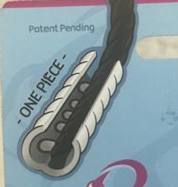
I like the above illustration of how the braided or twisted hair lays into the barrette, and it is labeled “One Piece”. It would be better if you could show how the ends of the hair should be folded back into the barrette (for the clean finish as described on the package back), instead of this drawing where the hair abruptly cuts off.

