Doggy Devotion Dog Collar
Innovated by Arthur Battaglia, Rohnert Park, CA on March 4th 2025
Rohnert Park, CA 94928
707-332-6677
dometric@comcast.net
This Product, is a Dog Collar decorated with PVC Rubber Charm Plugs to be protected with Intellectual Property via U.S. Design Patents and or Utility Patents if and where possible.
Develop any existing dog collar with a series of piercings numbering between 1 and 12. The piercings receive PVC Rubber Charms with a pre-shaped hard plastic plug that secures the charm in the collar in similar fashion to Pierced rubber sandals aka croc shoes that receive and hold have charms.
Conceived by Arthur Battaglia. Market receptivity, market discussions of croc charms with different FASI Distributor attendees helped affirm broad based appeal.
Witness to innovation – Sharon Battaglia, Wife of Arthur Battaglia
Witness to innovation, Sales Manager, FASI Show, Austin, TX
Ideally, charms pierce only the first or outer layer of a two layer collar. The purpose of two layers is to prevent discomfort to the dog from their hair collecting and pulling at the point of contact if it were a one layer collar.
Collar can be made of PVC, Silicone, Rayon, Leather, Faux leather PU Poly Urethane. Any of these collars need only receive precision piercings that allow for plug charms.
Alternative iterations or embodiments:
- Anti-flee medicine infused charms that are adorable and can be changed out for improved effectiveness.
- LED non-blinking plugs – another alternative embodiment.
- Eco Friendly charms can feature a self reducing dye sublimation rayon fabric. The image fades and the charm is destined for replacement. Discarded Plastic plug backers can go in to the recycling stream with their recycle number.

Images of PVC plug charms and snap closure bracelets are pictured. Image only serves to illustrate piercings.
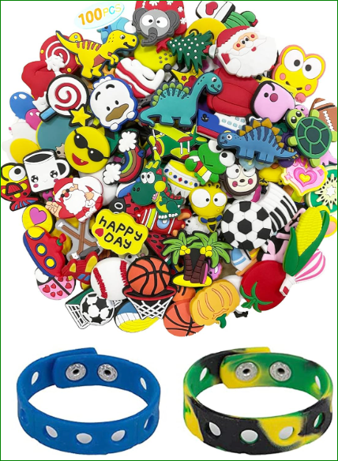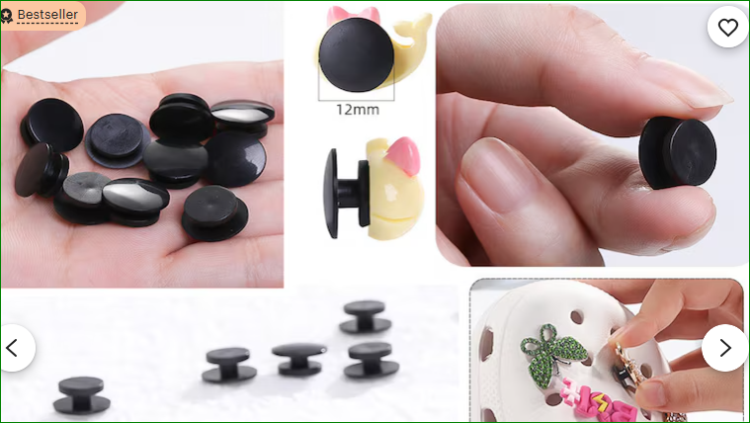
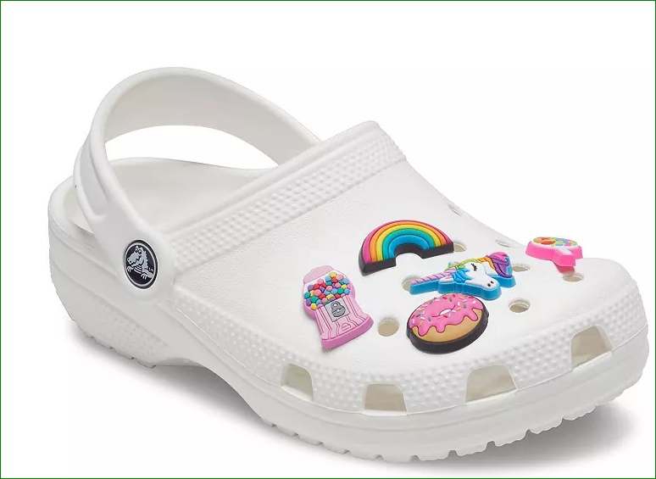

The above constitutes an all of market innovation insight conceived and delivered by Arthur Battaglia of Rohnert Park, CA.

Delivered on July 4th 2025
Arthur Battaglia
