Residential Design Guide: LB Harbors Roofing – Farmers' Market Residential Banner
Project: Farmers' Market Booth Banner (Residential Focus) Purpose: To attract homeowners, build local brand recognition, and generate qualified residential roofing leads at community events. Goal: To establish LB Harbors Roofing as the trusted local expert for residential roofing needs, offering peace of mind and quality service to homeowners.

1. Banner Specifications
- Type: Retractable / Pull-Up Banner
- Final Size: 33" wide x 78" tall (Standard Retractable Banner Size)
- Bleed: Please include standard bleed as per print vendor specifications, plus ensure a 1" margin at the bottom for retractable banner hardware bleed.
- Resolution: 300 DPI (dots per inch) for print quality.
- Color Mode: CMYK

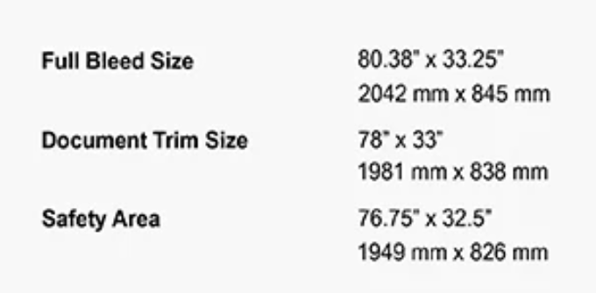

2. Brand Identity & Aesthetics
- Website for Brand Reference: LBHarbors.com (Refer for logo usage, overall brand feel, and primary colors).
- Brand Colors:
  - Teal: Approximately #009EA6
  - White
  - Charcoal
- Overall Tone: Professional, trustworthy, friendly, and approachable. Aim for a clean, inviting design that feels reliable and local.
- Logo: High-resolution vector logo file will be provided separately.

3. Key Messaging & Content
- Headline/Main Message: Needs to be clear, benefit-driven, and resonate with homeowners.
  - "Protecting Your Bay Area Home, Rain or Shine"
  - "Your Local Experts for a Healthy Bay Area Roof"
  - "Quality Roofing for Your Bay Area Home"
- Sub-headline/Key Benefits: (Choose 1-2 points to highlight homeowner advantages)
  - "Peace of Mind for Your Most Important Investment"
  - "Enhance Curb Appeal & Energy Efficiency"
  - "Reliable Repairs, Quality Replacements"
- Residential Roof Types We Work With (Bullet Points or Icons):
  - Asphalt Shingles (most common)
  - Tile Roofs (Clay & Concrete)
  - Metal Roofing
  - Flat & Low-Slope Roofs
  - (Optional: Wood Shakes/Synthetic Shakes - if commonly encountered)
- Core Services (Bullet Points or Icons):
  - Residential Roof Repair
  - New Roof Installation
  - Roof Inspections
  - Leak Detection
  - Gutter Cleaning & Repair (if offered for residential)
  - Emergency Services (if applicable)
- Local Focus Text Block: "Serving Bay Area Homeowners with Top-Rated Roofing Services on all common roof types."
- Call to Action: Simple and direct, encouraging interaction at the booth.
  - "Ask Us About a Free Roof Inspection!"
  - "Scan for Your Free Roof Estimate!"
- Phone: (925) 338-0080
- Website: www.LBHarbors.com
- Licensing Information: LB Harbors Roofing, Inc. C-39 Roofing Contractor Lic. #1126548

4. Visual Elements & Layout
- Imagery:
  - High-quality, professional photos of residential homes with clean, well-maintained roofs, specifically showcasing diverse Bay Area home styles and roof types (e.g., asphalt shingle, tile, metal).
  - Images showcasing healthy shingles, a clean roofline, or perhaps a discreet shot of a friendly technician on a roof. Avoid commercial buildings.
  - Consider a "before/after" of a residential roof if you have one.
- Recommended Layout (Top to Bottom):
  - Top: LB Harbors Roofing logo, centered and prominent.
  - Below Logo: Headline (e.g., "Protecting Your Bay Area Home, Rain or Shine").
  - Visual: A compelling, high-quality image of a beautiful residential roof or home, ideally one that features a common Bay Area roof type.
  - Mid-section: Concise list of Residential Roof Types We Work With and/or key benefits.
  - Below that: Core Services (e.g., as bullet points).
  - Text Block: "Serving Bay Area Homeowners with Top-Rated Roofing Services on all common roof types." (or similar phrasing)
  - Call to Action: "Ask Us About a Free Roof Inspection!"
  - Contact Information: Phone number (925) 338-0080 and Website (www.LBHarbors.com).
  - Bottom: QR Code (provided separately) + Licensing Information + potentially a line like "Your Trusted Local Roofer."
  - Certification Logos (GAF and Owens Corning)
- Readability: Ensure large, clear fonts that are easily readable from a short distance (5-10 feet away), as farmers' markets can be bustling. High contrast between text and background.

5. Design Goals
- Approachable & Trustworthy: Appeal to homeowners looking for reliable local service.
- Clear & Concise: Quickly convey what LB Harbors Roofing offers for residential properties, specifically highlighting expertise in local roof types.
- Benefit-Oriented: Highlight the advantages for homeowners (protection, peace of mind, value).
- Action-Oriented: Encourage visitors to stop, ask questions, or take a flyer.
- Brand Consistency: Maintain the professional look and feel of the LB Harbors Roofing brand while adapting to a residential focus.

