Commercial Customer Design Guide: LB Harbors Roofing 6-ft Retractable Banner
Project: Real Estate and Property Managers - Expo Booth
Purpose: To attract realtors and property managers, build brand awareness, and generate qualified commercial roofing leads.

1. Banner Specifications
- Type: Retractable / Pull-Up Banner
- Final Size: 33" wide x 78" tall (Standard Retractable Banner Size)
- Bleed: Please include standard bleed as per print vendor specifications, plus ensure a 1" margin at the bottom for retractable banner hardware bleed.
- Resolution: 300 DPI (dots per inch) for print quality.
- Color Mode: CMYK

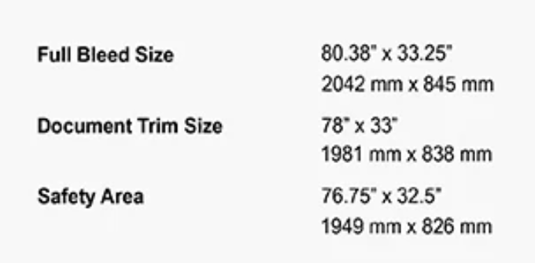

2. Brand Identity & Aesthetics
- Website for Brand Reference: LBHarbors.com (Please refer to the website for logo usage, overall brand feel, and additional visual cues).
- Brand Colors:
  - Teal: Approximately #009EA6
  - White
  - Charcoal
- Overall Tone: Professional, trustworthy, clean, and inviting. Avoid overly busy or cluttered designs.
- Logo: High-resolution vector logo file will be provided separately.

3. Key Messaging & Content
- Tagline: "Commercial Roofing That Protects Your Investment"
- Text Block: "Serving Property Managers & Realtors Across the Bay Area"
- Roof Types:
  - Flat Roofs
  - Low-Slope
  - TPO
  - PVC
  - Built-Up
  - Coatings
- Services:
  - Inspections
  - Leak Repair
  - Re-Roofing
  - Maintenance Plans
- Call to Action: "Call Today for a Free Roof Health Check"
- Phone: (925) 338-0080
- Website: www.LBHarbors.com
- Licensing Information: LB Harbors Roofing, Inc. C-39 Roofing Contractor Lic. #1126548

4. Visual Elements & Layout
- Recommended Layout (Top to Bottom):
  - Top: LB Harbors Roofing logo, centered and large.
  - Below Logo: Tagline: "Commercial Roofing That Protects Your Investment"
  - Visual: Prominent before/after photo or a high-quality drone image of a large commercial roof.
  - Text Block: "Serving Property Managers & Realtors Across the Bay Area"
  - Roof Types & Services: Present these clearly, perhaps as a concise list or with icons, ensuring readability.
  - Call to Action: "Call Today for a Free Roof Health Check"
  - Phone: (925) 338-0080
  - Website: www.LBHarbors.com
  - Bottom: QR Code (provided separately) + Icons (License #, Insurance, Local, etc. – actual icon files to be provided).
  - Certification Logos (GAF and Owens Corning)
- Imagery: Ensure high-quality, professional images of commercial roofing. Focus on clear, impactful visuals relevant to your services.
- Readability: Ensure large, clear fonts that are easily readable from a distance (10-15 feet away). Maintain high contrast between text and background.

5. Design Goals
- Professional: Reflect the expertise and reliability of LB Harbors Roofing.
- Engaging: Visually appealing to catch the eye of expo attendees.
- Informative: Clearly communicate core services, specialty, and value proposition.
- Action-Oriented: Drive visitors to call or visit the website.
- Consistent: Align with the existing brand identity on the website and other expo materials (like the table skirt and raffle sign).

