CMP Water – lots of images of water throughout.
Don’t Pay for Air – Every page should have Don’t Pay for Air on it.
Intro
Did you know that every home and business in America is overpaying for its water by 15-20%? When the water pressure from the water company’s pipes is reduced to accommodate home and business plumbing, air is created. You’re paying for that air. CMP’s hardware pushes the air back up the system so that you don’t pay for it. Its simple but very effective
The Science
Include the slides from deck
The Business Model
How does CMP Water make money? We split the water bill savings with you. We will install a small, simple device close to your water meter. Installation takes less than 3 hours, and you start saving money on your water bill immediately. It’s that easy.
Who Can Save?
If you spend more than $50K per year on your water & sewer bills, this product is for you. Hotels, data centers, car washes, multi-dwelling units, apartment buildings – they all use a lot of water - and they can all save thousands, even millions of dollars on their water bill. It’s that easy.
Contact
Larry Leikin
EVP
CMP Water
410.980.0626
larry@crescentminepartners.com

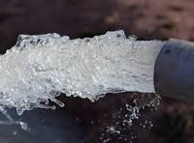
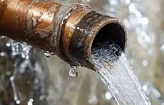
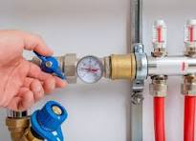
Especially cool images like this:


