
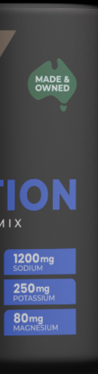
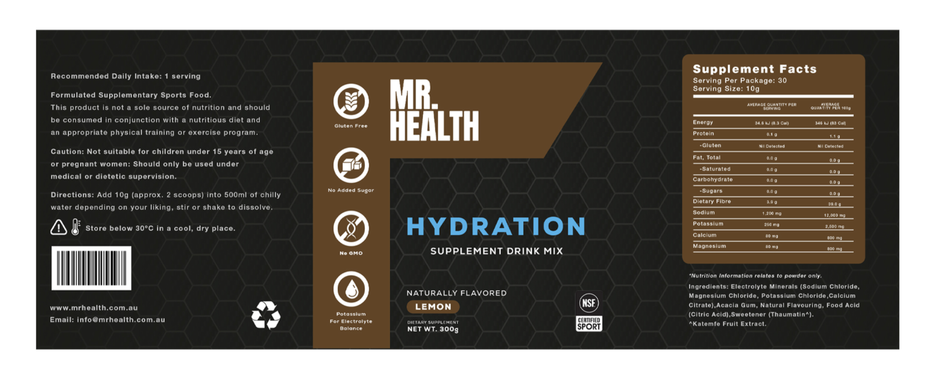
Change all this bronze to this gold colour
Add these like other persons design
Make yellow not bronze
Remove and only keep 3

