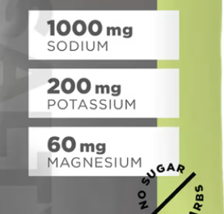
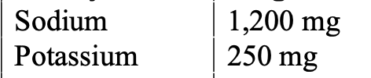
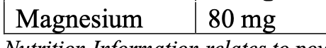
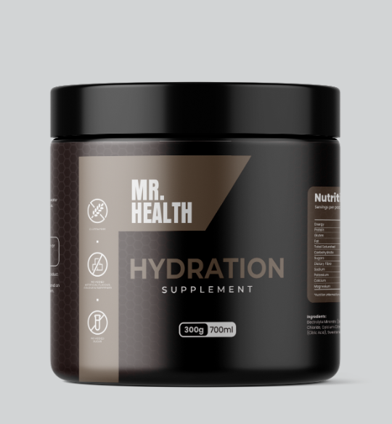
Add image above, you may need to create from scratch as it’s a screenshot
Needs to say Lemon flavour above 300g
Make Hydration letters blue
Add in this space this three stats, use same outline as you used for 300g, see example
Change to Supplement Drink Mix

