https://www.brandcrowd.com/maker/social/myshortlist/9e82jgmf7jjwg5bt2vwg8jdmvr

Short term rental property manager company.
Business Name: Glow Real Estate LLC
Dba: GLOW
Words: “G” or “GLOW” stands for “Gather.Live.Own.Wander.”
Goal: Simple Design, Easy to read modern, color pop, thin lines, letters glow
One design with “G” or “Glow”
One design with “Glow” and slogan: “Gather. Live. Own. Wander”
Colors: Purple, ultraviolet glow, black/white, also like indigo/blue; could be other colors to help pop

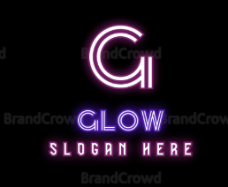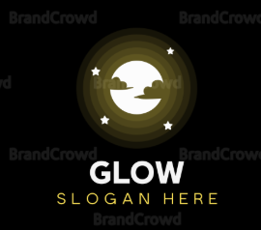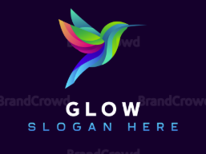
I like the actual glow and contrast between dark and light. The “G” could be better and the symbol could so how relate more to the company but I like how it stands out

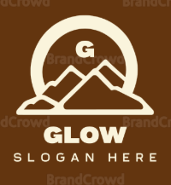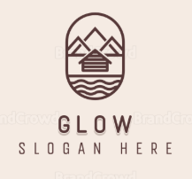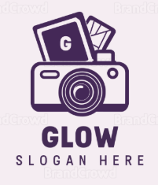
I like the idea of showing a symbol that relates to the short term rental business but I do not want it to look too busy. I would like to have it stand out on a shirt so maybe there is a few different designs that could tie together here - “G” only “Glow” with slogan and glow with symbol details??

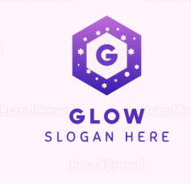
I like how legible the font is and easy to read. I would like thinner lines hexagon, but I like the idea about something around Glow or the G to better symbol the company
