THE GILK PROCESS DESIGNED TO MAXIMIZE INVESTMENT

FROM CONSTRUCTION TO COMPLETION
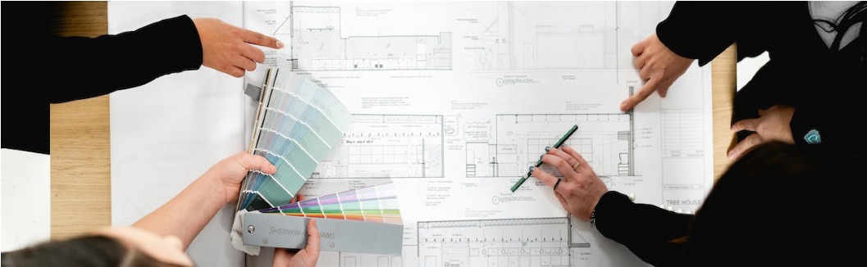
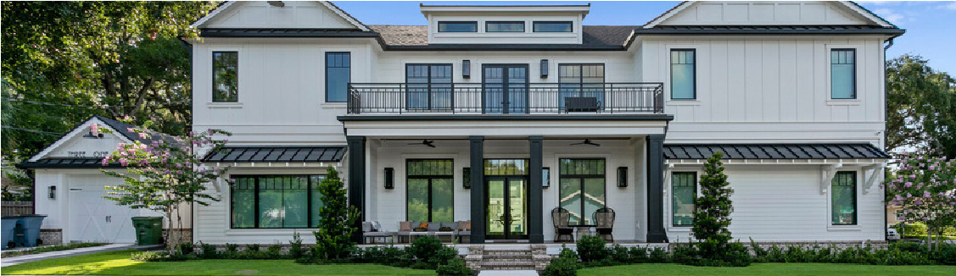
Our approach begins with a thorough consultation to understand the client’s specific needs, preferences, and budget. This allows us to create a preliminary design tailored to the client’s vision, along with an initial cost estimate. Throughout the project, our interior design team remains involved, providing input and refining the design as needed. Once the design is approved, we transition to the construction phase, overseeing all building activities and any necessary design modifications. We ensure continuous communication with the client, making timely decisions to maintain momentum and streamline the process from start to finish.

DUE DILIGENCE TO IDENTIFY KEY CONSIDERATIONS BEFORE DESIGN
Before diving into design, we guide our client through essential preparatory steps, such as:
- Compliance with local jurisdiction (city and county) requirements such as zoning, flood, height and other restrictions
- HOA, Architectural or other quasi-judicial requirements (if applicable)
- Wetland, Soil and Geotechnical Evaluations
- Zoning Restrictions
- Easements
This proactive approach helps ensure a smooth design and construction process while addressing all regulatory and technical needs upfront.
THE DESIGN-BUILD TEAM

ARCHITECT
Our Architect collaborates closely with the entire team to ensure seamless design integration, bringing together the interior design, cost, and construction teams to create a cohesive vision for your home. If you have chosen an architect outside GILK, we are happy to work alongside your chosen team seamlessly.

INTERIOR DESIGNER
Our Interior Design team works alongside the architect to meet your aesthetic and functional goals with materials selections. They listen to your design ideas and offer curated, beautiful options tailored to your aspirations.

PRECONSTRUCTION MANAGER
The Preconstruction team provides accurate cost projections based on current market trends, aligning your design vision with your budget through innovative solutions.

CONSTRUCTION MANAGER
Our Construction team builds your home with precision and quality. They’re available for on-site walkthroughs and prioritize delivering an exceptional building experience from start to finish.
1
DESIGN-BUILD TIMELINE

INITIAL CONSULTATION

(1-2 weeks)
3
We begin by understanding your vision, preferences, and functional needs, laying the foundation for a successful and meaningful project.

DESIGN DEVELOPMENT

(1-2 months)
We transform initial ideas into detailed plans, refining materials, finishes, and functionality. Advanced 3D modeling allows you to visualize the design, while cost estimates are continually honed to maintain alignment with your budget.
5

PERMITTING

(1-3 months)
We navigate the permitting process on your behalf, ensuring clear communication and minimizing potential delays to keep your project on track.
7

FINAL INSPECTION

(1-4 weeks)
A detailed walkthrough confirms that every aspect of your new home meets our exacting standards and your expectations. Any adjustments are promptly addressed, ensuring a seamless transition to completion.

SCHEMATIC DESIGN 2

(1-2 months)
Our architects and designers craft initial layouts and visual concepts, collaborating with you to align the design with your unique style. A Preconstruction Estimator helps establish a thoughtful and realistic budget.

CONSTRUCTION DOCUMENTS 4

(1 month)
Finalized plans and specifications are meticulously reviewed to ensure every design detail is accounted for, setting the stage for flawless execution.

CONSTRUCTION 6

(5-16 months)
With precision and care, your vision becomes reality. Our Project Manager ensures regular quality checks, a safe and organized site, and transparent communication throughout the process.

POST COMPLETION SUPPORT 8

(12 months)
Our relationship doesn’t end when construction is complete. We remain available to address any questions or needs, offering dedicated support throughout the warranty period and beyond.


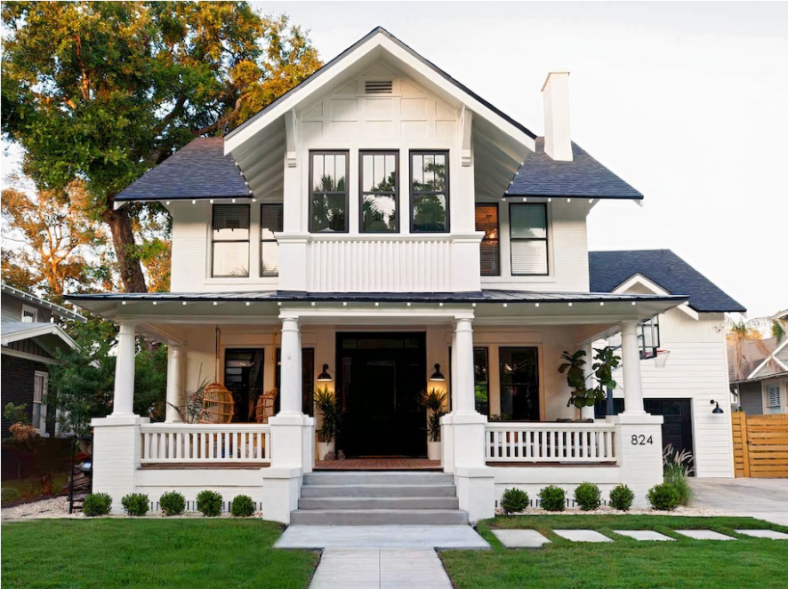
ABOUT US
At GILK, our success is driven by the
exceptional talent and dedication
of our team. Led by owners Garrett
Gilkey, M. Eng., and Ryan Jensen—
both esteemed former NFL players—
our diverse team brings together a
wealth of experience and expertise.
As a design/build company, GILK
seamlessly integrates design
and construction services. This
collaborative model ensures
transparent communication,
streamlined workflows, and efficient
problem solving throughout the
project lifecycle. Clients benefit from
a holistic and cohesive approach to
their project, resulting in superior
quality, cost-effectiveness, and
timely delivery.

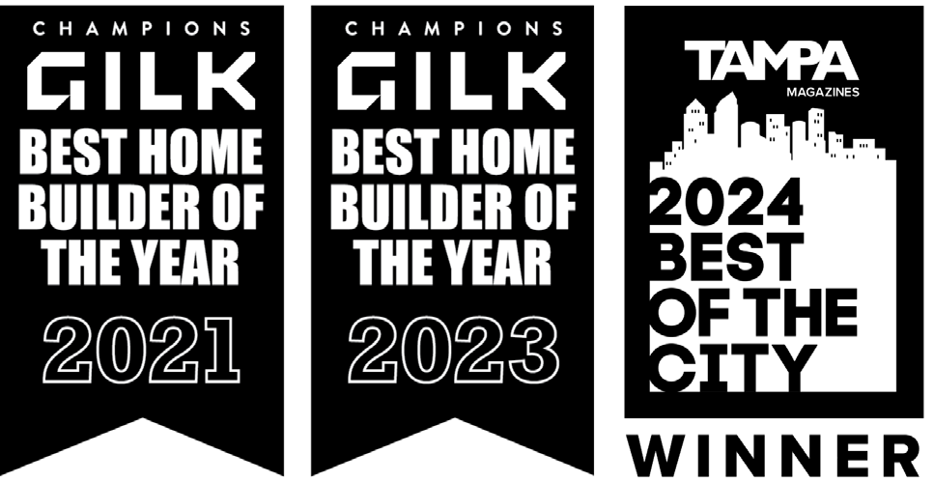
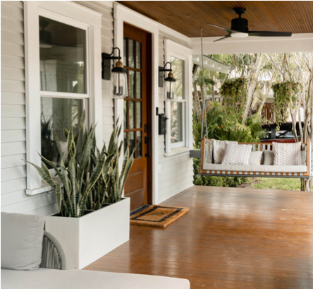
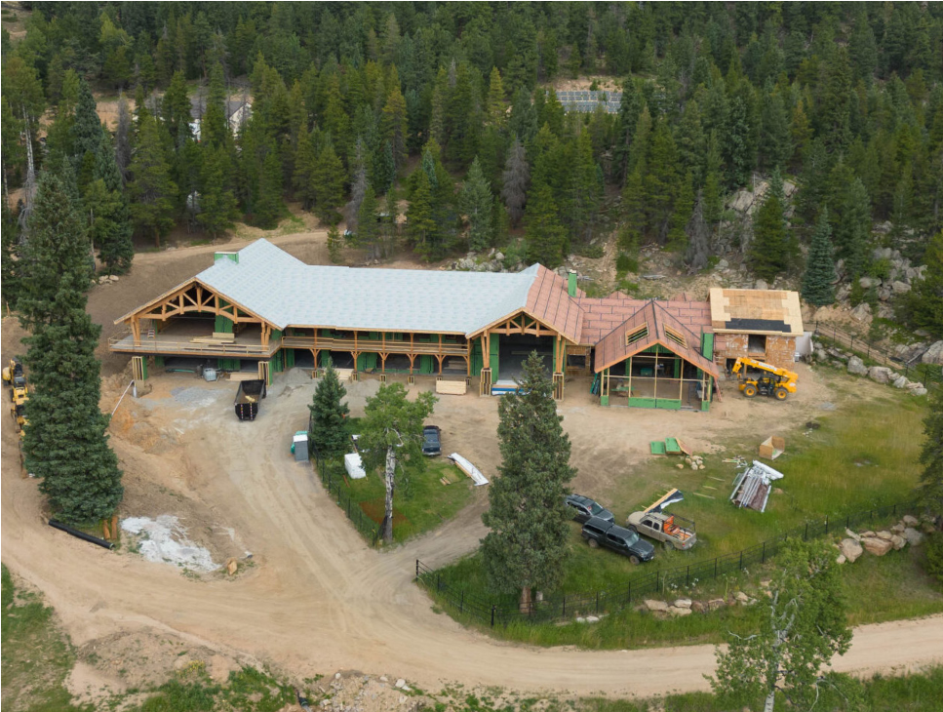
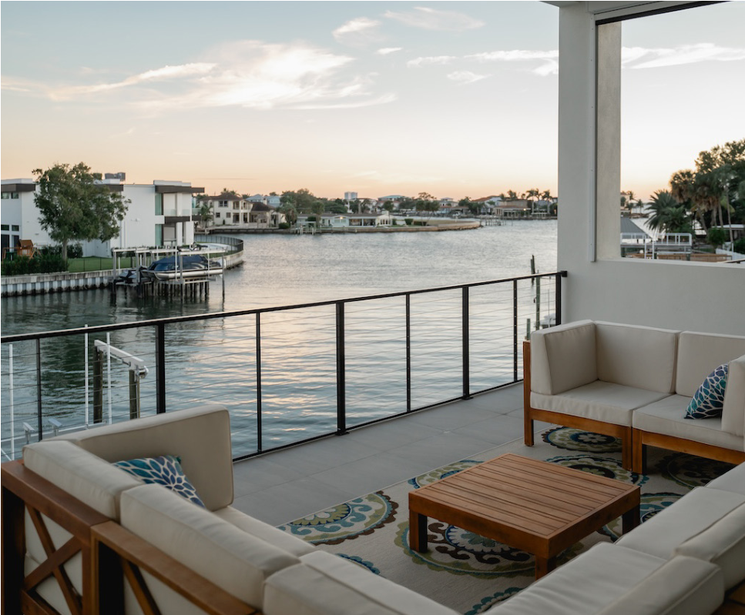
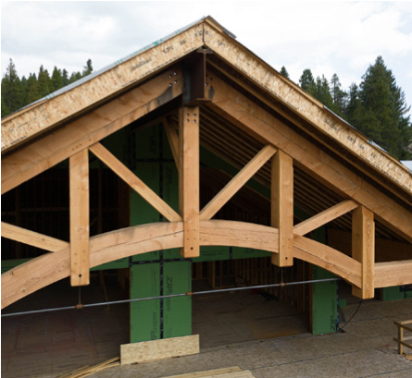
In regions like Florida and Colorado, where
extreme weather is a constant challenge,
GILK Design Build sets itself apart with its
expertise in resilient construction. By focusing
on reinforced foundations and materials that
exceed building codes, GILK creates homes
that combine energy efficiency, durability, and
architectural elegance.
From hurricane-resistant roofing and
moisture-proof materials in Florida to
insulated siding and framing designed for
Colorado’s harsh winters, every detail is
thoughtfully engineered to withstand the
elements. GILKStrong represents the perfect
balance of strength, efficiency, and design,
ensuring that each home remains a secure
and timeless investment.
GILKSTRONG
RESILIENT HOMES BUILT TO ENDURE
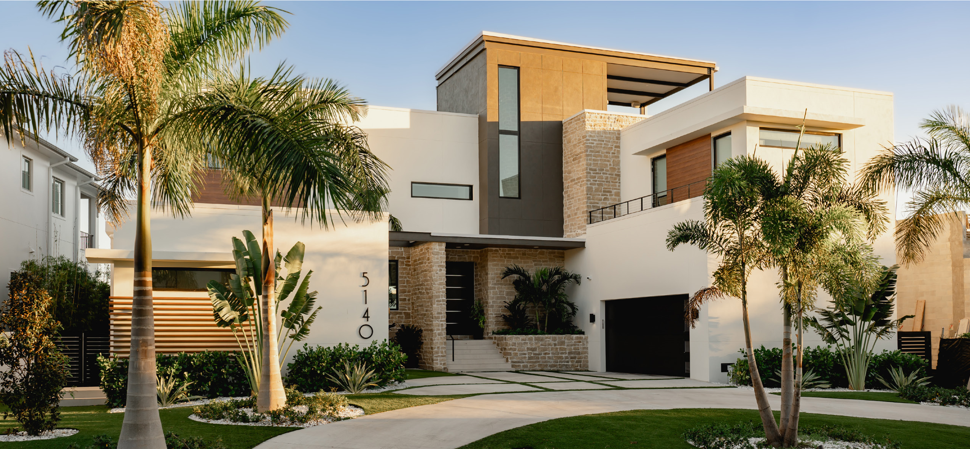
BUILDING DREAMS
Our clients are not just investing in structures, but
in their dreams, aspirations, and legacies. GILK
specializes in new home builds, transformative
renovations, and select commercial ventures.
TRANSFORMING LIVES
We create spaces that not only reflect our clients’
unique lifestyles but also foster a sense of belonging
and connection. Whether you’re blazing a new trail or
reimagining the old, we’re ready to collaborate every
step of the way.
NEVER THE SAME THING TWICE
From the unconventional to the ambitious, we embrace
a no-limits attitude—building whatever our clients can
imagine, and then some. From sleek modern marvels
to historic restorations with a contemporary twist, our
portfolio is as diverse as the clients we serve.
AT GILK, WE BUILD
CUSTOM LUXURY HOMES
AND SPACES PERFECTLY
ALIGNED WITH YOUR
UNIQUE VISION.
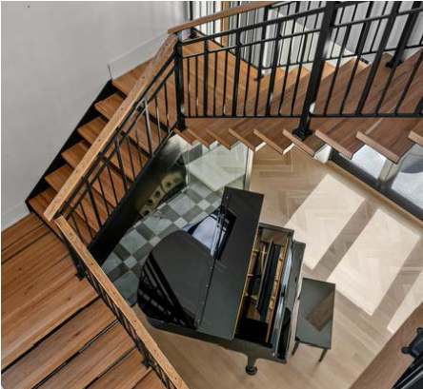
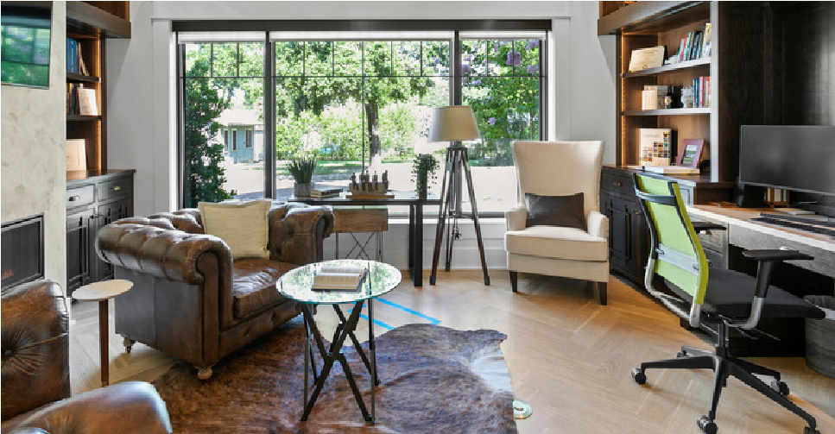
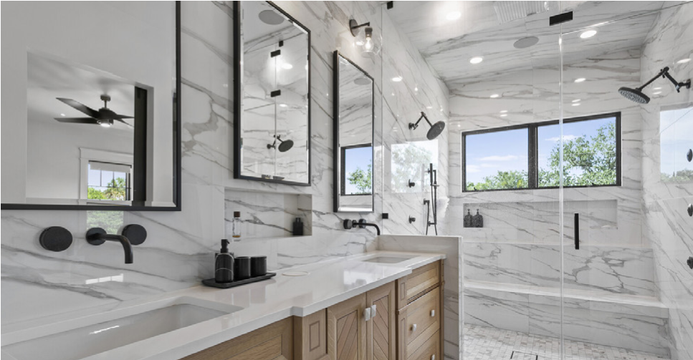
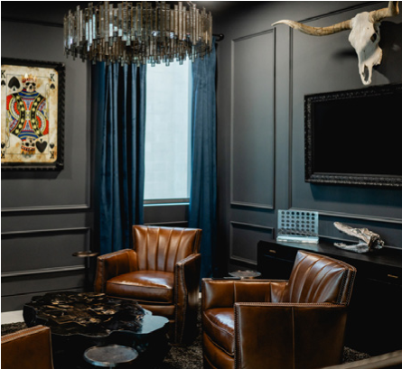
GILK.COM
WHEN IT COMES TO REALTOR REFERRALS,

WE AIM TO MAKE YOU LOOK GOOD.
REAL ESTATE PROFESSIONAL

PARTNERS PROGRAM
Realtors looking to provide exceptional
homes for their clients will find a valuable
partner in GILK Design Build. GILK brings a
unique advantage with their integrated team
of in-house interior designers, architects, and
general contractors, ensuring a seamless
approach to crafting homes that not only
meet but exceed expectations. By staying
on top of the top-selling features and design
trends, GILK tailors each home to align with
both buyer demands and the local market.
Our commitment to resilient construction
goes beyond standard codes, guaranteeing
that homes are built to withstand changing
environmental conditions and maintain long-
term value. Whether renovating a current

home, or building new, we are here to assist
during the entire process.
For Realtors, recommending GILK means
offering clients peace of mind, quality, and a
home that embodies the latest in design,

safety, and enduring craftsmanship—all
delivered through a client-centered process
that makes GILK a trusted name in the industry.

