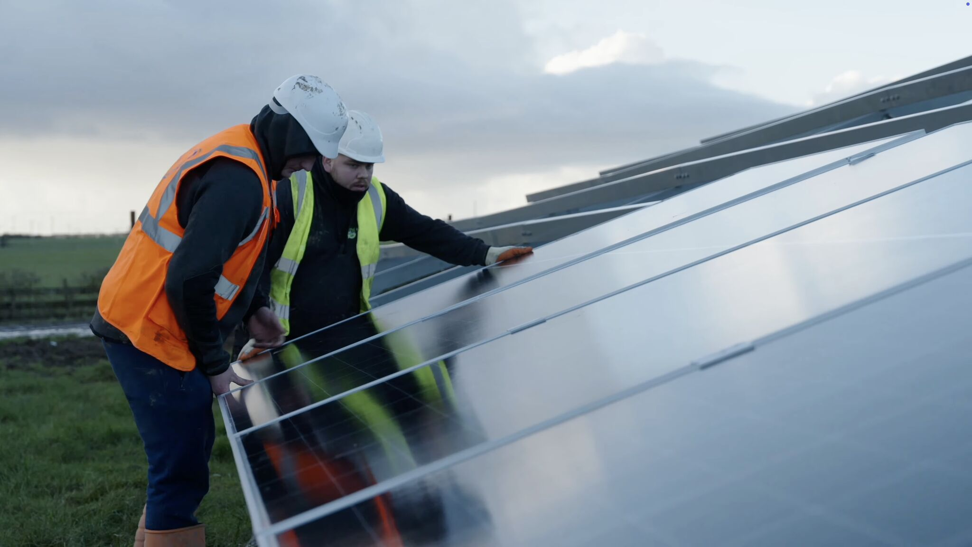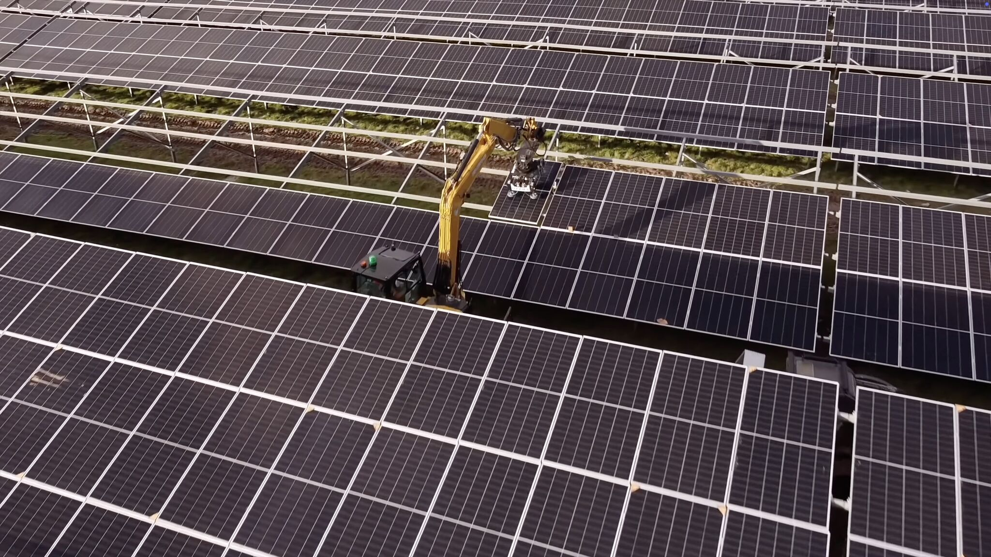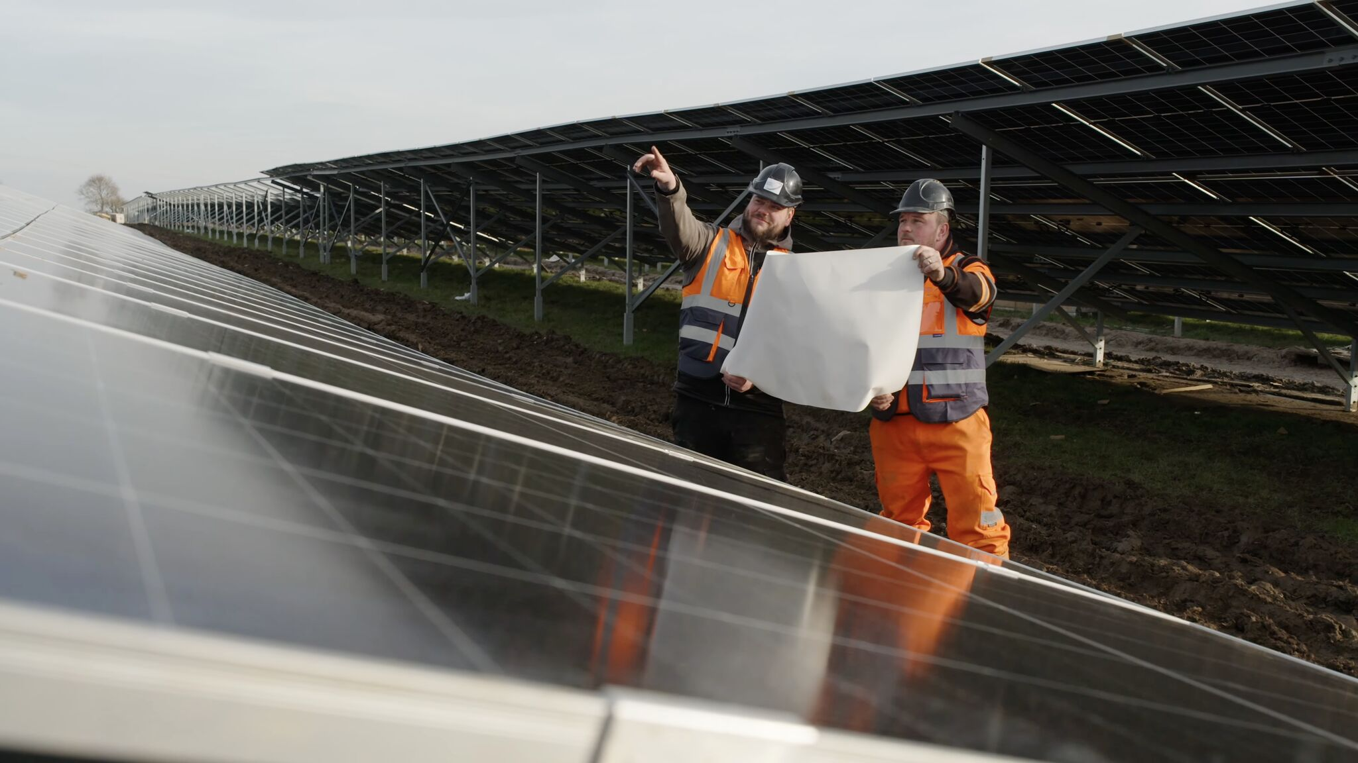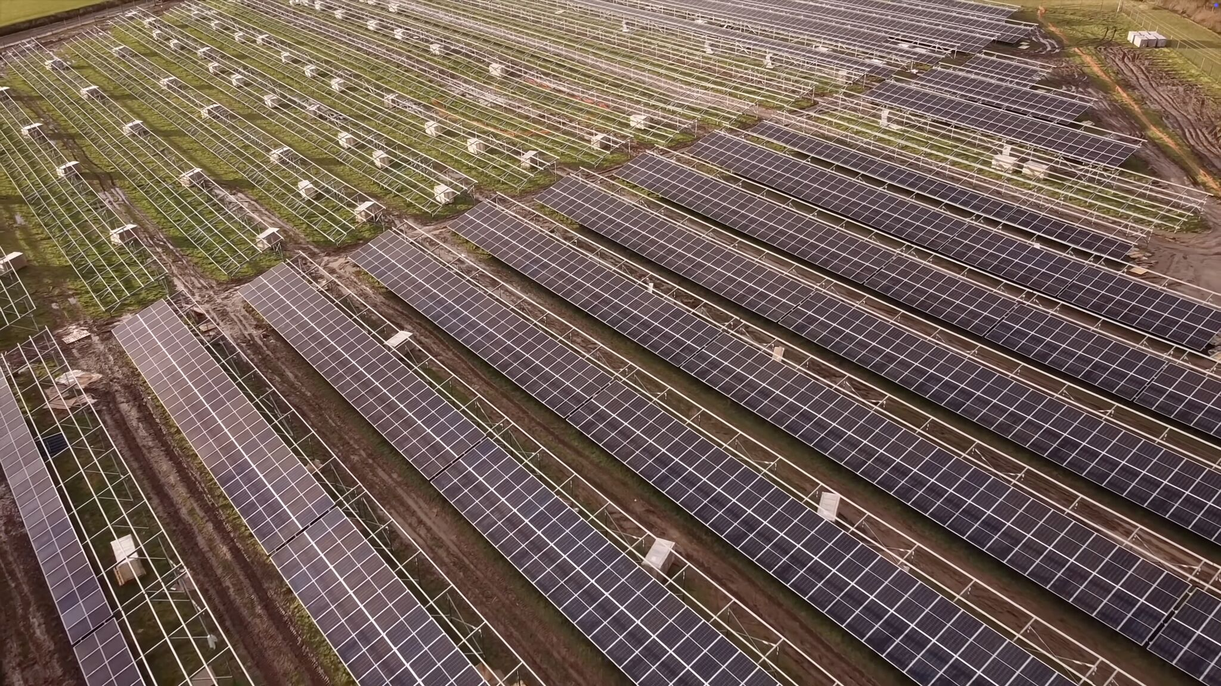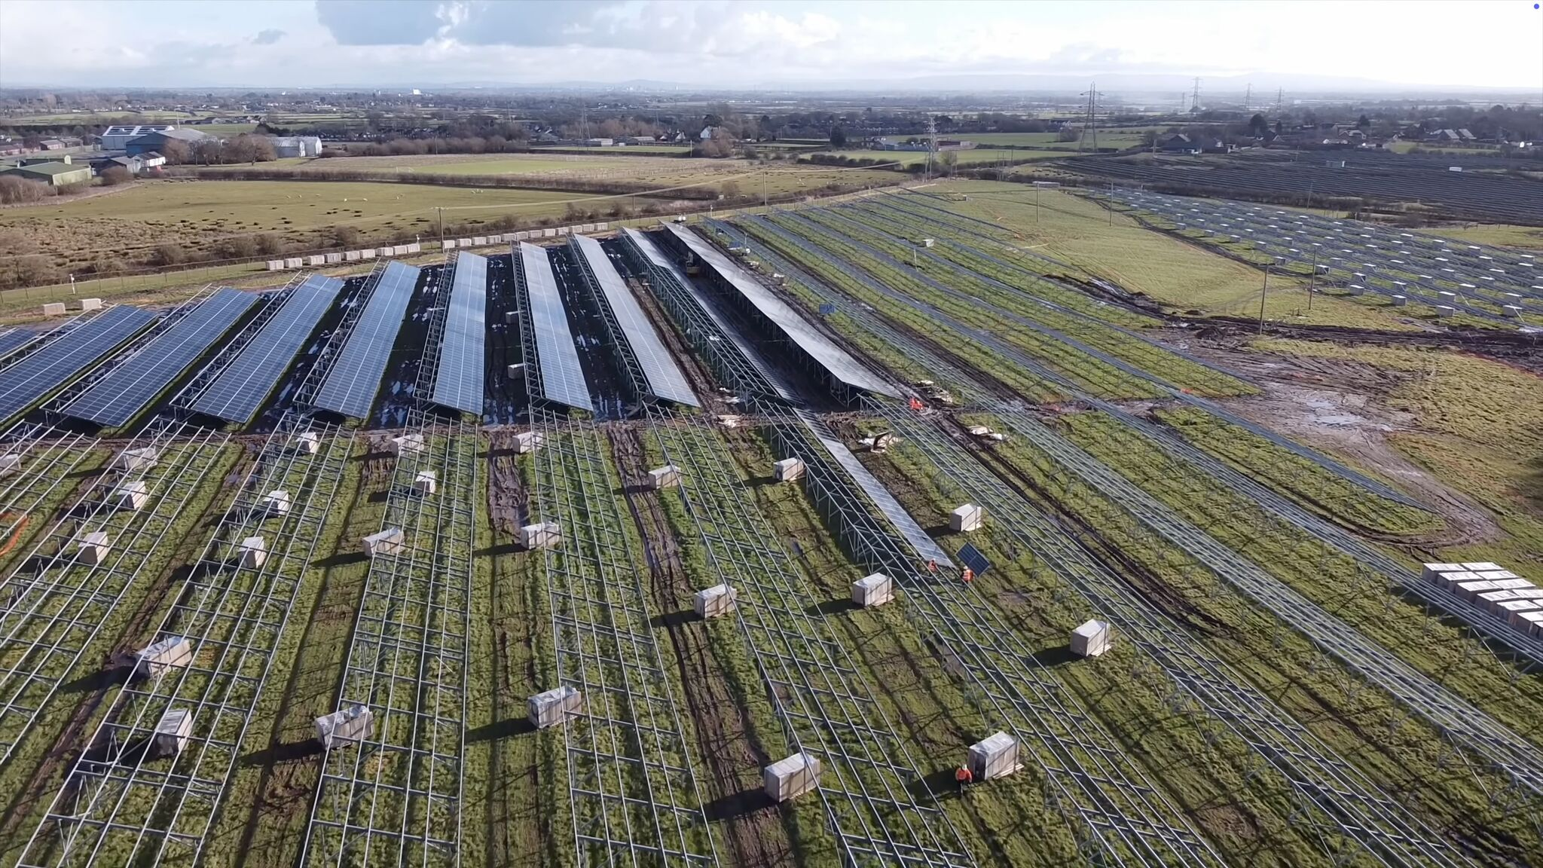

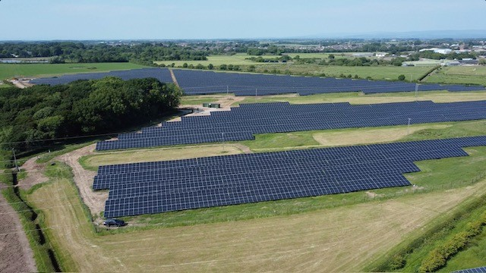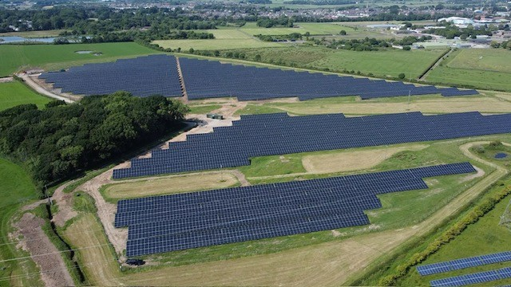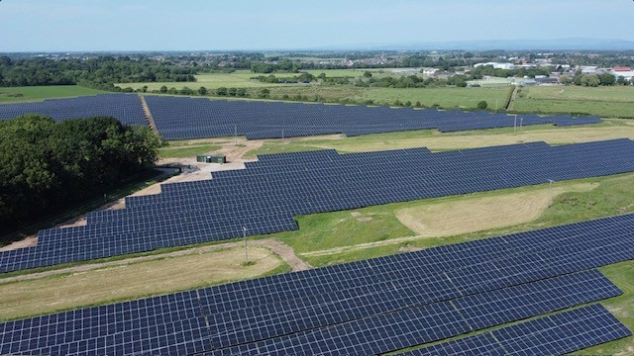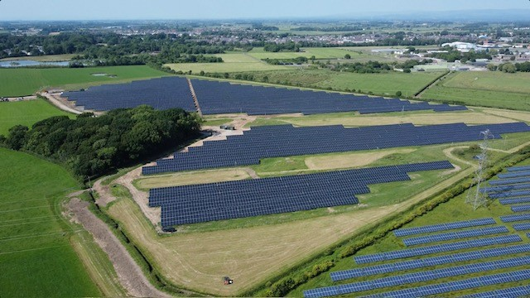

Case Study: 9.63MW Ground Mount Solar Installation for ADE

Overview
In an era of increasing demand for renewable energy solutions, ENER-G Renewable Solutions (ERS) was contracted by ADE to deliver a comprehensive Engineering, Procurement, and Construction (EPC) service for a 9.63MW Ground Mount Solar installation. This project, which is connected behind the meter at high voltage, represents a significant step toward sustainability for ADE’s client with the PPA in partnership with a FTSE100 listed company.

Project Details
Client: ADE
Project Type: 9.63MWp Ground Mount Solar Installation
Contract Value: Approximately £4.8 million GBP
Contract Period: July 2024 to April 2025
Role: Principal Contractor
Services Provided: Full EPC services including pre-construction, design, and construction activities.

Key Facts
7km of 400mm Triplex HV cable
100,000m of DC Cable
1500 of AC Armoured Cable
13,959 Solar panels installed
4500 piles installed
1.5km fencing
44 No. CCTV Cameras
2 x Containerised 4.5MVA Substations
23 x SG350HX Sungrow Inverters

Objectives
The primary objectives of the project included:
- Designing a solar installation that meets the energy needs of the client..
- Ensuring seamless integration of the solar asset into the client’s existing high voltage infrastructure.
- Delivering the project within the stipulated timeline and budget.

Execution Strategy
ERS implemented a structured approach to ensure the successful execution of the project:
- Pre-construction Planning:
  - Conducted thorough site assessments and feasibility studies.
  - Developed a detailed project plan outlining timelines, resources, and responsibilities.
- Design Phase:
  - Collaborated closely with ADE’s engineering services team to create an innovative design that optimised energy generation while ensuring compliance with all regulatory requirements.
  - Focused on sustainable design practices to enhance the environmental benefits of the installation.
- Construction Activities:
  - Managed the construction phase with a focus on safety, efficiency, and quality.
  - Coordinated with various stakeholders to ensure that all construction activities were aligned with the project goals.
- Integration with HV Infrastructure:
  - Engaged in continuous dialogue with ADE’s engineering team to ensure that the integration of the solar asset into the HV infrastructure was executed smoothly.
  - Addressed any challenges proactively to minimise disruptions.

Results
- The project was delivered within the agreed contract timeline.
- The collaboration with ADE has fostered a strong working relationship, enhancing ERS's reputation as a reliable partner in renewable energy solutions.
- The installation is expected to significantly reduce the client’s carbon footprint and contribute to their sustainability goals whilst providing energy security.

Conclusion
The 9.63MW Ground Mount Solar installation for ADE exemplifies ERS's commitment to delivering high-quality renewable energy projects. Through effective planning, design, and collaboration, ERS has positioned itself as a leader in the renewable energy sector, paving the way for future sustainable initiatives. This case study highlights the importance of comprehensive EPC services and strong client partnerships in achieving successful project outcomes.

