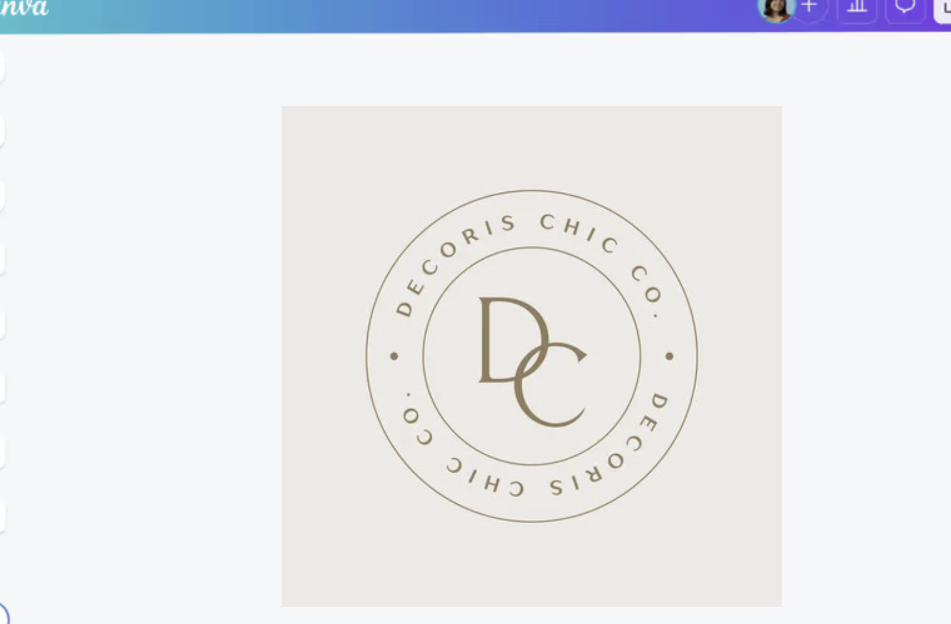
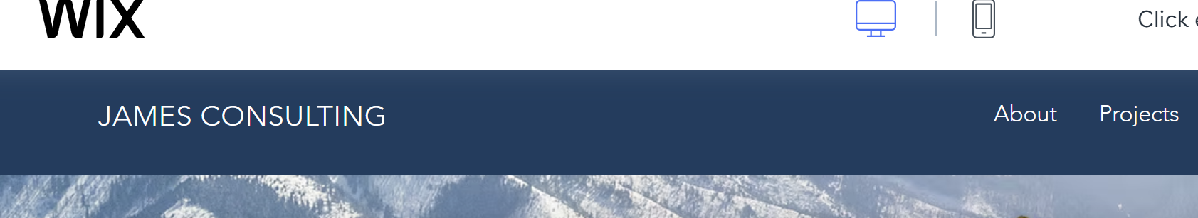
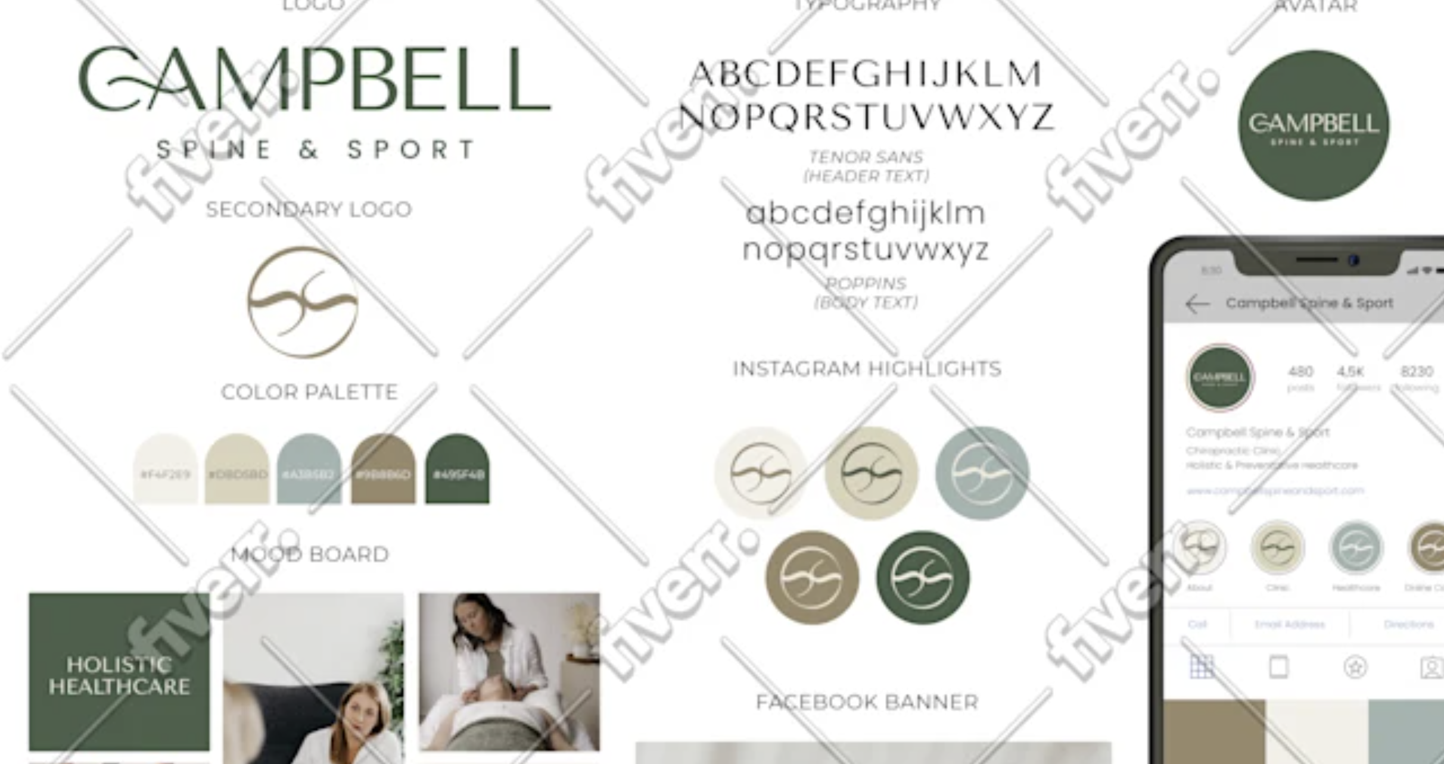

I require a logo for a new recruitment business i am about to launch. The business will solely focus on one niche, that being sales roles. So i want the logo and eventual website to have a more boutique feel rather than something super corporate. I prefer minimal design, nothing too busy.

The name Kooringa relates to a farm that is special me. Rather than naming the business something generic and corporate i figured i should just name it something that means something to me. Symbols that come to mind are wheat, fields, windmill etc.. however i don't know that there is an easy way to give a subtle nod to a farm in the design given its a recruitment business! So that can be ignored unless you can think of a way. I'm ok with it not having anything in the logo design related to the farm. I just thought i would throw it in here just in case it brought any ideas out.

Other than that i think it can just be nice simple typography logo or a basic logo with typography. I have attached the document to show some colours i'm drawn to. Not totally fixed on them however, i like the green in the Campbell spine and sport Instagram logo screen shot. I can imagine a nice theme using that colour on my logo and website.. I also don't mind the blue tone in the centre of the word doc. This is another possible theme colour. I also like the lighter background colour in the first image at the top of the attachment. Perhaps this could form part of a website theme with the green and or blue mentioned earlier. I just saw those and saved screen shots. They might not work well together. I'm not skilled in bringing colour palates together. I just saw things i liked and saved them.

I thought including this information and the fact i will be using this logo to form the theme for the business website might help inform your design decisions.

Thanks for your help!
Sam

