SJP Branding
Our colour palette is bold, impactful and eye catching. It retains our confident heritage with the bold use of white and navy, while introducing a striking and recognisable supporting palette that makes us stand out from our competitors.
Our new colour palette
We have provided RGB and HEX codes which can be used when selecting colours in a digital setting. Print designers will need to refer to the brand guidelines to obtain corresponding CMYK and PMS codes.
Primary colours
White is an important brand colour. It’s not just negative space but should be used as an active colour choice to allow our other assets a clear stage to communicate on. White enhances our palette.
We have evolved but not forgotten who we are. Our recognisable navy has become richer and more digital friendly.
Our distinctive turquoise
To support our primary colours, we’re adding a recognisable element to our visual identity and giving depth and emotion to our tapestry story.
This is our primary way of representing St. James’s Place. Our colour palette in these proportions should be a recognisable feature of our corporate communications.
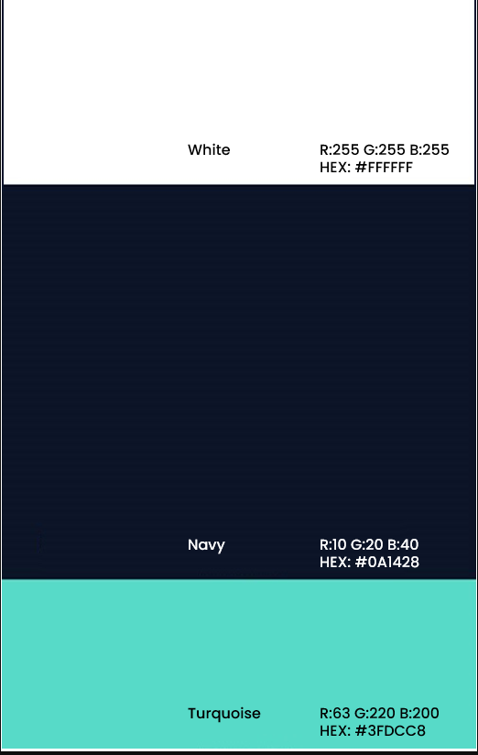

Secondary and neutral colours
When the layout calls for more information further into a document, white is used as the background colour, supported by blue, lilac, yellow, orange, pink, green and our three neutrals, light, mid and dark silver.
We’re known for our ability to understand and translate information. Our infographics and signposting require the flexibility to differentiate and communicate using our complimentary supporting colours.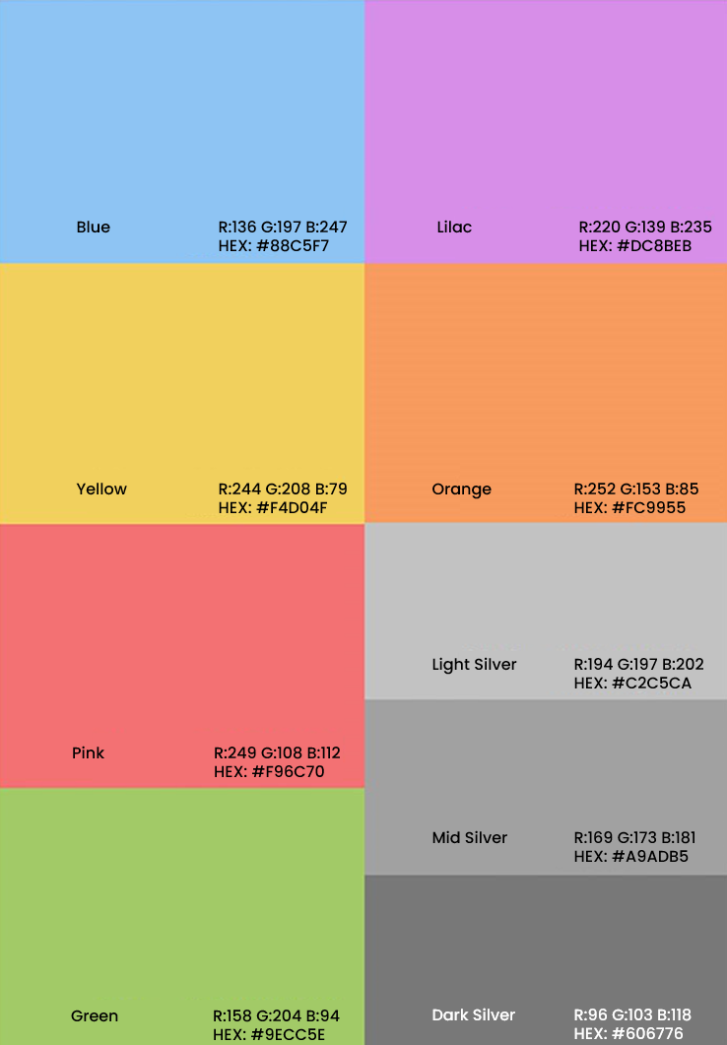

Using colours
Primary colours
Using a combination of colours is key in creating a powerful visual appearance for our brand. SJP’s unique look comes from our consistent application of our primary colours, navy and white.
Maintaining this balance of white and navy keeps us looking light and contemporary.
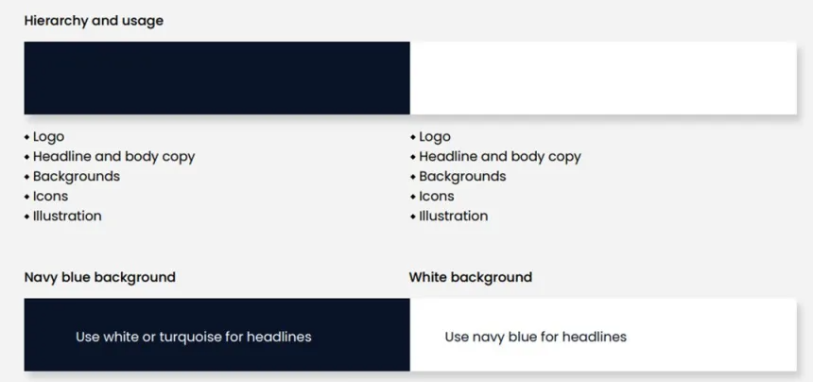

Colour balance
Working out the correct colour balance for all our communications is never an exact science. To avoid mistakes, follow our colour balance chart as closely as possible.
Our primary colours, white and navy, are ever-present and are used on all top-line communications. Together they make up approximately two thirds of colours used.
Turquoise is our lead supporting colour and should be used predominantly throughout top-level and defined secondary spaces. Our secondary colours should occupy the same amount of real estate as the turquoise alone, combined making up one third of colours used.
