Text and guide for designer - use the template page as an example. Use the previous flyer

Page 1:

- Change photo of Nick Brook to the photo of all three doctors. PLeSe dit photo so we are standing closer together if you can.
- Change the text on page “How we work and what makes our practice different” change to “We are very grateful for your consideration of our urology service for your patients in the Lower Eyre Peninsula.”
- Delete “Nick Brook Urologist”
- Keep the remainder of the text and design the same for this page

Page 2:

(main text)

Our urologists bring broad experience to your patients’ care. We have a strong focus on evidence-based treatments and can offer your patients a range of treatment choices for urological conditions. Across our surgeons, we have a wealth of knowledge and skills gained through extensive training, including fellowships in the UK & Australia, as well as advanced robotic surgery training in Belgium and London. We are actively involved in the all aspects of the medical community, with positions in the public and private sectors, active academic work at the University of Adelaide and service delivery at multiple hospitals and clinics. Our team have published extensively and are actively involved in clinical research and clinical trials. We are dedicated to remaining at the forefront of urological advancements, and between us can cover all areas of urological care.

We are pleased to offer in person or telehealth services to your patients, with rapid access. Please also feel free to call us direct (medical staff only please) if we can be of help: Nick Brook 0413 125652
Dan Spernat 0416 069686
Mark Lloyd 0409 336461

(Areas of practice – please put this down the side as per the example)
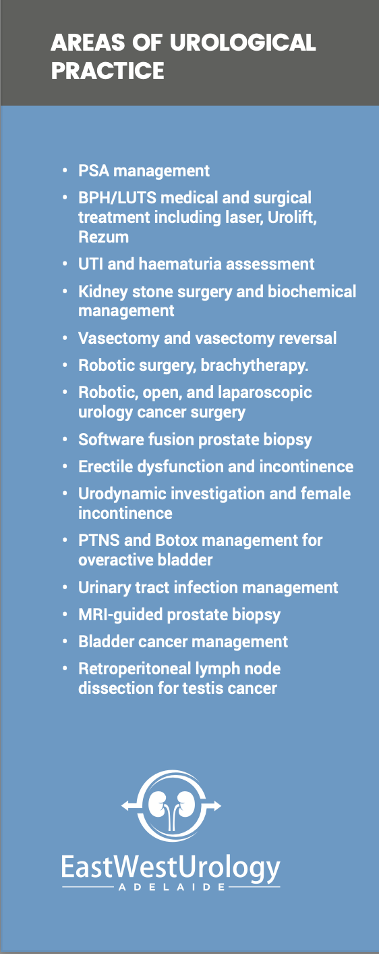

- Contact details at the bottom – side by side:

For Nick Brook:
St Elizabeth Suites Calvary North Adelaide Hospital
89 Strangways Terrace, SA 5006
Tel: 08 7095 1600 Fax: 08 6266 3756
Email: reception@nickbrook.org
Healthlink: ewurolog

For Dan Spernat and Mark Lloyd:
QE Specialist Centre, 35 Woodville Road,
Woodville South, SA 5011
Tel: 8244 4105 Fax: 8243 2766
Email: info@qespecialistcentre.com.au
Healthlink: drmlloyd

Consulting at:

Aldinga
Ashford
Burnside
Calvary North Adelaide
Flinders Private
Mount Barker
Ridgehaven
Tennyson Centre
QE Hospital
Woodville

Operating at:

Ashford
Burnside
Calvary Adelaide
Calvary North Adelaide
Flinders Private
Tennyson Centre
QE Hospital

