Baked Chicken with Salsa and Sour Cream

Looking for a weeknight dinner that’s both effortless and packed with flavor? This Baked Chicken with Salsa and Sour Cream is a creamy, cheesy, oven-baked comfort dish that’s as satisfying as it is simple. Seasoned with taco spices and smothered in a tangy sour cream and salsa blend, each bite delivers the kind of Tex-Mex comfort food warmth your whole table will love.

What sets this recipe apart is the addition of El Picante salsa—its bold, all-natural flavor infuses the dish with just the right amount of heat and brightness. Whether you use the All Natural, Diablo, or Verde variety, El Picante brings depth and authenticity that turns ordinary baked chicken into something unforgettable.

Topped with melted Cheddar and served over rice, tortillas, or even cauliflower mash, this is a versatile dish you'll return to again and again. It's a no-fuss way to bring bold Texas flavor to your kitchen with minimal prep and maximum satisfaction.

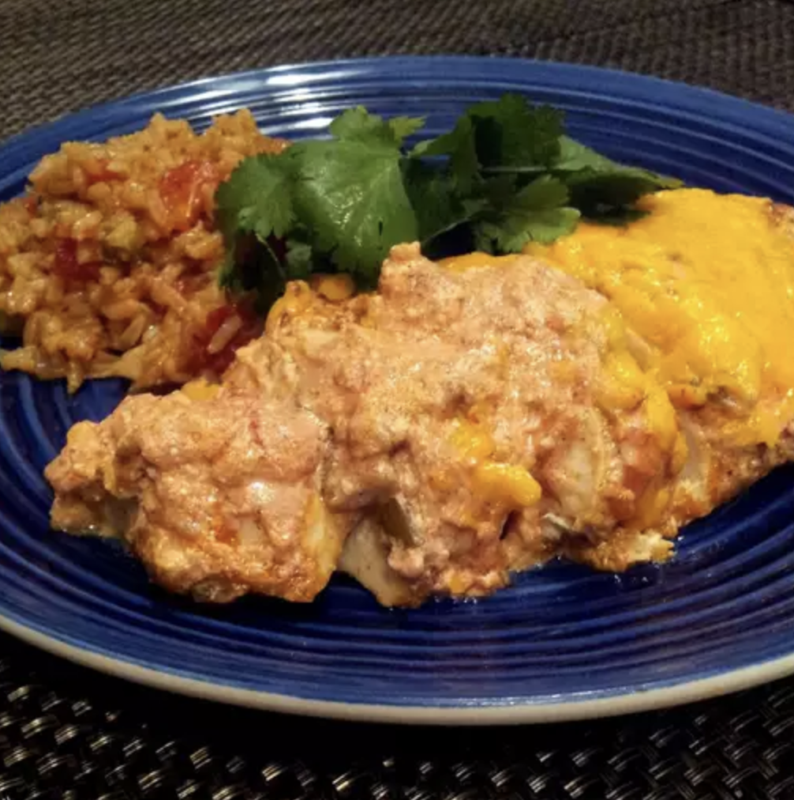

Prep Time:
10 mins

Cook Time:
40 mins

Total Time:
50 mins

Servings:
4

Yield:
4 chicken breast halves

Ingredients
- 4 skinless, boneless chicken breast halves
- 1 (1 ounce) packet taco seasoning
- 1 cup sour cream
- 1 cup salsa
- 1 cup shredded Cheddar cheese

Directions
- Preheat your oven to 350°F (175°C).
- Place the chicken breasts and taco seasoning into a large resealable plastic bag. Seal the bag tightly and shake until the chicken is evenly coated with seasoning. Transfer the seasoned chicken to a baking dish, arranging the pieces in a single layer.
- In a small bowl, mix together the sour cream and salsa until well combined. Spoon this mixture evenly over the top of the chicken.
- Bake the dish for 30 minutes. Then, sprinkle Cheddar cheese over each piece of chicken and return to the oven. Continue baking for another 10 minutes, or until the chicken is fully cooked—no longer pink in the center and juices run clear. For best results, use an instant-read thermometer to ensure the internal temperature reaches at least 165°F (74°C).


