Spiced-Up Chicken Burgers with a Kick
Juicy, bold, and packed with flavor, these Spiced-Up Chicken Burgers with a Kick are everything a grilled sandwich should be—easy to make, full of personality, and layered with fresh ingredients. Blended with guacamole seasoning, lime juice, onion, and cilantro, the ground chicken patties are seasoned from the inside out and grilled to perfection.

What sets these burgers apart is the finishing touch: a generous spoonful of El Picante salsa. Whether you choose our All Natural, Diablo, or Verde variety, each adds a burst of heat and bright flavor that takes these burgers to the next level. Served on toasted ciabatta and topped with melted Cheddar and fresh cilantro, this burger delivers the perfect balance of spice, tang, and richness in every bite.

It’s a quick and crave-worthy dinner option, ideal for backyard cookouts or casual weeknight meals. Pair with a cold drink, some tortilla chips, and maybe a little extra El Picante on the side—you won’t regret it.

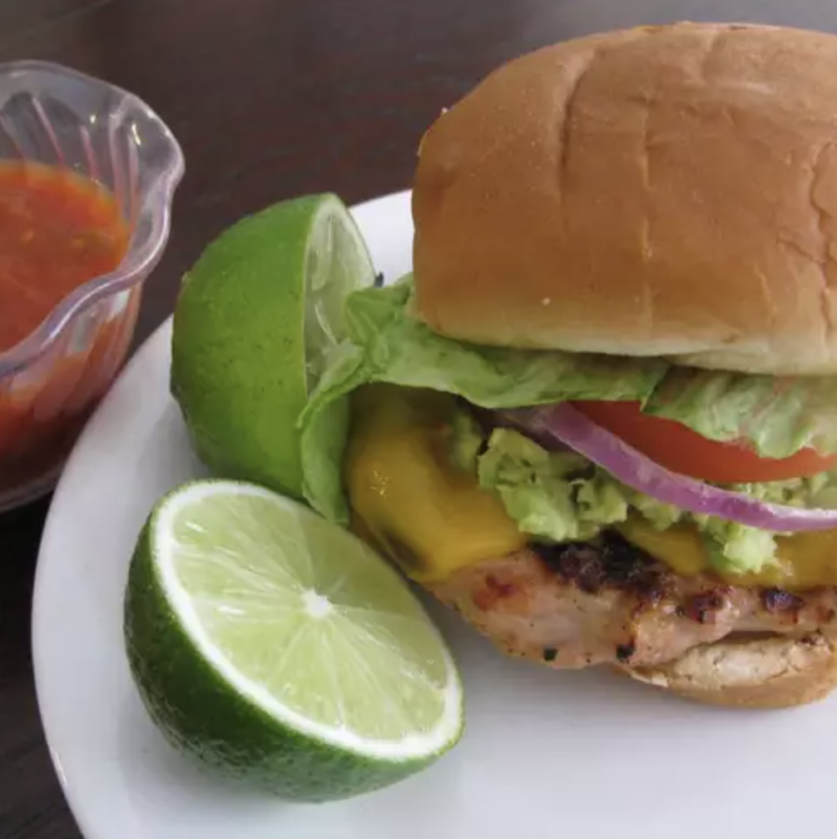

Prep Time:
15 mins

Cook Time:
10 mins

Total Time:
25 mins

Servings:
4

Yield:
4 burgers

Ingredients
- 1 pound ground chicken
- ½ (1 ounce) package guacamole seasoning mix
- ½ cup chopped fresh cilantro, divided
- ½ lime, juiced
- ¼ cup minced onion
- 8 slices ciabatta bread
- ¼ cup El Picante salsa, divided
- 4 slices Cheddar cheese

Directions
- Heat a grill to medium and lightly coat the grates with oil to prevent sticking.
- In a mixing bowl, combine the ground chicken, guacamole seasoning, lime juice, minced onion, and half of the chopped cilantro. Blend well until fully incorporated, then shape into 4 even patties. Set the remaining cilantro aside for later use.
- Place the patties on the hot grill and cook until they’re fully done—no pink in the center, juices run clear, and grill marks are visible—about 5 to 8 minutes per side depending on thickness.
- As the burgers near completion, toast the ciabatta bread directly on the grill—about 1 minute per side. In the final minute of grilling, place a slice of Cheddar cheese on each patty and allow it to melt.
- Assemble the burgers on the toasted ciabatta. Top each with approximately 1 tablespoon of El Picante salsa and a sprinkle of the reserved fresh cilantro. Serve immediately.


