El Picante’s Tex-Mex Skillet Fiesta

This hearty and flavorful skillet dish brings together everything you love about Tex-Mex comfort food—perfectly seasoned ground meat, warm rice, melty cheese, and the bold kick of El Picante salsa. Ready in just 25 minutes, it’s a quick and satisfying meal for busy nights, and it’s flexible enough to adapt to what you have on hand. Add black beans and jalapeños for extra texture and heat, or keep it simple and savory with the essentials.

El Picante salsa is the star of this one-pan meal, infusing the dish with rich tomato flavor and just the right amount of spice. Whether you use the All Natural, Diablo, or Verde variety, each bite delivers freshness and depth you won’t get from jarred sauces full of preservatives. Served with avocado, sour cream, or wrapped in a warm tortilla, this dish is perfect for family dinners or casual get-togethers.

Leftovers (if there are any!) make excellent taco or burrito fillings the next day, and cleanup is a breeze. With minimal prep and maximum flavor, this is a weeknight winner you’ll come back to again and again.

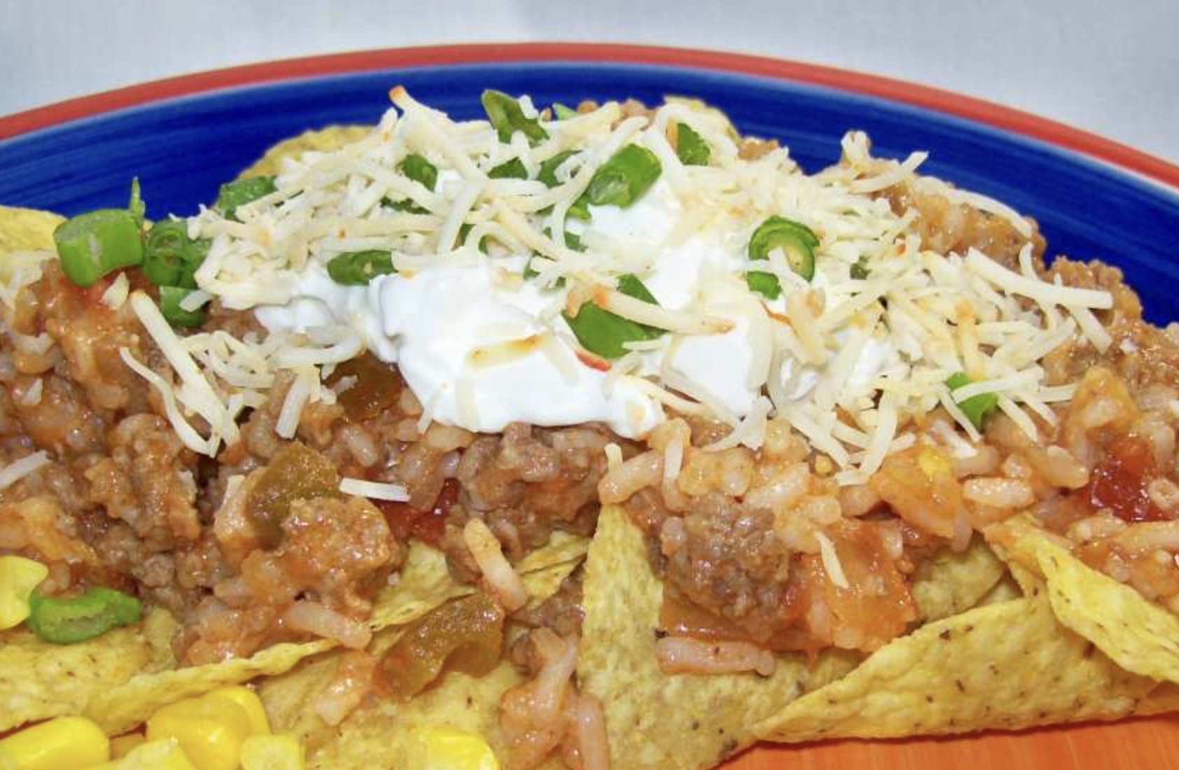

Prep Time:
5 mins

Cook Time:
20 mins

Total Time:
25 mins

Servings:
8

Ingredients
- 1 lb extra lean ground beef (or ground turkey breast, or ground pork)
- ¹⁄ ₂cup 0nion, chopped (optional, if desired)
- 1(1 ounce) package taco seasoning
- 2cups cooked rice (or one 8.8-ounce package 90 second microwaveable rice)
- 1 ¹⁄₂cups sharp cheddar cheese, shredded (or pepper jack cheese)
- 1 ¹⁄₂ - 2cups El Picante salsa
- 1(15 1/2 ounce) can black beans (optional, rinsed and drained)
- 1tablespoon pickled jalapeno (chopped)
- avocado, sliced (optional, for garnish)
- cilantro (0ptional, for garnish)
- sour cream (optional, for garnish)
- 4 -8 tortillas (optional, for garnish)

Directions
- Preheat your grill to medium and brush the grates lightly with oil to help prevent sticking.
- In a large skillet, sauté the chopped onion (if using) over medium heat until soft and translucent.
- Add ground meat to the skillet and cook with taco seasoning until browned, draining off any excess grease if needed.
- Stir in the cooked rice, shredded cheese, El Picante salsa, and optional mix-ins like black beans and jalapeños. (Tip: Use the full 2 cups of salsa if you're including beans.)
- Mix everything together until well combined and heated through.
- Serves 6–8. Garnish with fresh cilantro, sour cream, and sliced avocado for extra flavor and color.

⏱️ If you're cooking rice from scratch, allow an extra 20 minutes to prepare it before assembling the dish.


